In the diagram below, transversals m and p are intersecting two parallel lines, a and w.

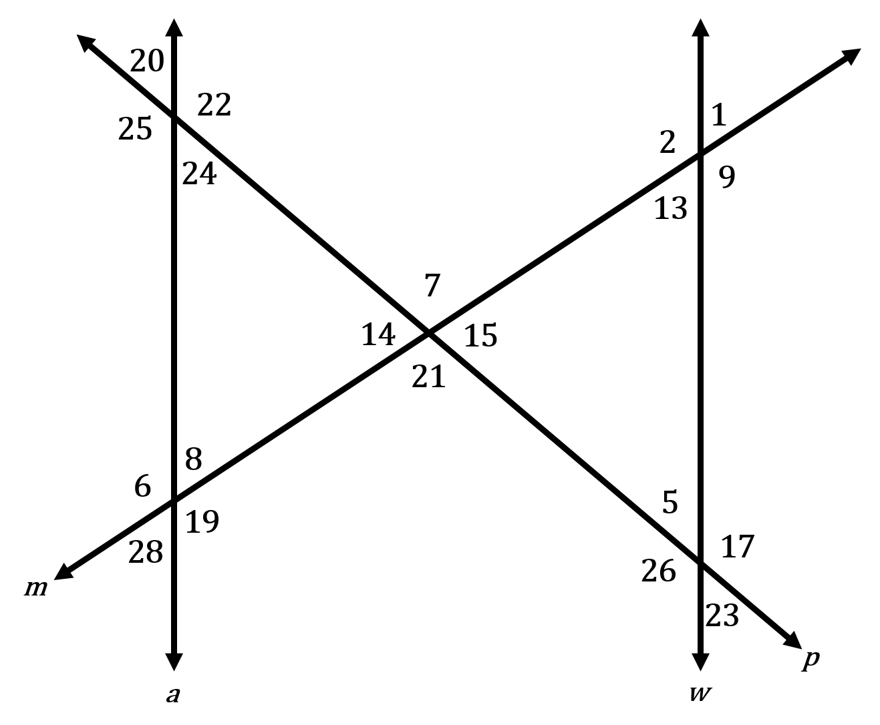
Part I
- Identify all vertical angles.
- Identify all linear pairs.
- If , then what is the
- If , then what is the
- If , then what is the
Part II
- Identify each pair of alternate interior angles.
- Identify each pair of consecutive interior angles.
- Identify each pair of alternate exterior angles.
- Identify each pair of consecutive exterior angles.
- Identify each pair of corresponding angles.
- If , then what is the
- If , then what is the
- If , then what is the
- If , then what is the
- If , then what is the

