For problems 1–3:
- Write an equation to solve for .
- Choose a sentence from the list below to justify your equation.
- Find the indicated values.

Possible justifications:

1. If alternate interior angles are congruent, then a transversal intersected parallel lines.
2. If alternate exterior angles are congruent, then a transversal intersected parallel lines.
3. If corresponding angles are congruent, then a transversal intersected parallel lines.
4. If same-side interior angles are supplementary, then a transversal intersected parallel lines.

Example: Find so that .

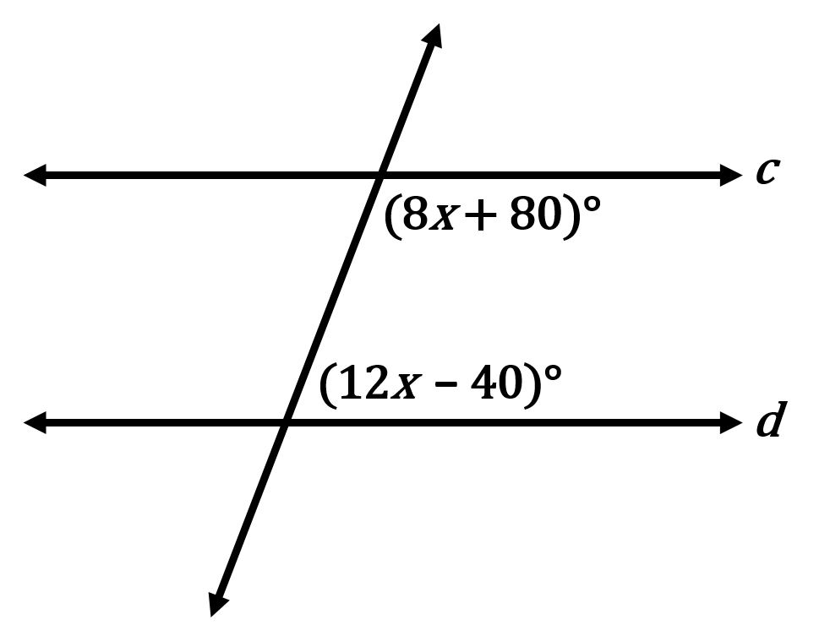

- Equation to solve for :

- Justification #4: If same-side interior angles are supplementary, then a transversal intersected parallel lines.

1. Find so that .
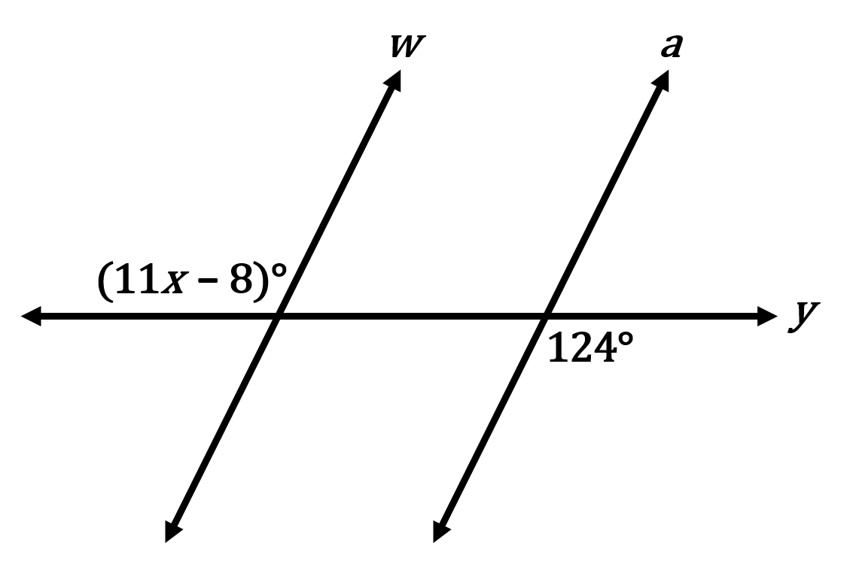

- Equation to solve for : ________________________________________________________

- Justification # _____ : _________________________________________________________________________

_________________________________________________________________________________________________

- ______

2. Find so that .
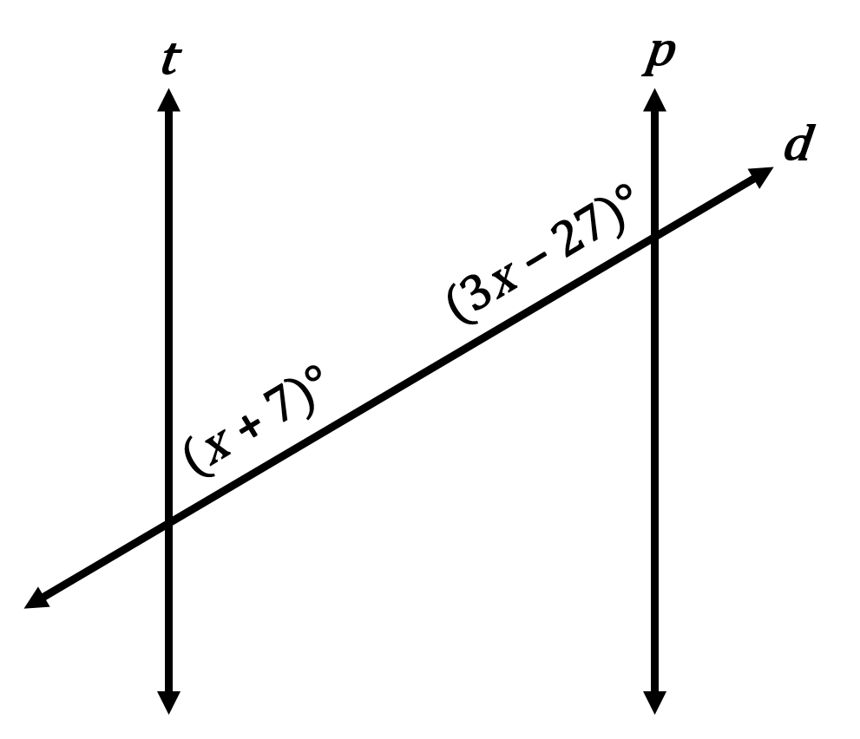

- Equation to solve for : ________________________________________________________

- Justification # _____ : _________________________________________________________________________

_________________________________________________________________________________________________

- ______
3. Given: and
Find so that . Then, find .
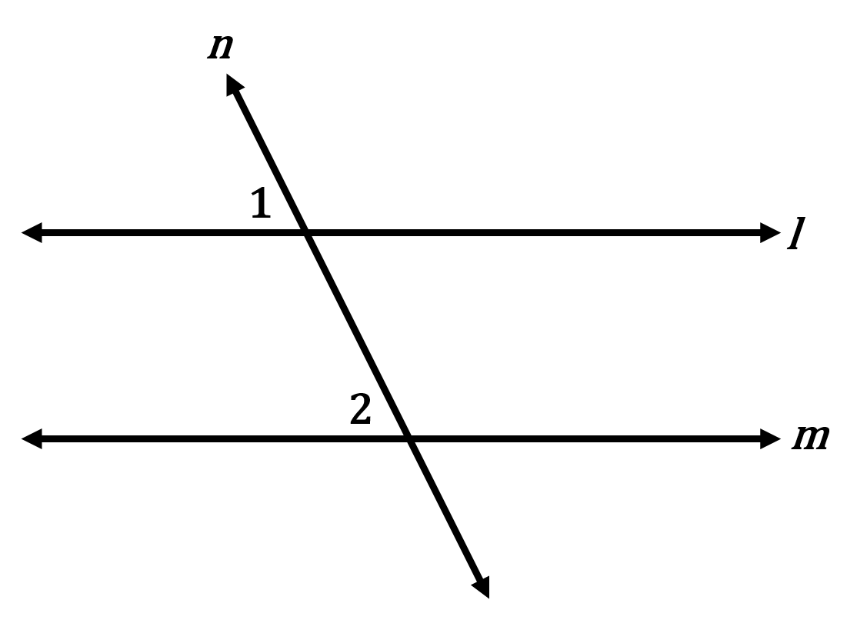

- Equation to solve for : ________________________________________________________

- Justification # _____ : _________________________________________________________________________

_________________________________________________________________________________________________

- ______

______

For problems 4–6: Determine which lines or segments are parallel. Explain your reasoning.

4. Which lines are parallel? Explain your reasoning.
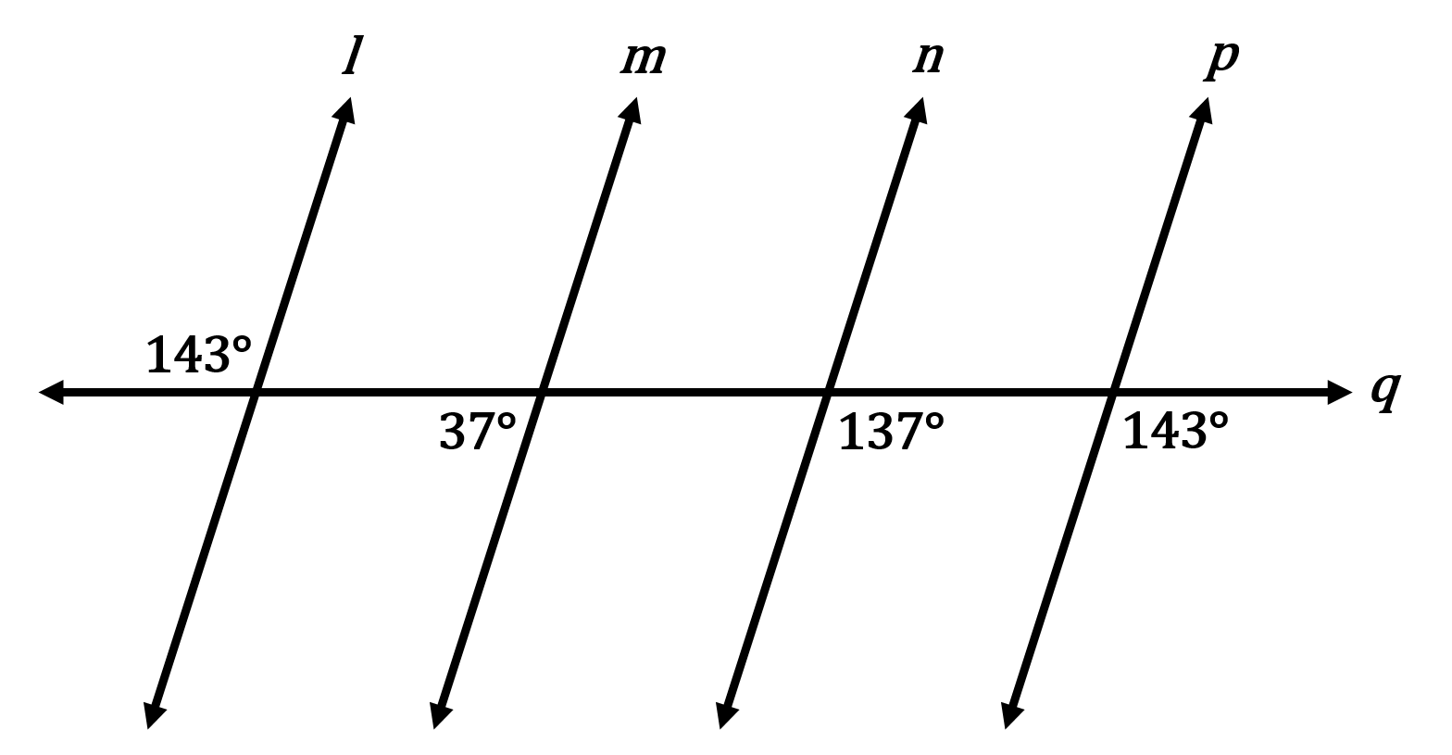
_________________________________________________________________________________________________________

_________________________________________________________________________________________________________

_________________________________________________________________________________________________________
5. Which lines are parallel? Explain your reasoning.
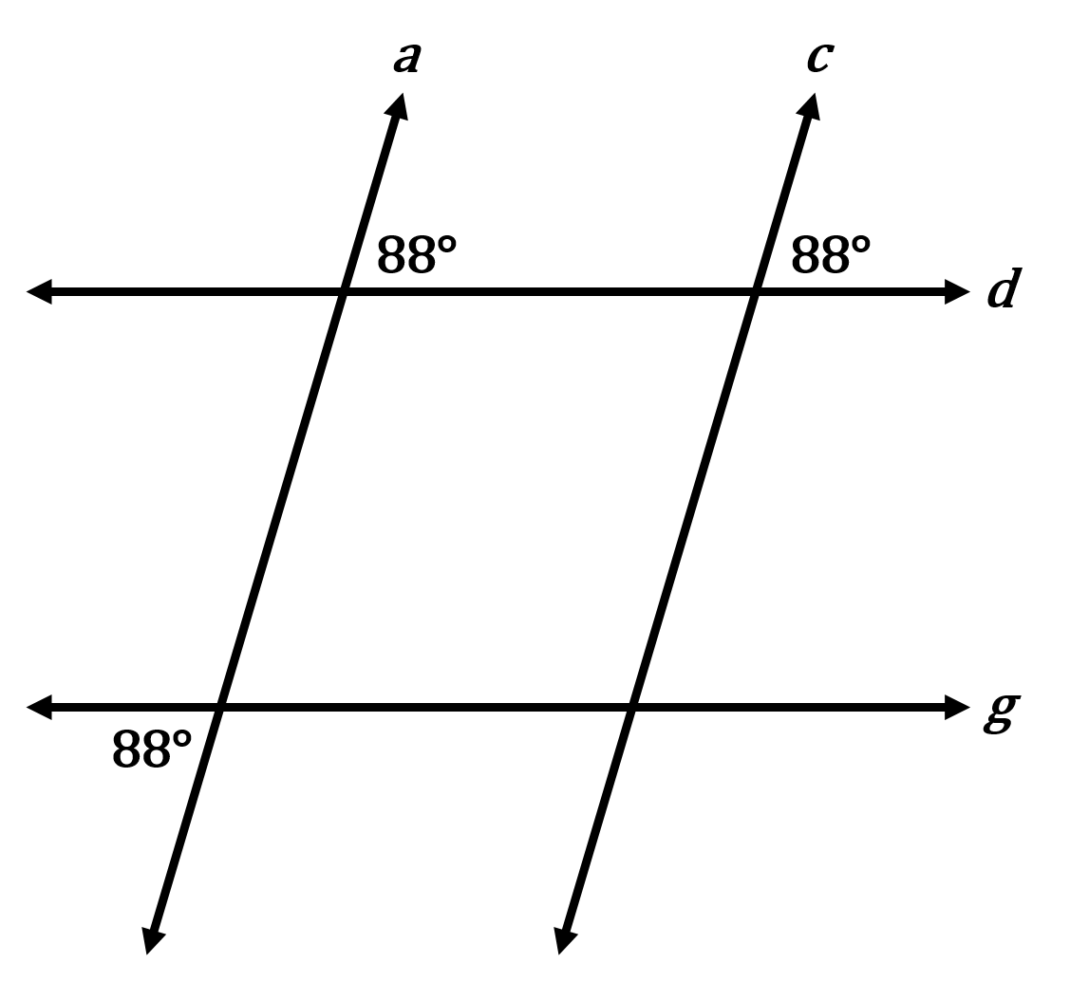
_________________________________________________________________________________________________________

_________________________________________________________________________________________________________

_________________________________________________________________________________________________________

6. Which lines (or segments) are parallel? Explain your reasoning.
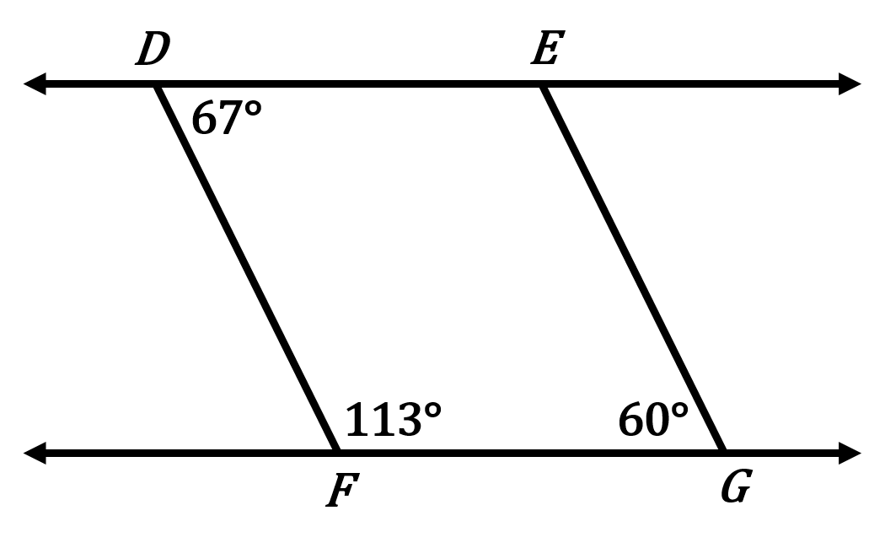
_________________________________________________________________________________________________________

_________________________________________________________________________________________________________

_________________________________________________________________________________________________________

For problems 7–8: Provide the appropriate reasons to complete the two-column proof.

7. Given: and are supplementary
Prove:
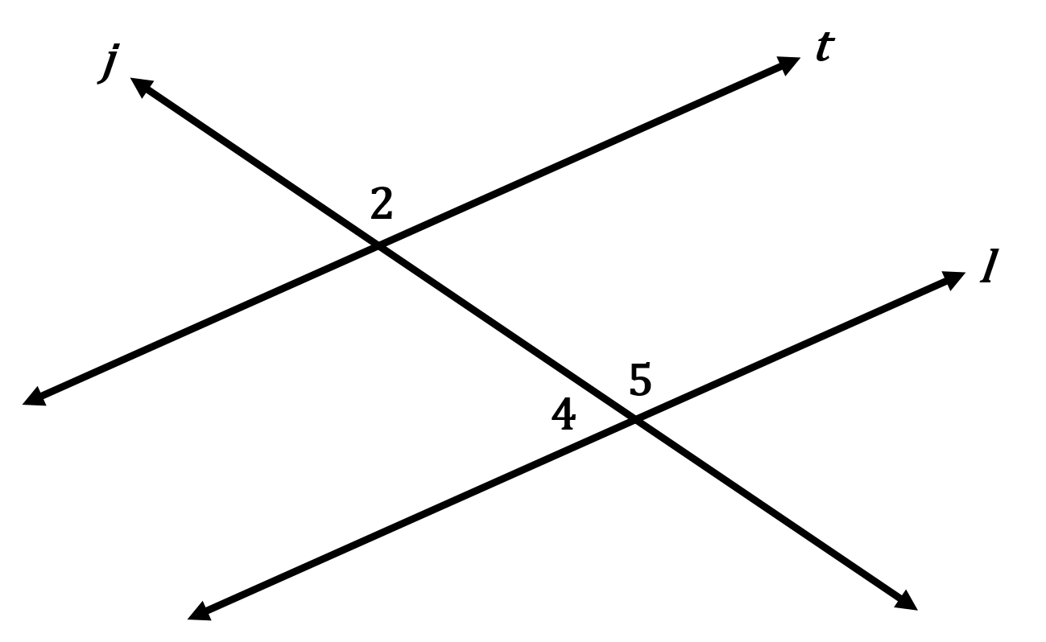

Statements | Reasons
1. and are supplementary. | 1.
2. and form a linear pair. | 2.
3. and are supplementary. | 3.
4. | 4.
5. | 5.

8. Given: ;
Prove:
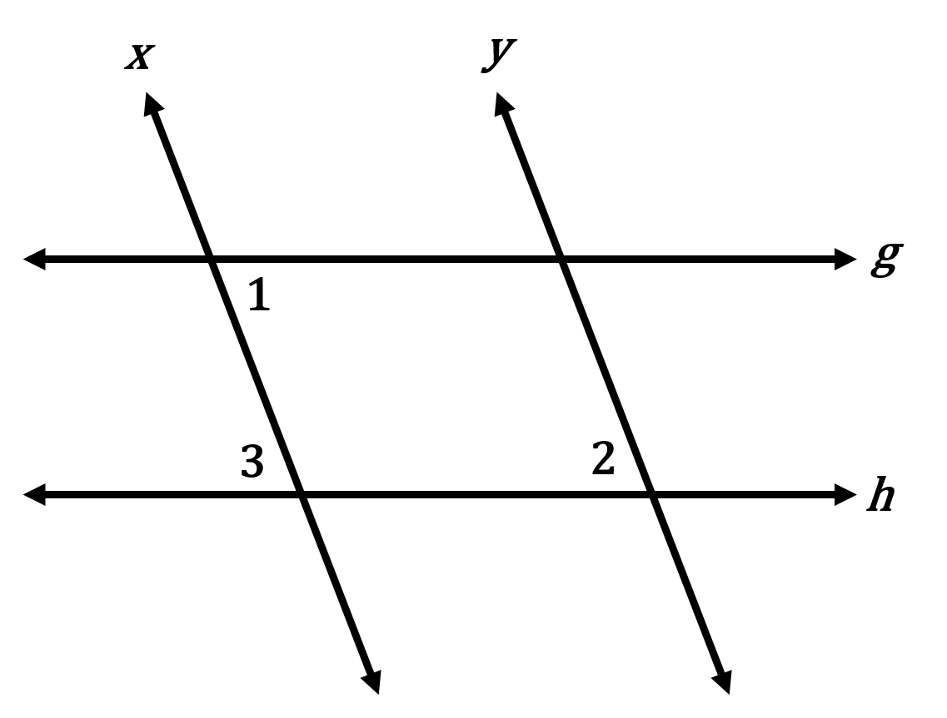

Statements | Reasons
1. ; | 1.
2. | 2.
3. | 3.
4. | 4.

For problem 9: Use the given information to write a paragraph to prove .

9. Given: and are supplementary
Prove:













