Use your knowledge of the Distance Formula to answer the following questions.
- What is the distance between points and ? Round your answer to the nearest tenth.

- Find the distance between points and ? Round your answer to the nearest tenth.

- What is the length of Round your answer to the nearest tenth.
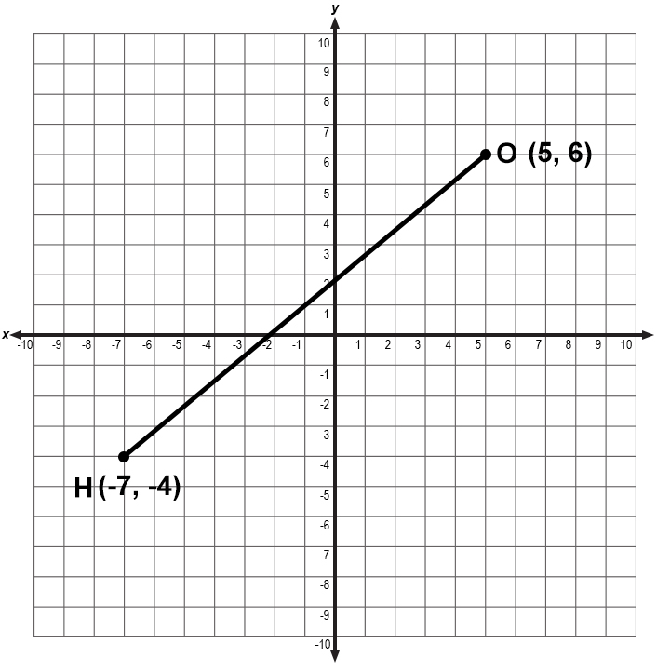

- What is the distance between V and T ? Round your answers to the nearest tenth.

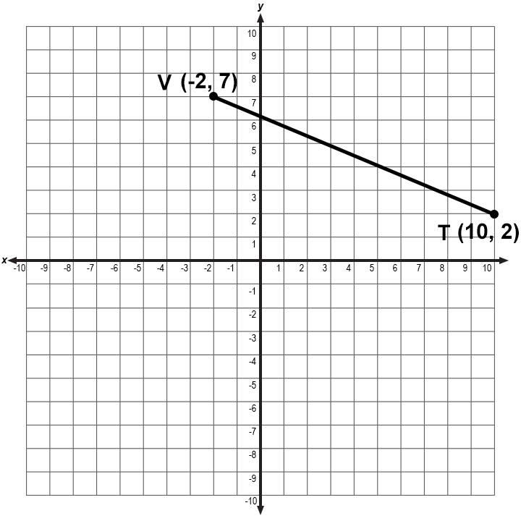

- Determine if and are congruent using the distance formula. Explain why or why not.

- has the points and
- has the points and

