Use your knowledge of the slopes of parallel and perpendicular lines to answer the following questions.

- Given: and
What is the slope of ?

- What is the slope between the points and ?

- What is the slope of a line that is perpendicular to a line that contains the points and ?

- What is the slope of a line that is parallel and perpendicular to the line on the graph?
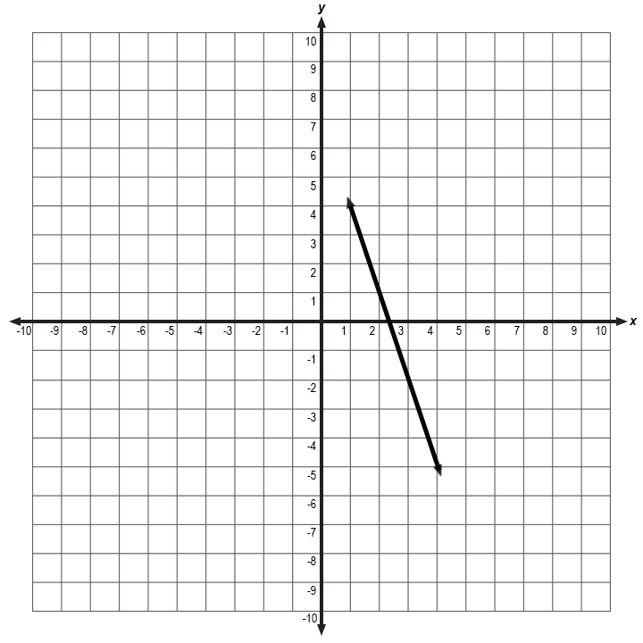
Parallel:
Perpendicular:

- Choose which of the following equations is parallel to the line .

- Which of the followings equations is perpendicular to the line ?

- 8

- Determine if the following lines are parallel, perpendicular or neither.
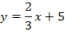

- Determine if the following lines are parallel, perpendicular or neither.

- Determine if the following lines are parallel, perpendicular or neither.
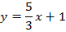

- What are the possible coordinates of , so that is parallel to line ?

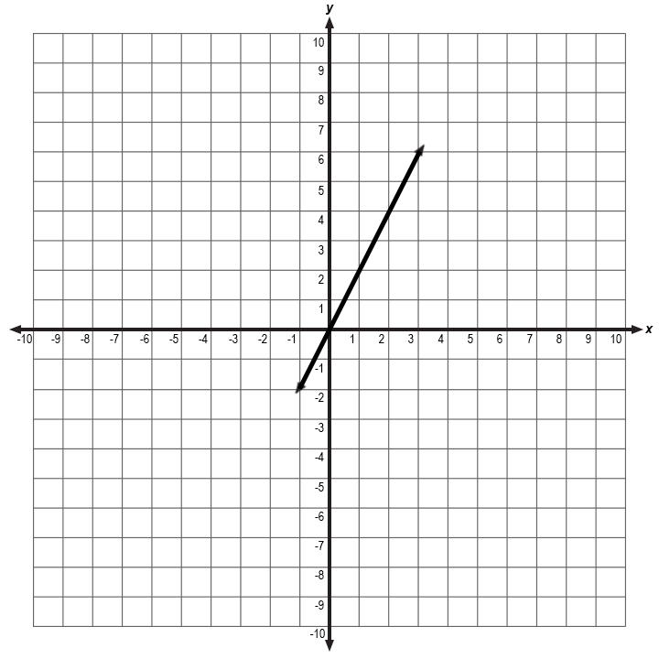

- (4,3)

