The vertices of polygon JTWC are J(1, 5), T(4, 4), W(6, 2), and C(3, 2).

For each of the problems below, graph the polygon JTWC and the following reflection as indicated.

1. Reflection across
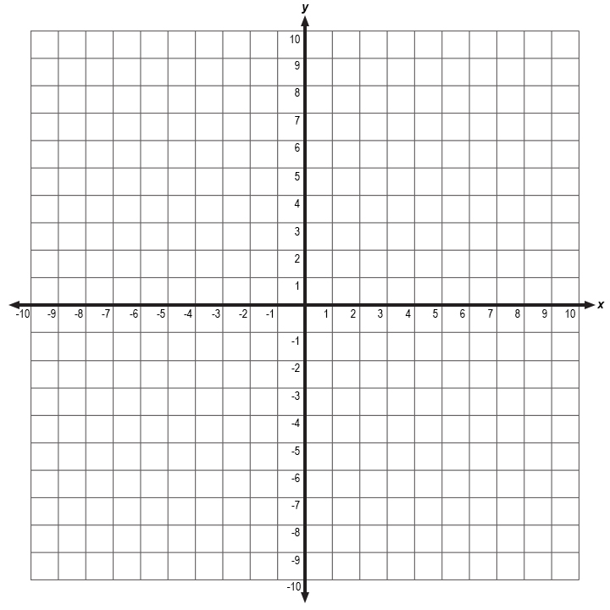

2. Reflection across

3. Reflection across

