Part A: Magazine Scavenger Hunt

- Explain the meaning of point symmetry and line symmetry.

_________________________________________________________________________________________________

_________________________________________________________________________________________________

_________________________________________________________________________________________________

- Find images in magazines or online media sources of figures that have point symmetry, horizontal line symmetry, and vertical line symmetry. If you find hard copy images, you can take photographs of the images for submission to the assignment's dropbox, or you can scan them and then submit them to the assignment's dropbox.

- Find images in magazines or online media sources of figures that do not have point symmetry, horizontal line symmetry, or vertical line symmetry. If you find hard copy images, you can take photographs of the images for submission to the assignment's dropbox, or you can scan them and then submit them to the assignment's dropbox.

Part B: Graphing Challenge

- The vertices of polygon STAR are S(−4, 3), T(0, 3), A(−2, −1), and R(−6, −1). Graph polygon STAR on the coordinate plane.
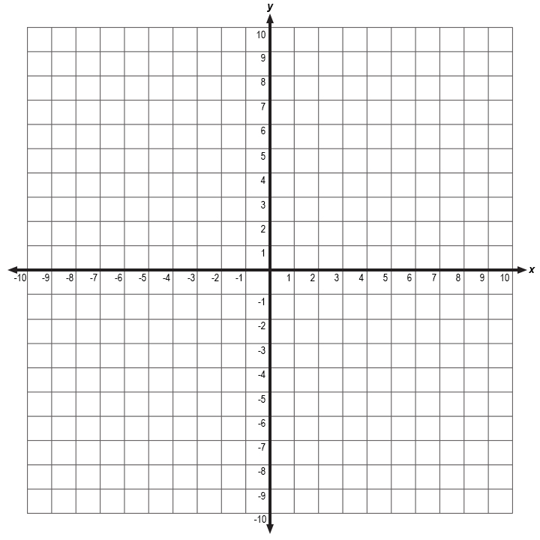

- Determine each line of symmetry for polygon STAR and give the equation for each line.

_________________________________________________________________________________________________

_________________________________________________________________________________________________

_________________________________________________________________________________________________

_________________________________________________________________________________________________

