1. Given the lengths of the sides of △SPO: 20, 17, and 9
Place the lengths along the appropriate sides of △SPO.

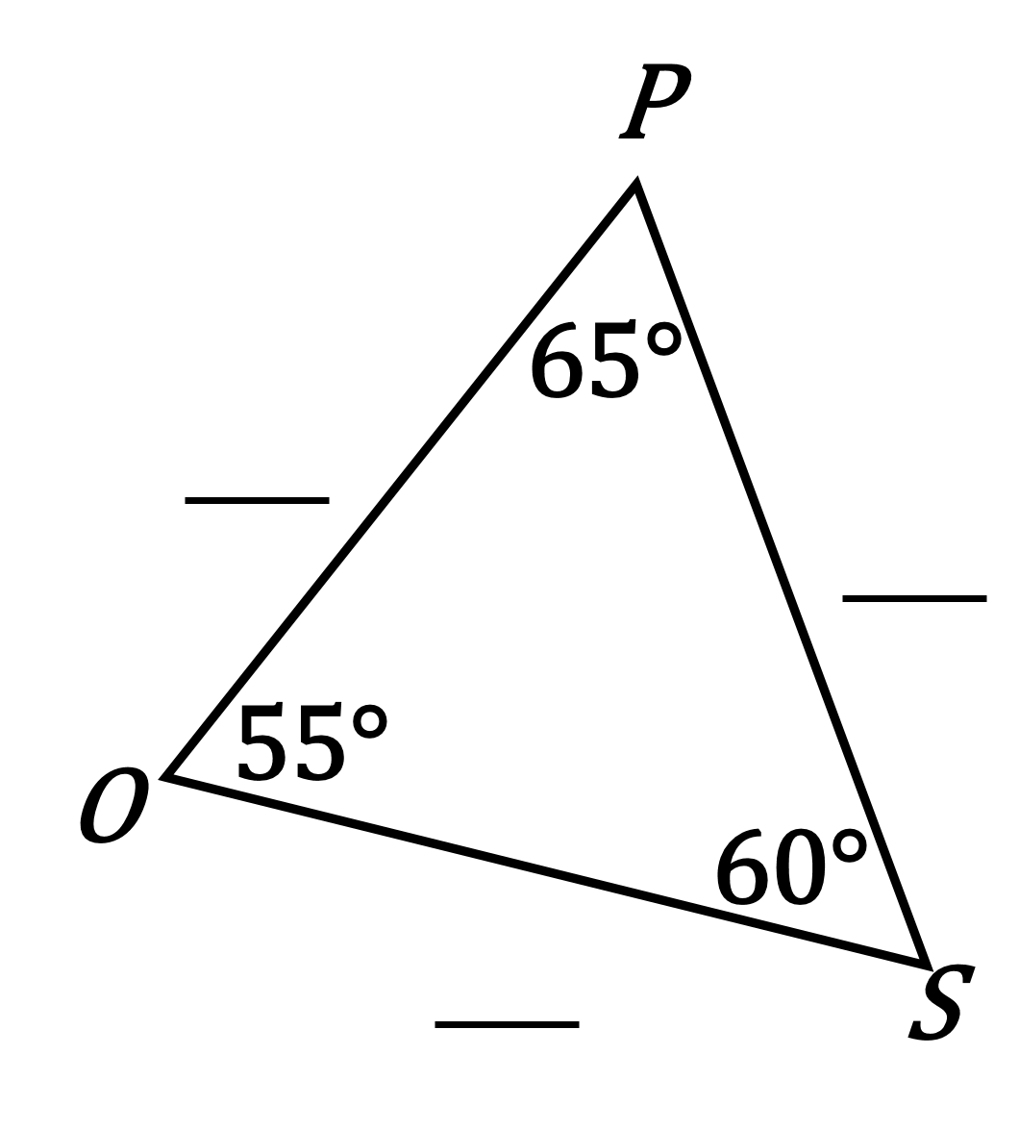

2. Why is it impossible for and
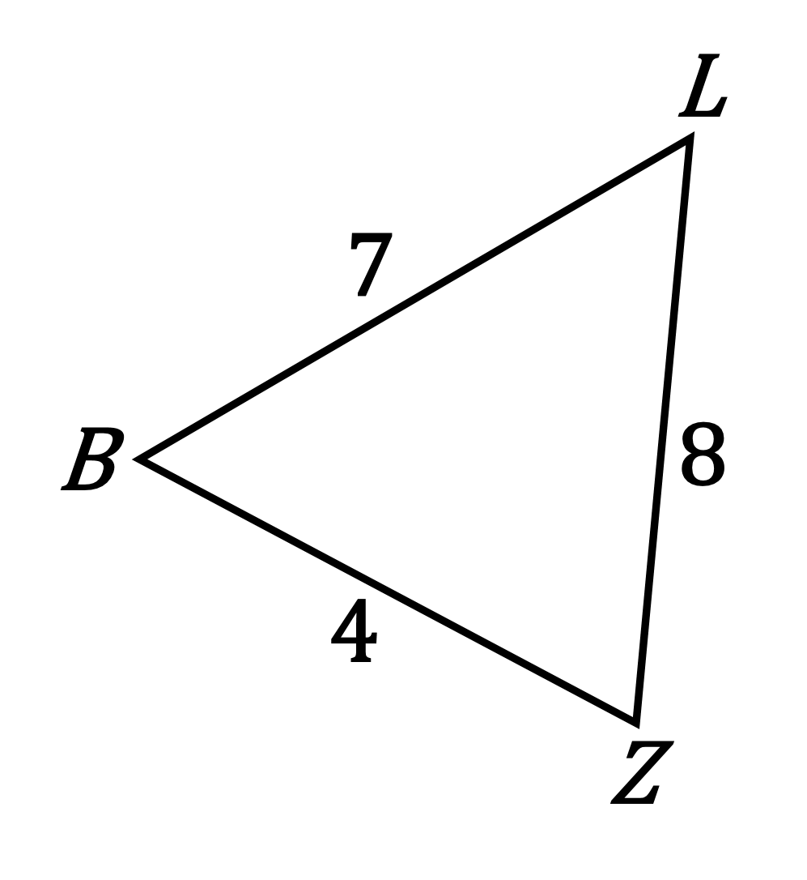
_________________________________________________________________________________________________________

_________________________________________________________________________________________________________

_________________________________________________________________________________________________________

3. Given: △RHQ
Choose angle measures so that RH > HQ > QR.
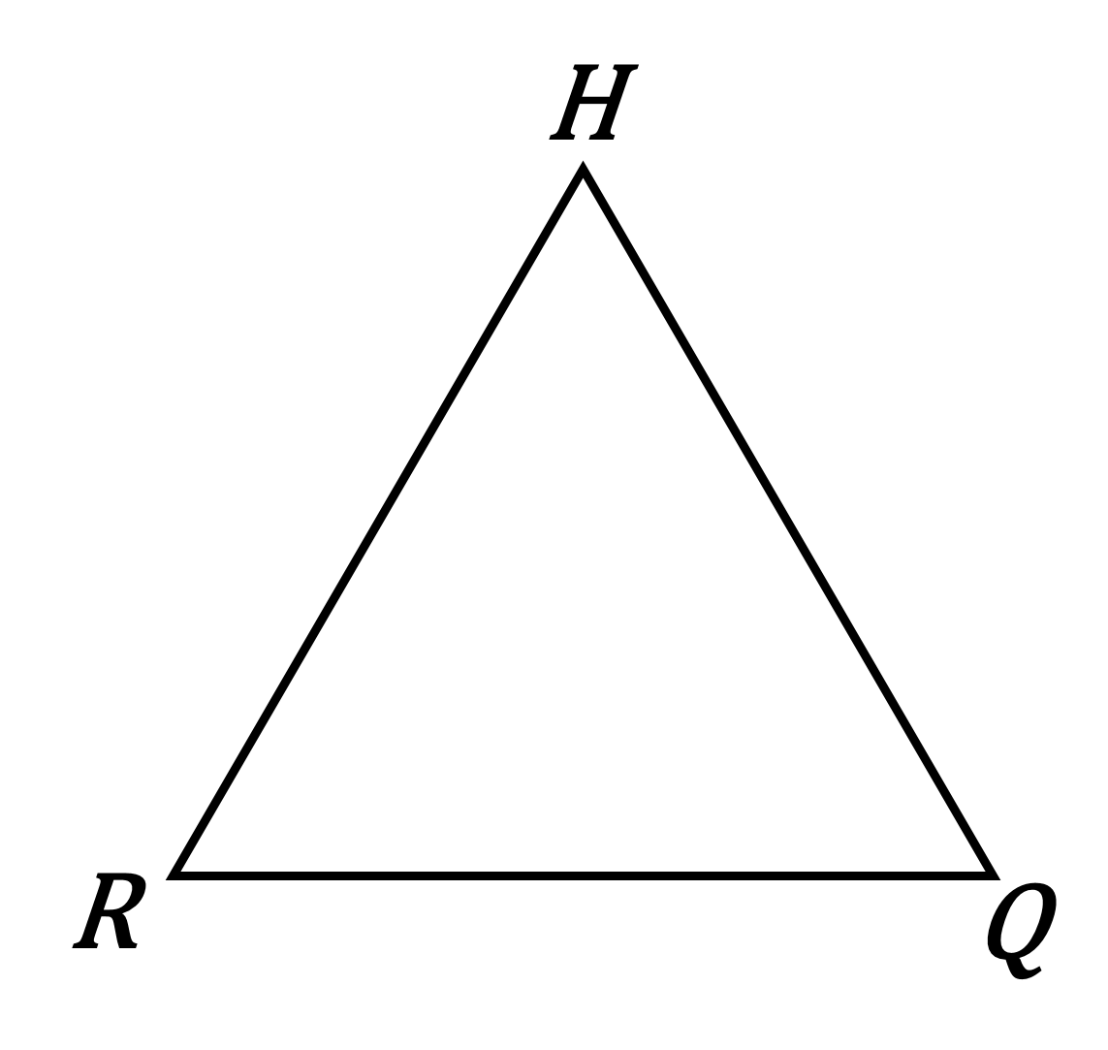

4. Is it possible for ? Explain.
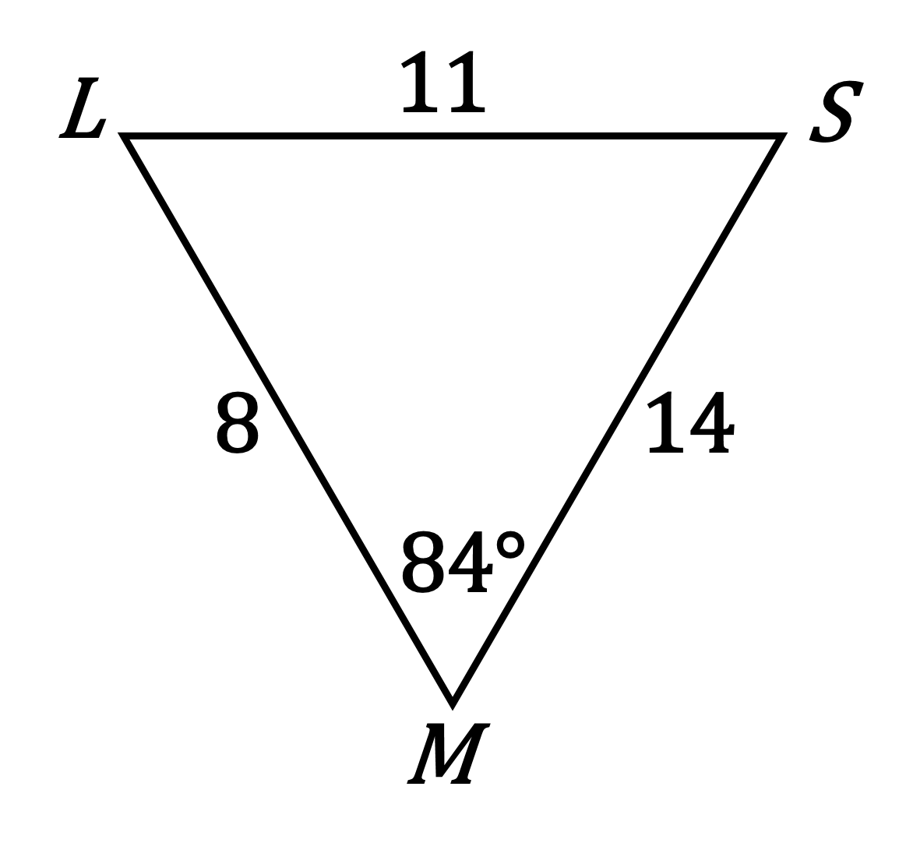
_________________________________________________________________________________________________________

_________________________________________________________________________________________________________

_________________________________________________________________________________________________________

5. Given the angle measures of △ABC: , , and . Which is the shortest side? Explain.

_________________________________________________________________________________________________________

_________________________________________________________________________________________________________

_________________________________________________________________________________________________________

