1. Given △FDR ≅ △TGH, what is the value of x? Please make sure to show all your work.
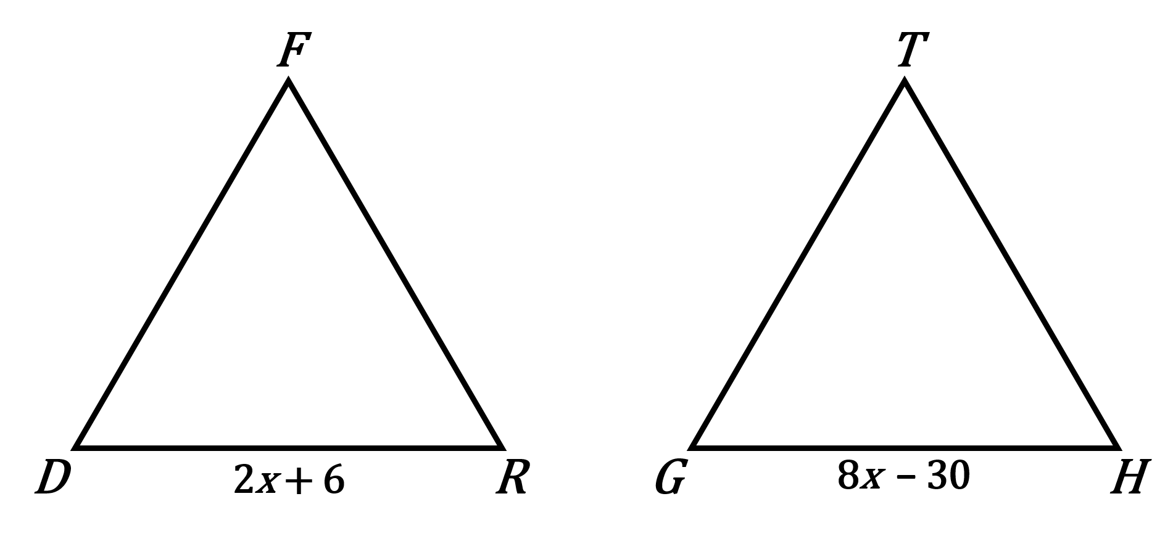

2. Which postulate proves that the given triangles are congruent? Please make sure to show all your work and provide the congruence statement.
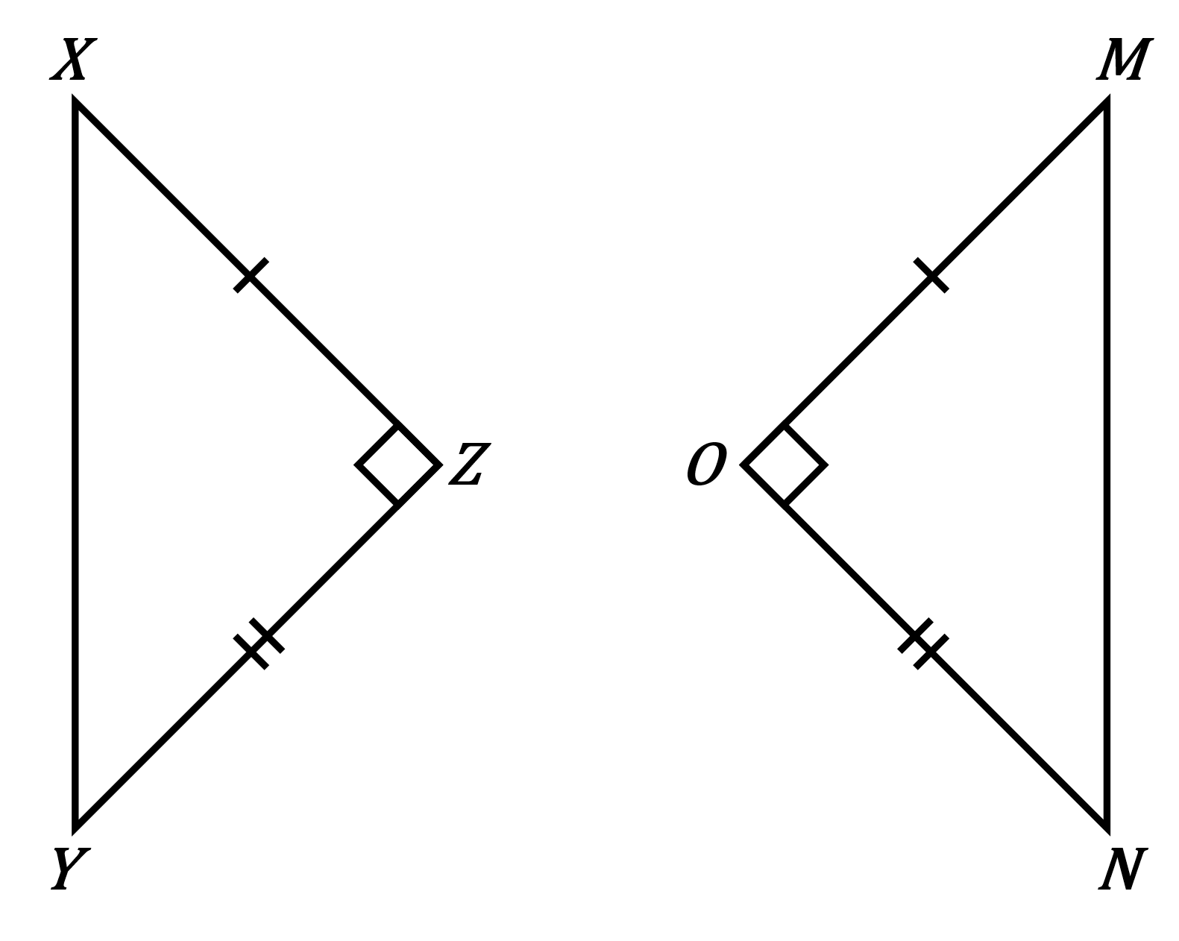

3. What information is missing to make △TRY ≅ △COW by the SAS Postulate? Please explain your answer.
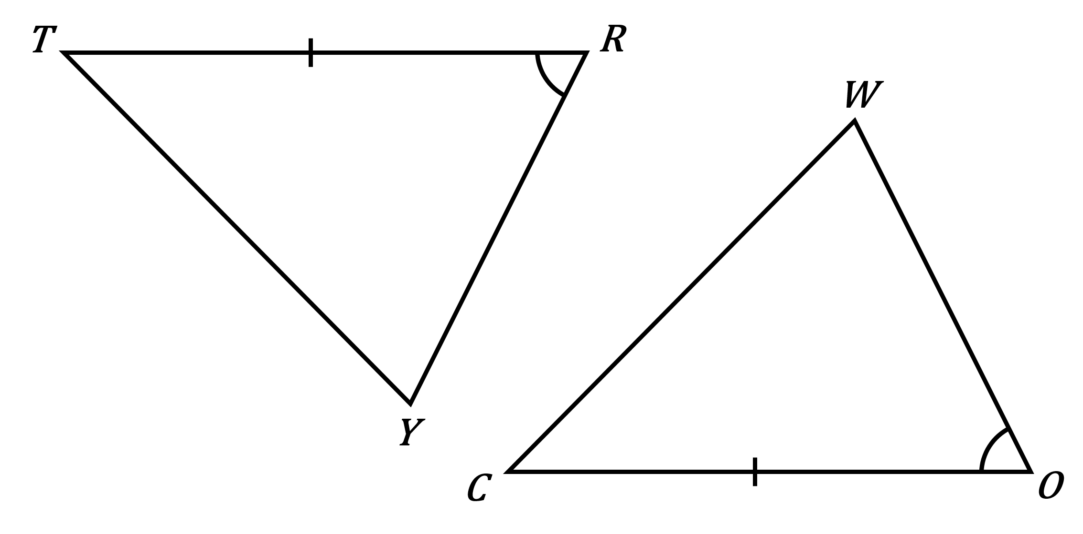

4. Which postulate proves that the given triangles are congruent? Please make sure to show all your work and provide the congruence statement.

