- Are the two triangles congruent? If so, provide a proof using ASA or AAS along with the correct congruence statement. If not, explain why the triangles are not congruent.
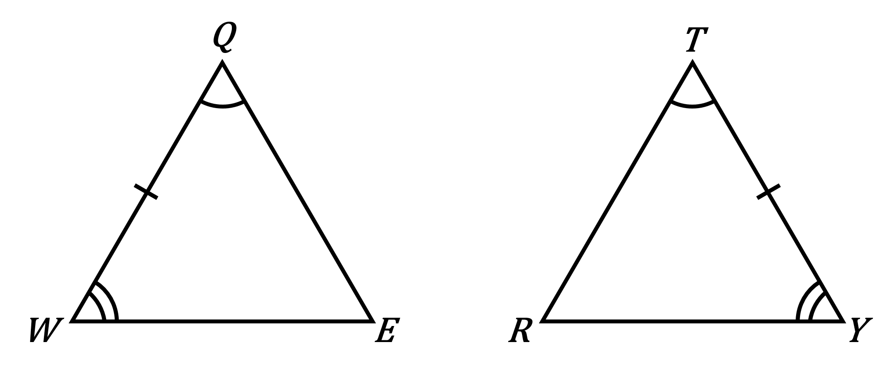

- Are the two triangles congruent? If so, provide a proof using ASA or AAS along with the correct congruence statement. If not, explain why the triangles are not congruent.
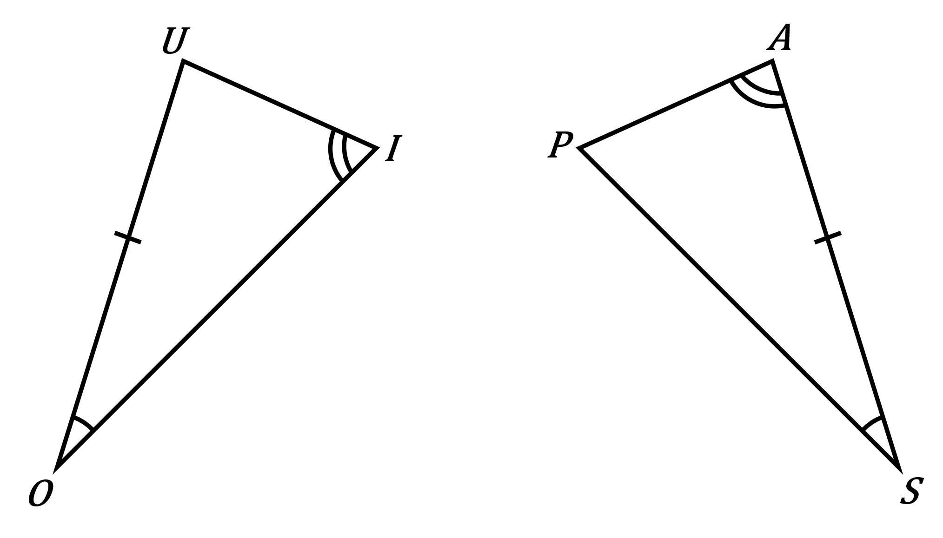

- Are the two triangles congruent? If so, provide a proof using ASA or AAS along with the correct congruence statement. If not, explain why the triangles are not congruent.
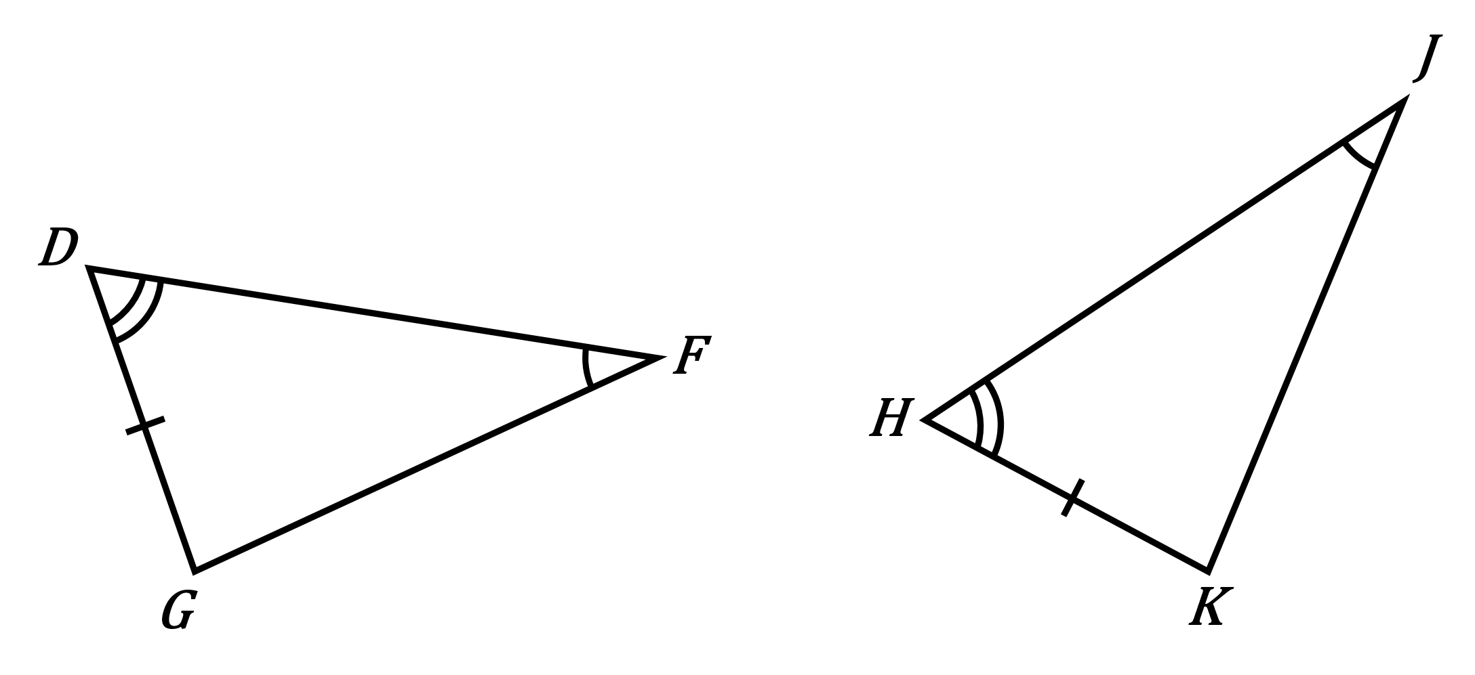

- What missing piece of information is needed to prove the triangles congruent by the AAS Theorem? Please provide the congruence statement.
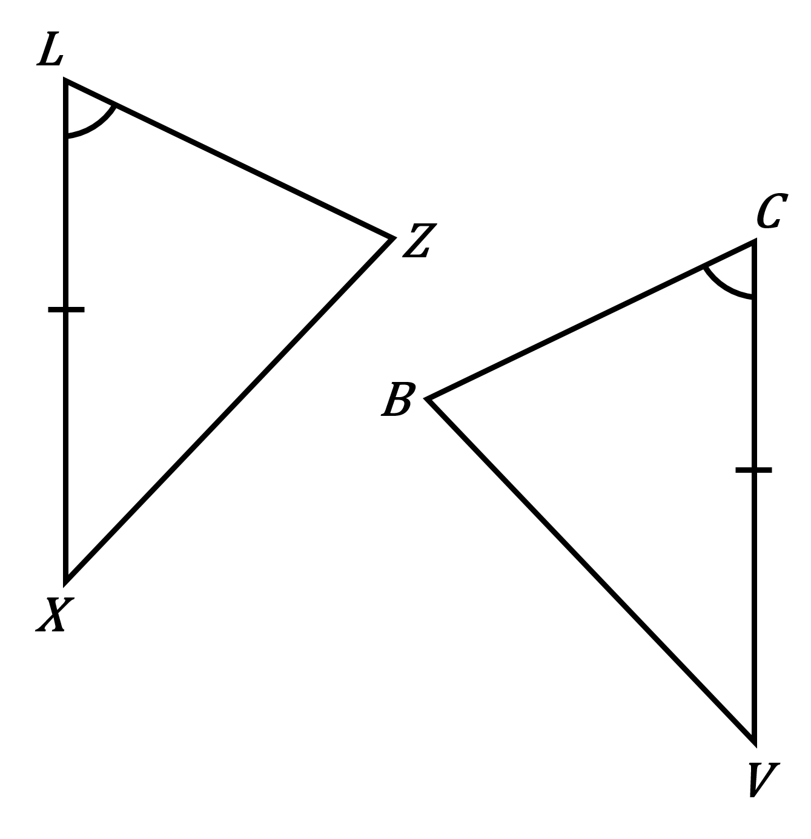

- What missing piece of information is needed to prove the triangles congruent by the ASA Postulate?

