- Given: E is the midpoint of and .
Prove: △AEB ≅ △DEC
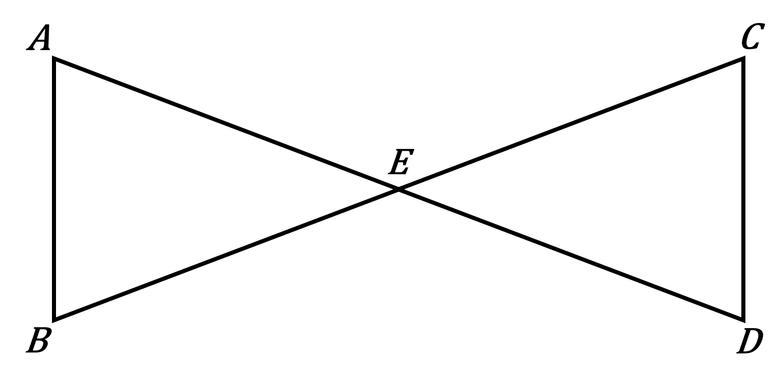
Statement | Reason
1. E is the midpoint of and . | 1.
2. | 2.
3. | 3.
4. ∠AEB ≅ ∠DEC | 4.
5. △AEB ≅ △DEC | 5.

- Given: , and H bisects .
Prove: △GFH ≅ △JFH
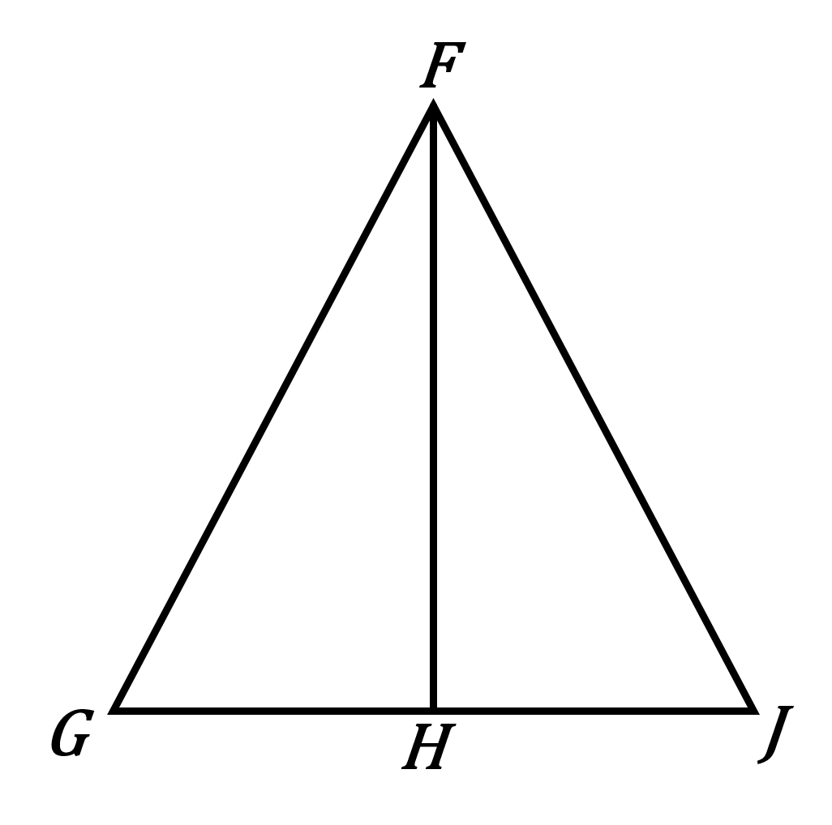
Statement | Reason
1. | 1.
2. H bisects . | 2.
3. | 3.
4. | 4.
5. △GFH ≅ △JFH | 5.

- Given: △ALT and △TSA are right triangles, and .
Prove: △ALT ≅ △TSA
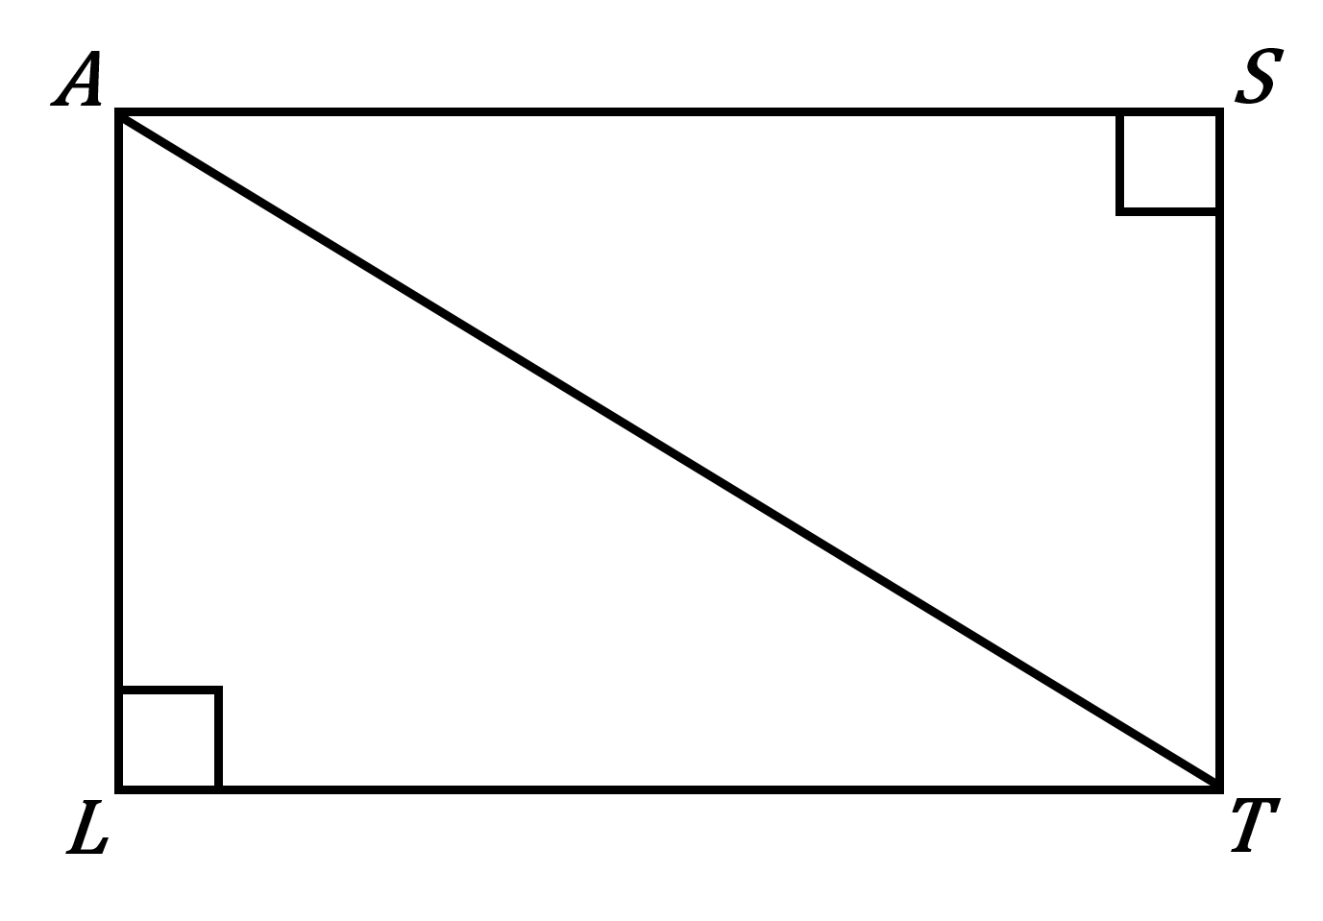
Statement | Reason
1. △ALT and △TSA are right triangles. | 1.
2. | 2.
3. | 3.
4. △ALT ≅ △TSA | 4.

- Given: bisects ∠BDC, and ∠B ≅ ∠C.
Prove: △BED ≅ △CED
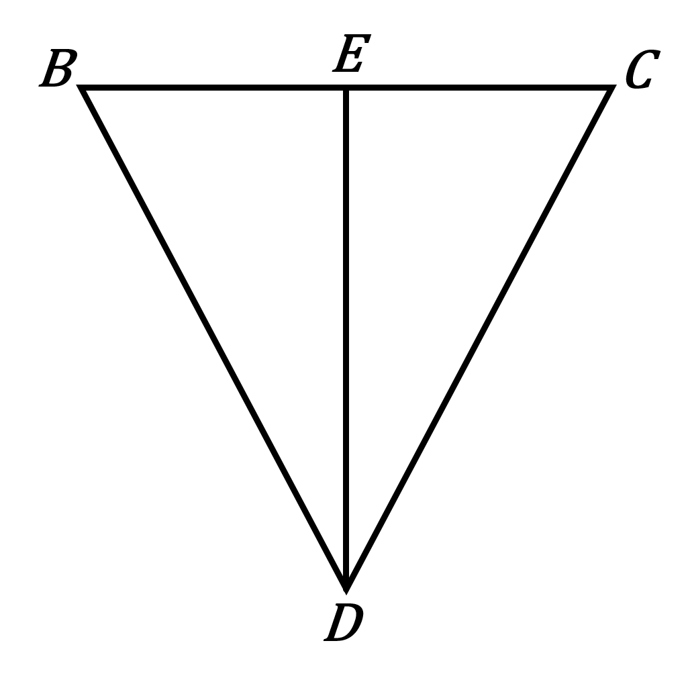
Statement | Reason
1. bisects ∠BDC. | 1.
2. ∠B ≅ ∠C | 2.
3. ∠BDE ≅ ∠CDE | 3.
4. | 4.
5. △BED ≅ △CED | 5.

- Given: ∠E ≅ ∠H, and I is the midpoint of .
Prove: △EIF ≅ △HIG
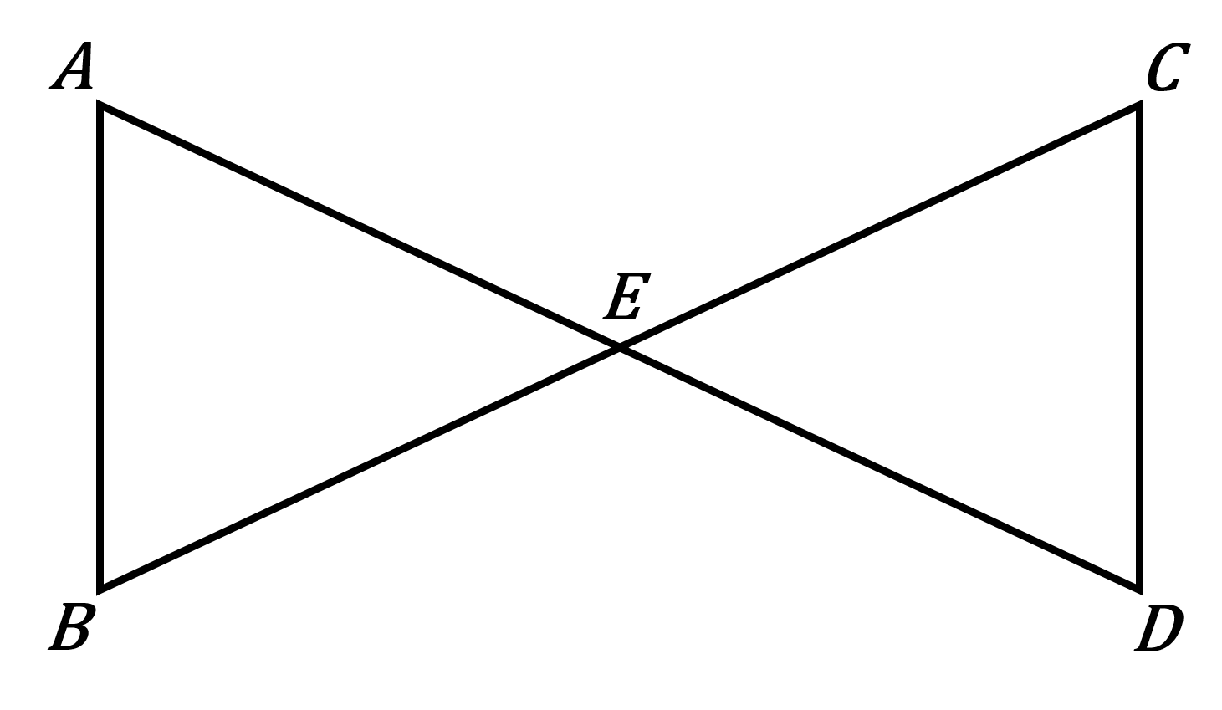
Statement | Reason
1. ∠E ≅ ∠H | 1.
2. I is the midpoint of . | 2.
3. | 3.
4. ∠EIF ≅ ∠HIG | 4.
5. △EIF ≅ △HIG | 5.

