- Using coordinate methods, determine whether △CXZ ∼ △NVB by the SSS Similarity Theorem. Please make sure to show all your work.
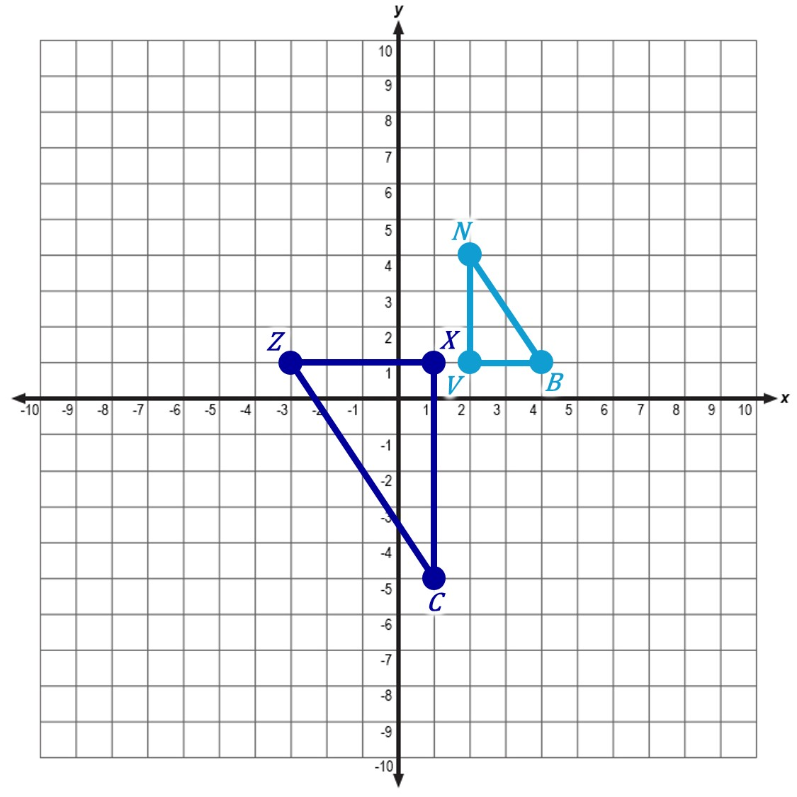

- Which postulate or theorem proves that △TRE ∼ △TYU ? Please make sure to show all your work and provide the similarity statement, if applicable.
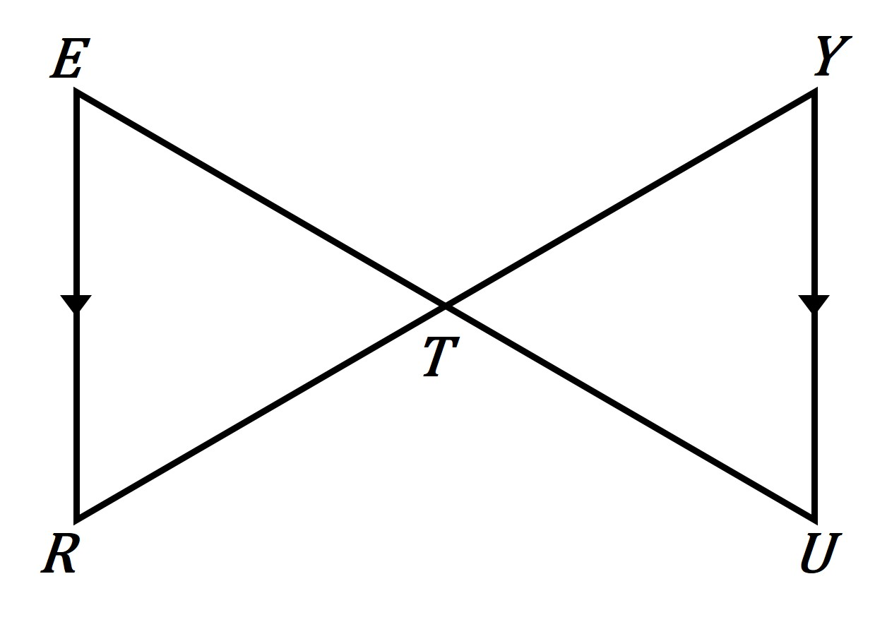

- Which postulate or theorem proves that △FGH ∼ △FJK ? Please make sure to show all your work and provide the similarity statement, if applicable.
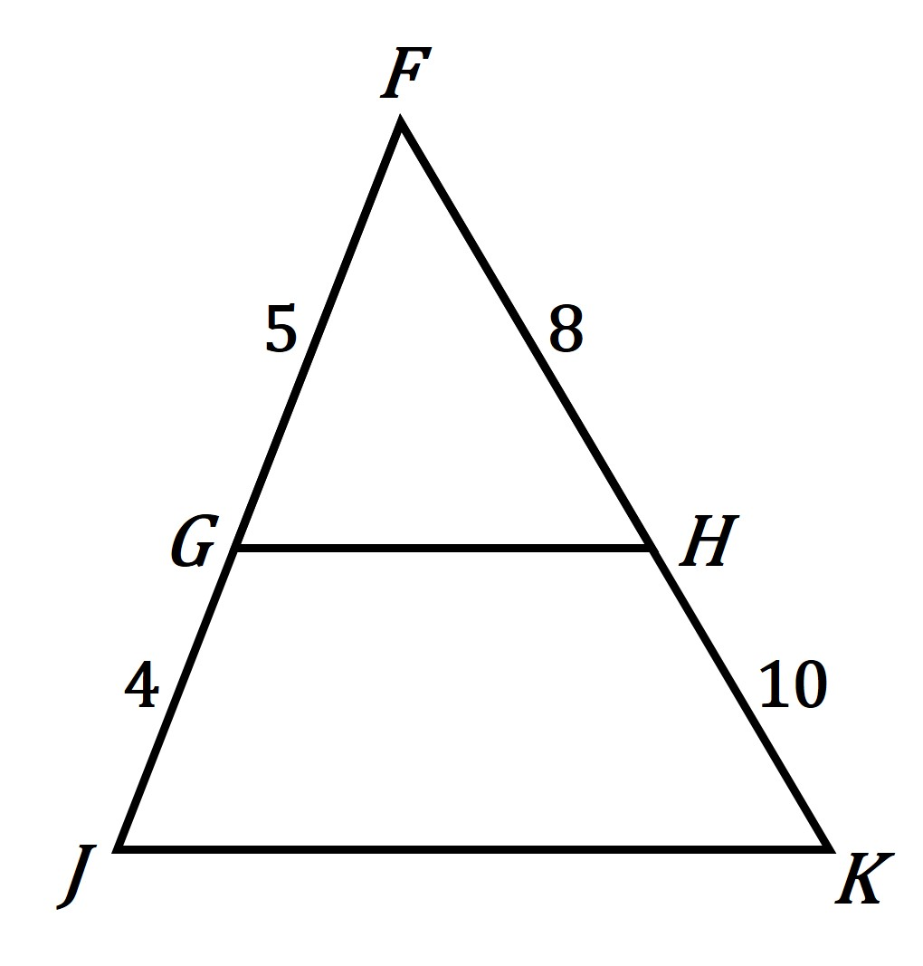

- Given: ∠A and ∠D are right angles.
Prove: △ABC ∼ △DEC
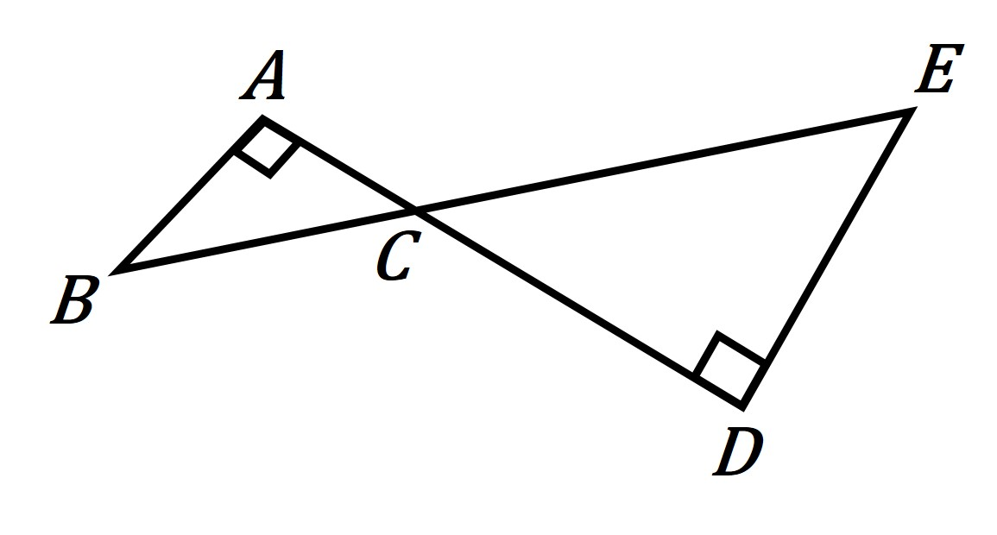
Statement | Reason
1. ∠A and ∠D are right angles. | 1.
2. ∠A ≅ ∠D | 2.
3. ∠ACB ≅ ∠DCE | 3.
4. △ABC ∼ △DEC | 4.

