- After offering to help your friends move in to their new home, you decide that a ramp for the moving truck would make it easier to move the heavy furniture out of the truck. You can rent a ramp with lengths of 10, 12, 14, and 16 feet. However, the longer the ramp, the more expensive it is.

The closest the truck can park to the house is 11 feet. If the floor of the truck is 3 feet off the ground, which of the of available ramp sizes should you rent to save the most money and still get the job done? Once the ramp is in place, what will be the angle of elevation? Please show all your work and round to the nearest whole number.

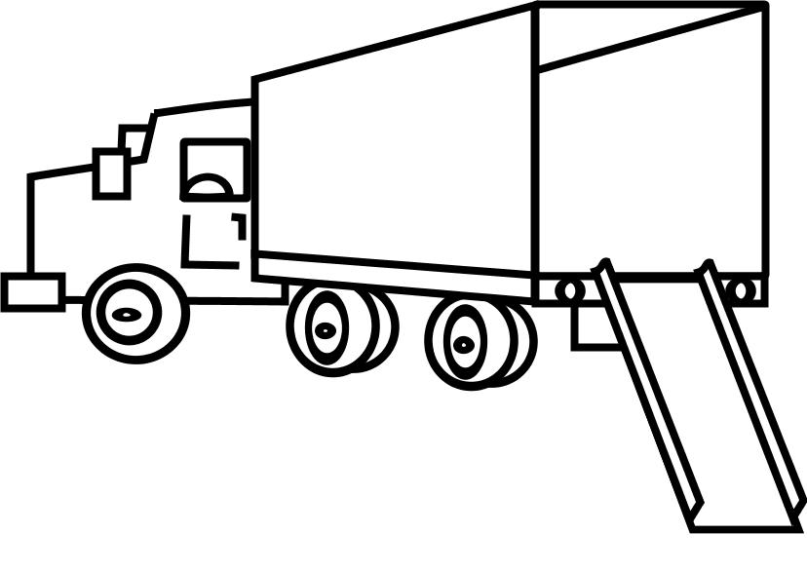

- You are hired to work with a team in designing a local water park. Safety regulations dictate that water slides cannot have an angle of elevation greater than 30 degrees. If the park manager wants the Tsunami Slide to be 25 feet high, what must the minimum length of the slide be in order to meet the safety standards? Please show all your work.

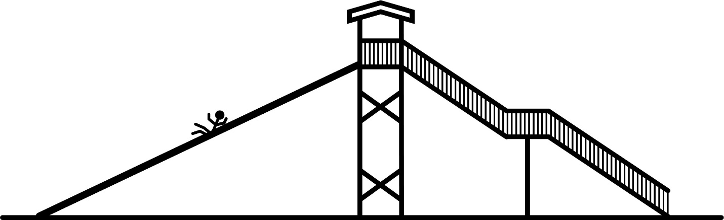

- Your neighbor has a large tree on his property, and he's worried that the next serious storm will knock the tree onto his house. However, tree removal is an expensive service. Since your neighbor's budget is limited, you offer to help him determine how high the tree is. If the distance from the house to the tree is greater than the height of the tree, then the house should be avoid damage should the tree ever fall.
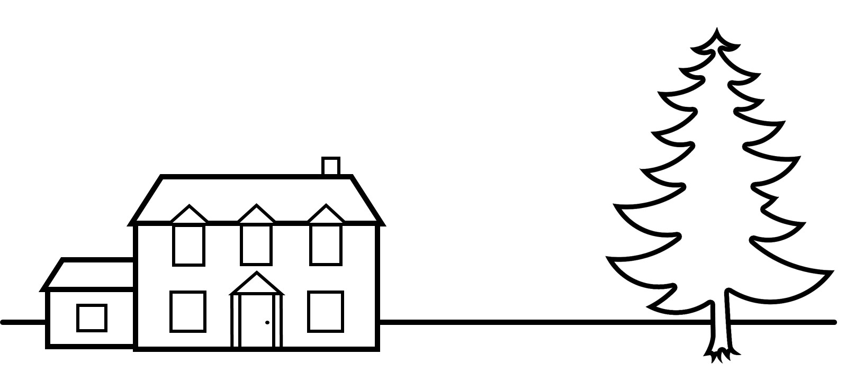
Using a long tape measure, you determine that the distance from the house to the base of the tree is 80 feet. Then, you cut a square piece of paper in half along the diagonal so that you have two triangles. Standing between the tree and the house, you hold one of the triangles up to your eyes so that the hypotenuse is pointing toward the tree and the 90° angle is parallel to your eyes. As your neighbor helps guide you, you carefully walk backwards while facing the tree until you can see through one eye the top of the tree aligned with the top of the triangle.
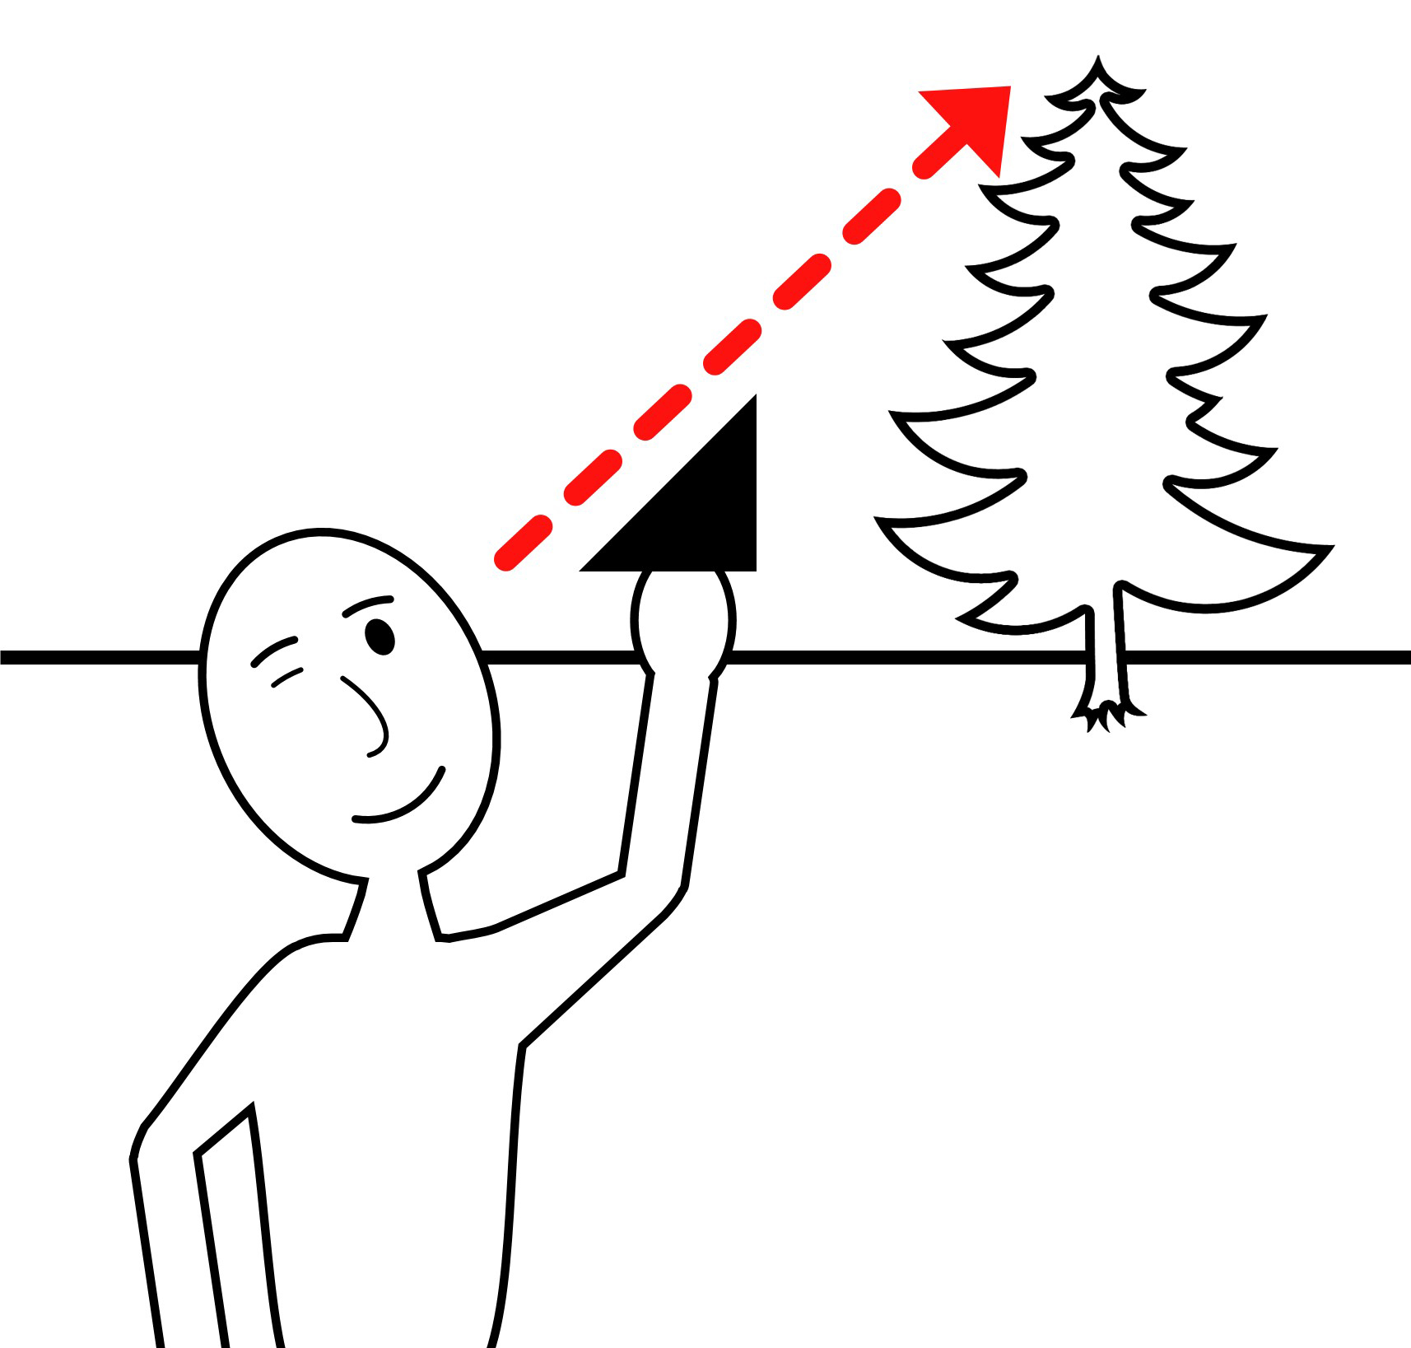
You mark this spot in the ground and measure its distance from the base of the tree. To this distance you add your own height, the sum of which is 73 feet. Based on your knowledge of right triangles, what is the height of the tree? Should you neighbor worry about damage to his house? Please show all your work.

- You read an article in your local newspaper about a discussion between the owner of a popular business and a group of community members. The business owner keeps a flag raised on an outdoor flagpole during nighttime hours, but the community members are calling for the flag to be properly illuminated at night. The business owner says that the flag cannot be illuminated because the only power source available for the spotlights is solar power, but there is too much shade on the ground for solar-powered spotlights to charge sufficiently during the day.

You realize that you can offer a solution to the problem by suggesting that the solar-powered spotlights be mounted on the roof of the building where it can be charged by sufficient sunlight. You decide to contact the business owner to suggest angling the spotlight down to the raised flag from the roof instead of angling it up to the raised flag from the ground. The business owner informs you that the flagpole is located 55 feet from the building. If the building is 45 feet high and the flagpole is 25 feet high, at what angle should you tell the business owner to angle a spotlight mounted on the roof? Please show all your work.

