Use your knowledge of parallelograms to answer the following questions.
For Problems 1 - 4, fill in each blank with the correct response.

- Opposite sides are __________ and __________.
- Opposite angles are __________.
- Consecutive angles are ___________.
- Diagonals __________ each other.

For Problems 5 - 10, given each parallelogram, find the indicated measure(s).
- Find the indicated measures.
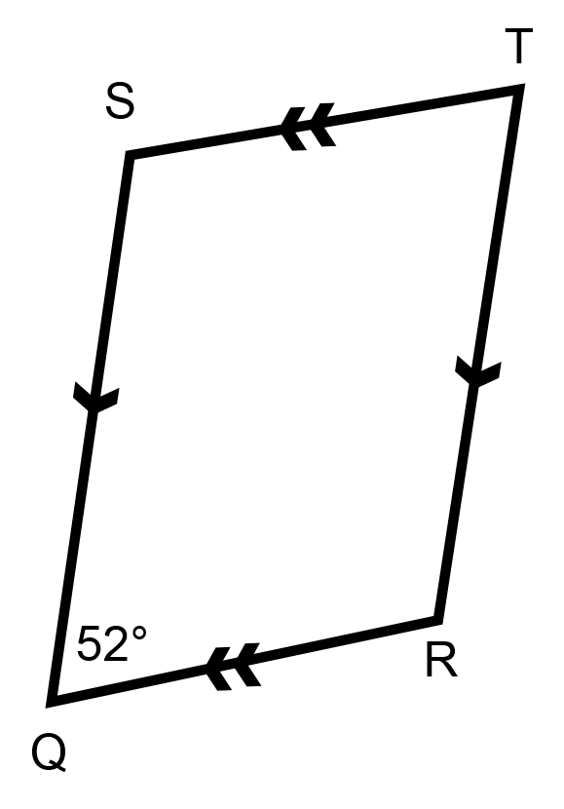
  - m∠S = __________
  - m∠T = __________
  - m∠R = __________

- Find the indicated measures.
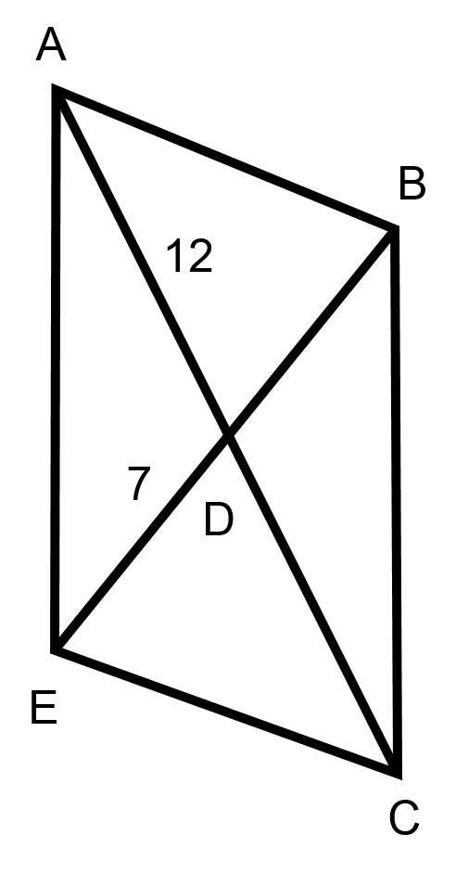
  - DC = __________
  - AC = __________
  - EB = __________

- Find the indicated measures.
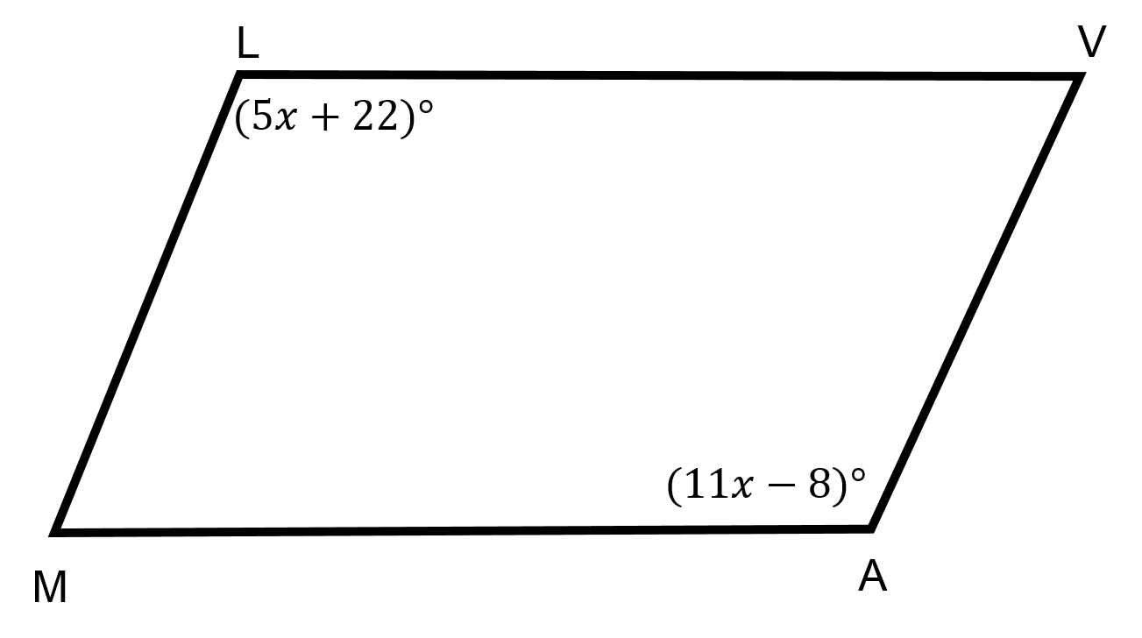
  - x = __________
  - ∠L = __________
  - m∠V = __________

- Find the indicated measures.
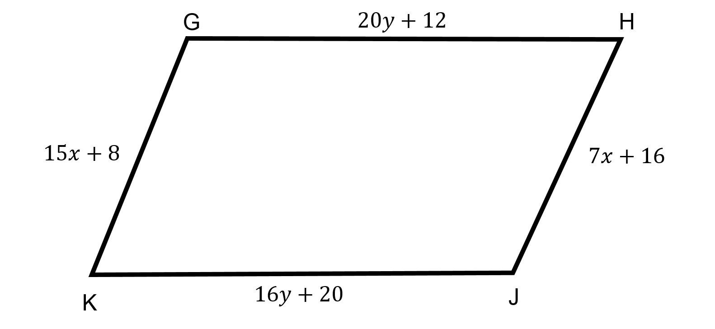
  - GH = __________
  - HJ = __________
- Given the parallelogram GHJK:
GJ = 4x + 22
GF = 7x − 14
What is the value of x?

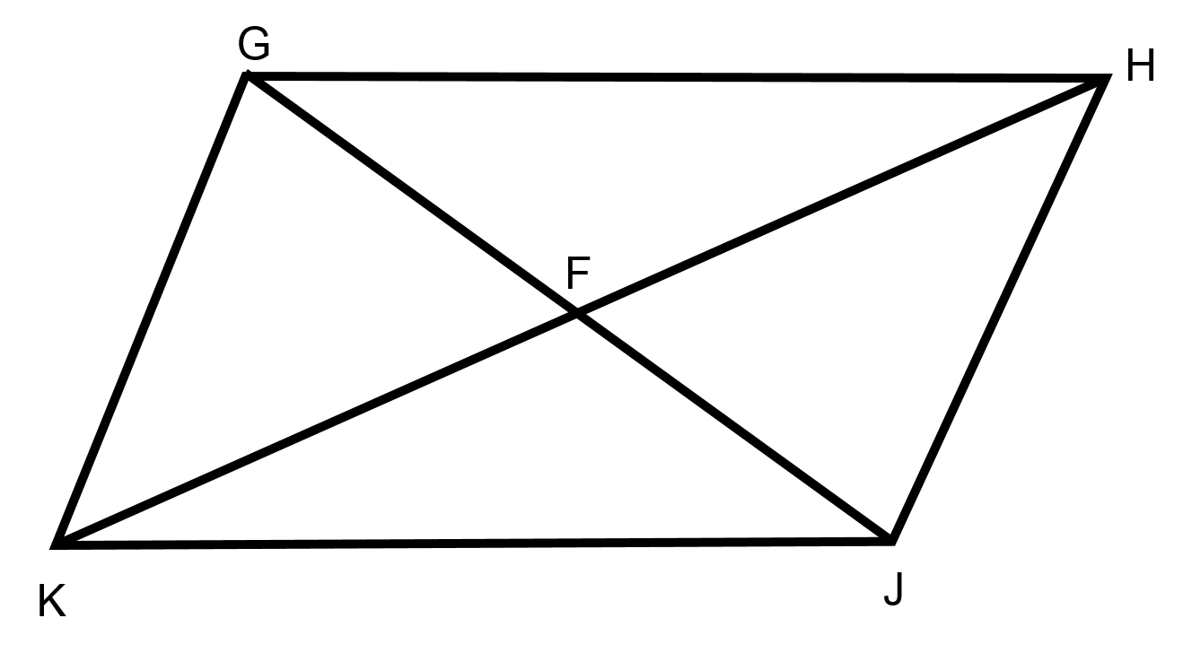
- ∠JKH is 3x − 9, and ∠GHK is 2x + 7. What is the value of x if GHKJ is a parallelogram?

