Use your knowledge of rectangles to answer the following questions.
- Given the rectangle below, determine each indicated value.
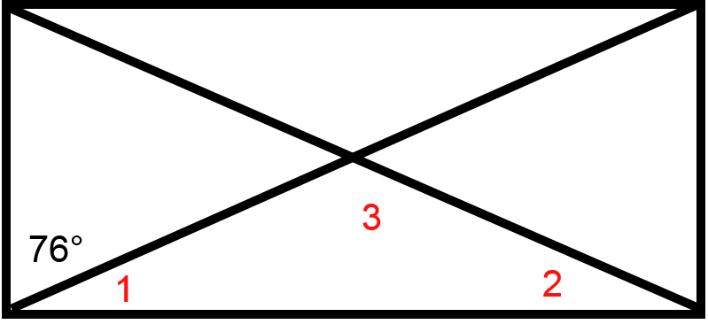
  - m∠1 = __________
  - m∠2 = __________
  - m∠3 = __________
- Given the rectangle below, determine each indicated value.
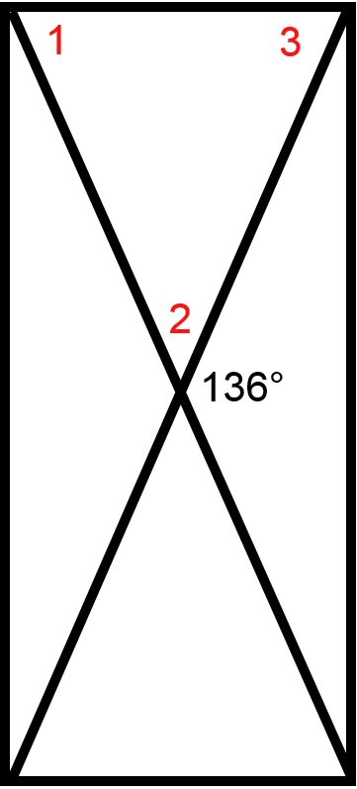
  - m∠1 = __________
  - m∠2 = __________
  - m∠3 = __________

- Given the rectangle below, determine each indicated value.
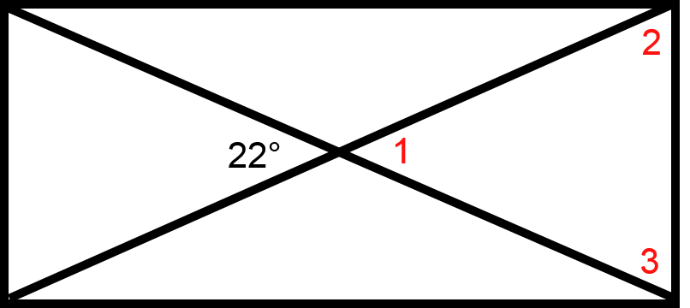
  - m∠1 = __________
  - m∠2 = __________
  - m∠3 = __________
- Given the rectangle below, determine each indicated value.
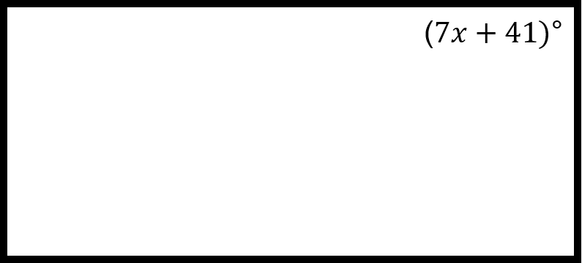
  - x = __________

- Given the rectangle below, determine each indicated value.
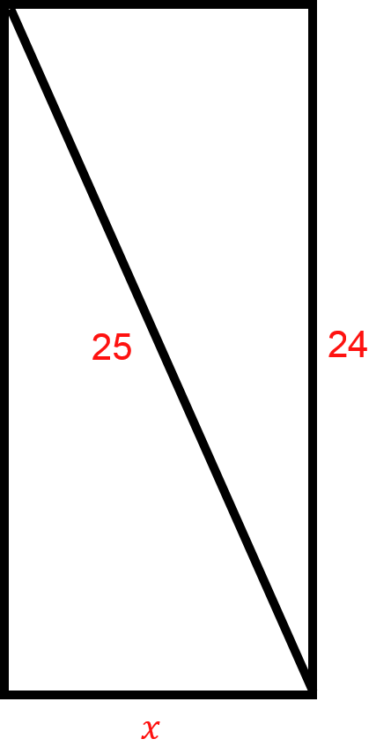
  - x = __________
- Given the rectangle below, determine each indicated value.
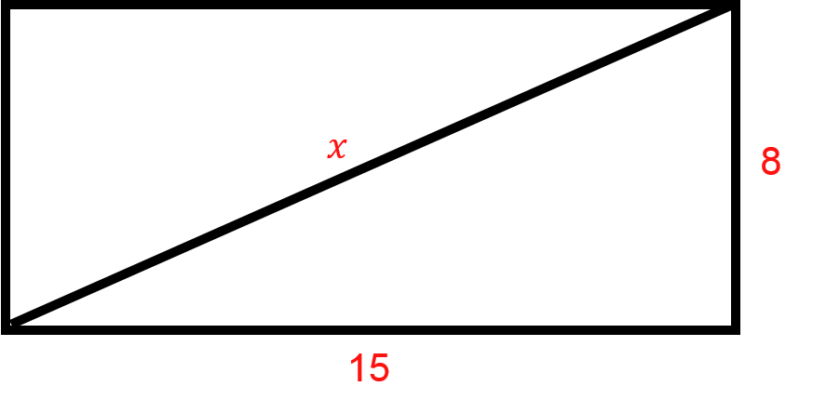
  - x = __________

- LT = 4x − 5 and BY = 7x − 8
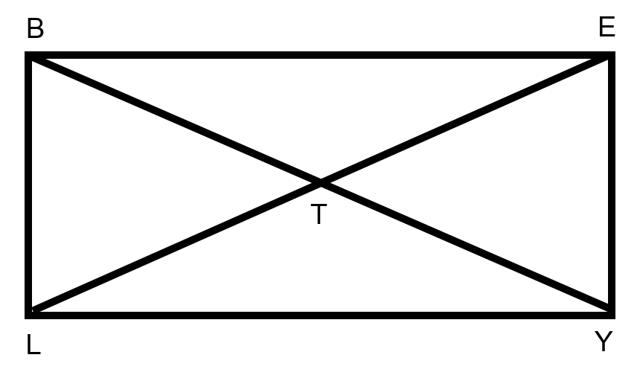
  - x = __________
- SA = 15x − 14 and AW = 91
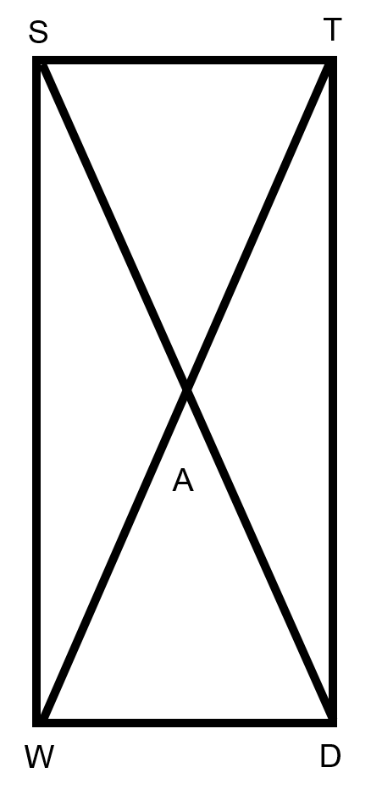
- x = __________
- John has a rectangular garden. If one of the angles in his garden is 16x − 6, what is the value of x?
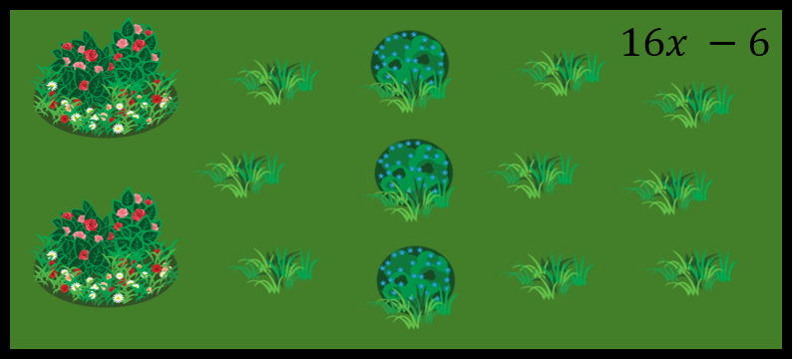
- x = __________
- Bill has a map of a park that is shaped like a rectangle as shown. He knows that BZ is 4x +7, and BD is 20x − 10. How far is it from A to Z?
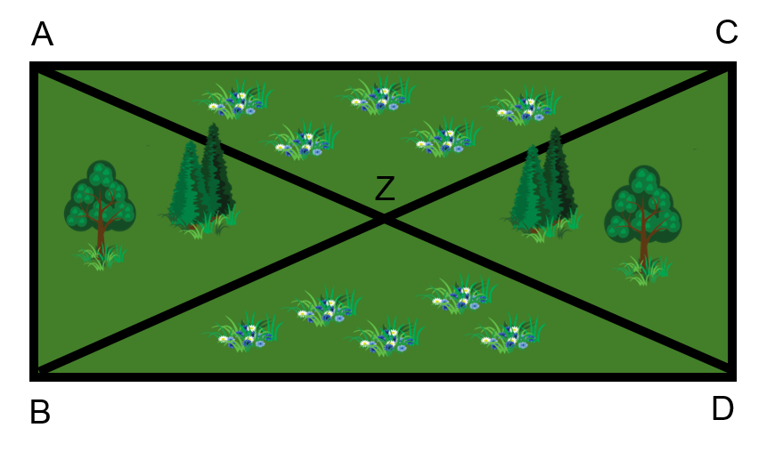
- Distance from A to Z = __________

