Squares Problem Set
Using what you have learned about parallelograms, rhombi, and squares, fill in the missing side lengths and angle measures. ACEG is a square. BLFK is a rhombus. BCFG is a parallelogram.
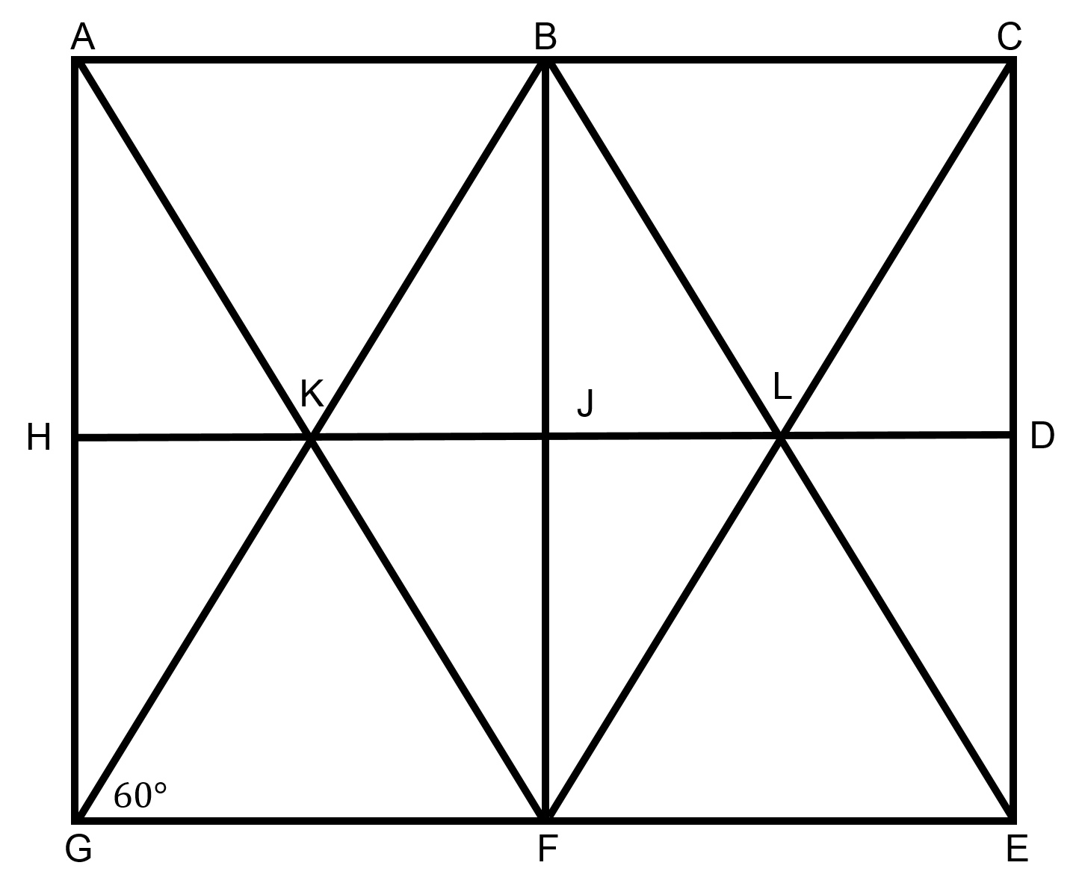
- ∠BGF = 60°
- ∠GFC = __________
- ∠GBC = __________
- ∠AGB = __________
- ∠BJL = __________
- BK = 12
- BL = __________
- BC = 12
- AC = __________
- GE = __________
- ∠BLJ = __________
- ∠BLF = __________
- ∠KBL = __________
- GB = 24
- CF = __________
- KL = __________

