Your knowledge of the interior angles of a polygon is continually growing. In this assignment, you need to answer the questions, “What polygon am I?”, “What is my value?”, and “What is my measure?” Think about the new information you have learned about the interior angles of a polygon. Then, answer each of the following questions in the blank space provided.
- I am a regular polygon. Each of my interior angles measures. What polygon am I?

- I am a regular polygon. Each of my interior angles measures. What polygon am I?

- The sum of my interior angles measures What polygon am I?

- The sum of my interior angles measures What polygon am I?

- I am one of the interior angles of a regular octagon. What is my measure?

- I am one of the interior angles of a regular 15-gon. What is my measure?

- Use the diagram below to answer the question: I am What is my measure?
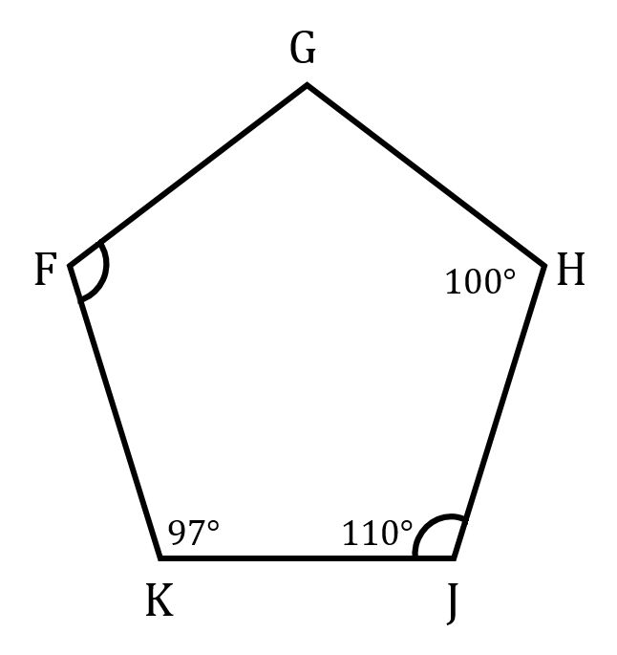

- Use the diagram below to answer the question: I am What is my measure?
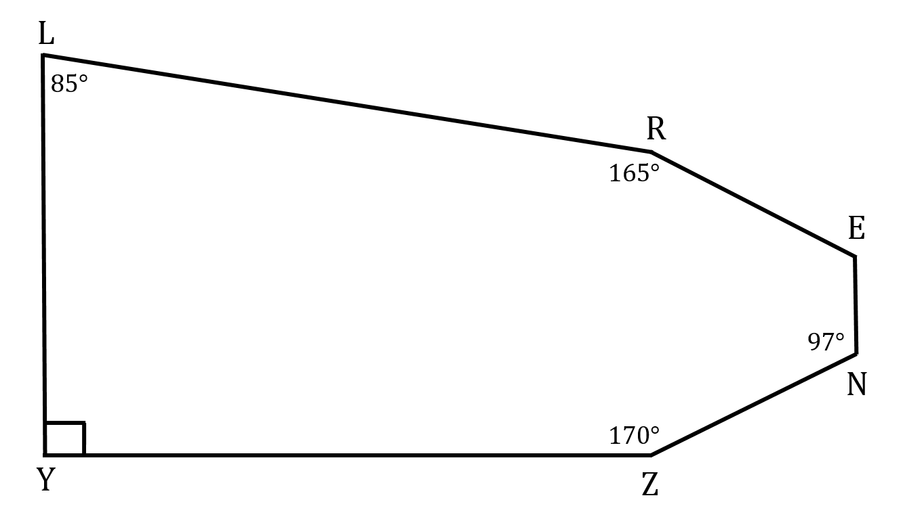

- Use the diagram below to answer the question: I am x. What is my value?

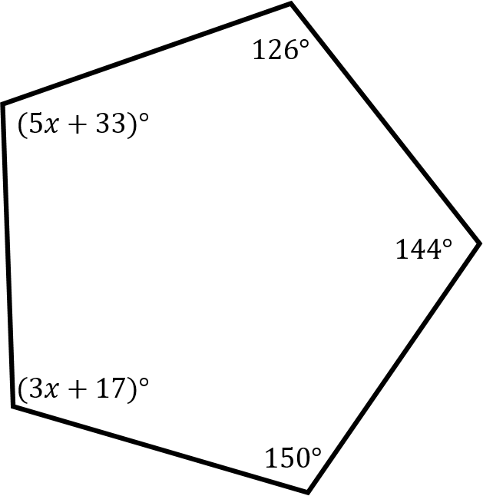

10. Use the diagram below to answer the question: I am x. What is my value?
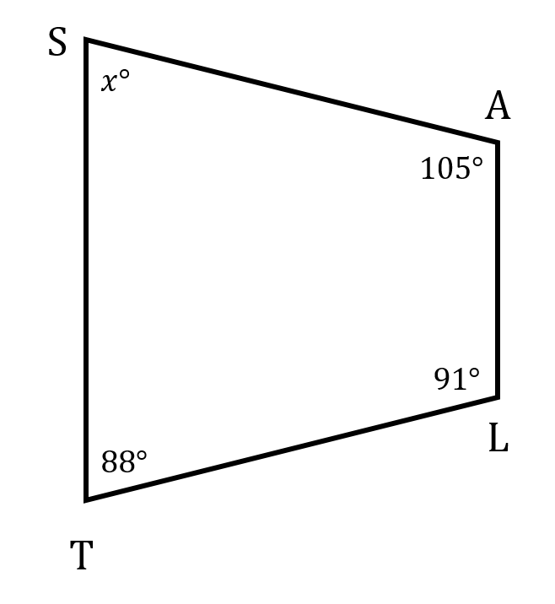

11. Use the diagram below to answer the question: I am What is my measure?
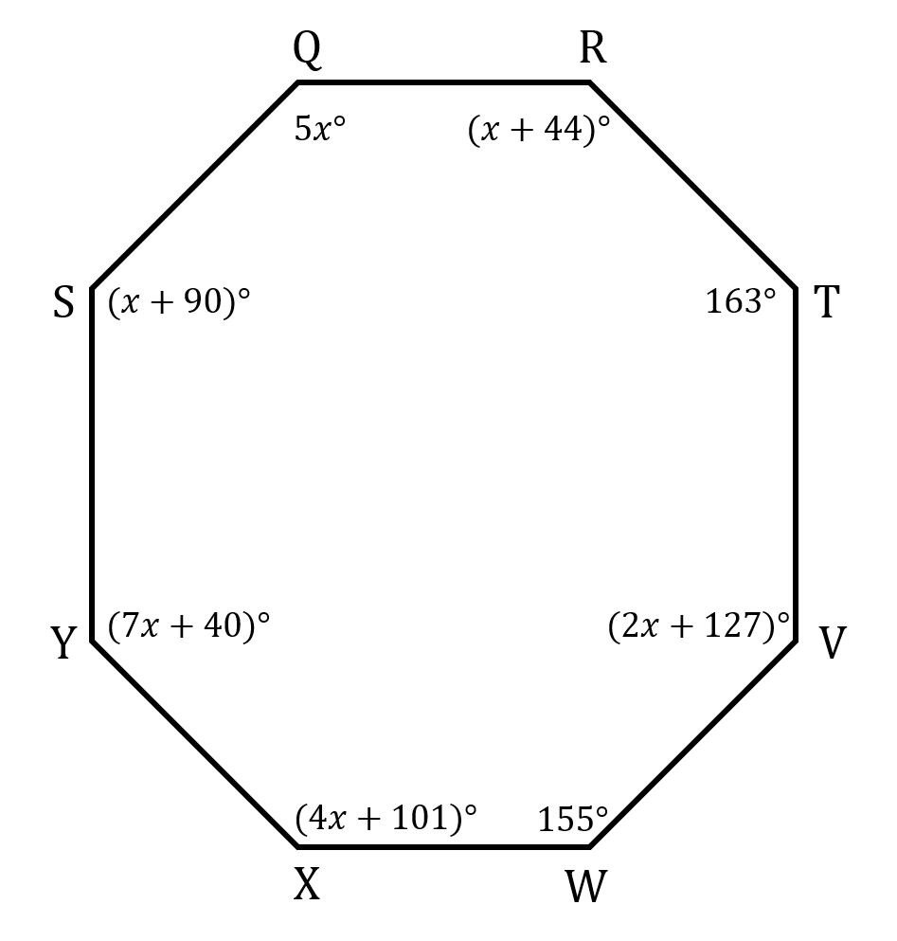

12. Use the diagram below to answer the question: I am What is my measure?
