Using what you have learned about the angle measures of polygons, complete each question.

- Select which of the following regular polygons will tessellate the plane.

- Square
- Heptagon
- Octagon
- Triangle

- Given the following regular pentagon and nonagon, what is the ?
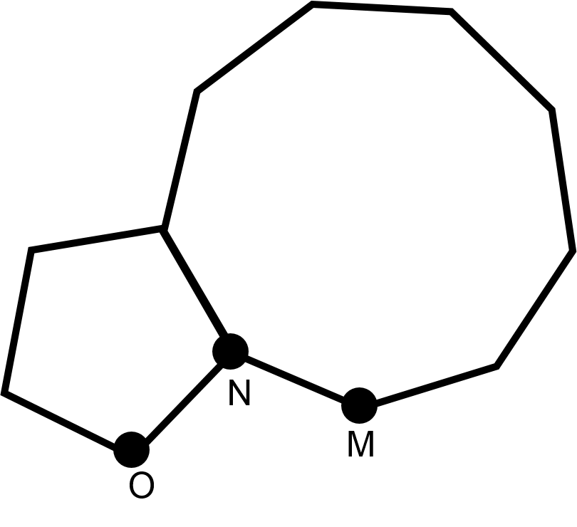

- Given the following regular polygons, what is the ?

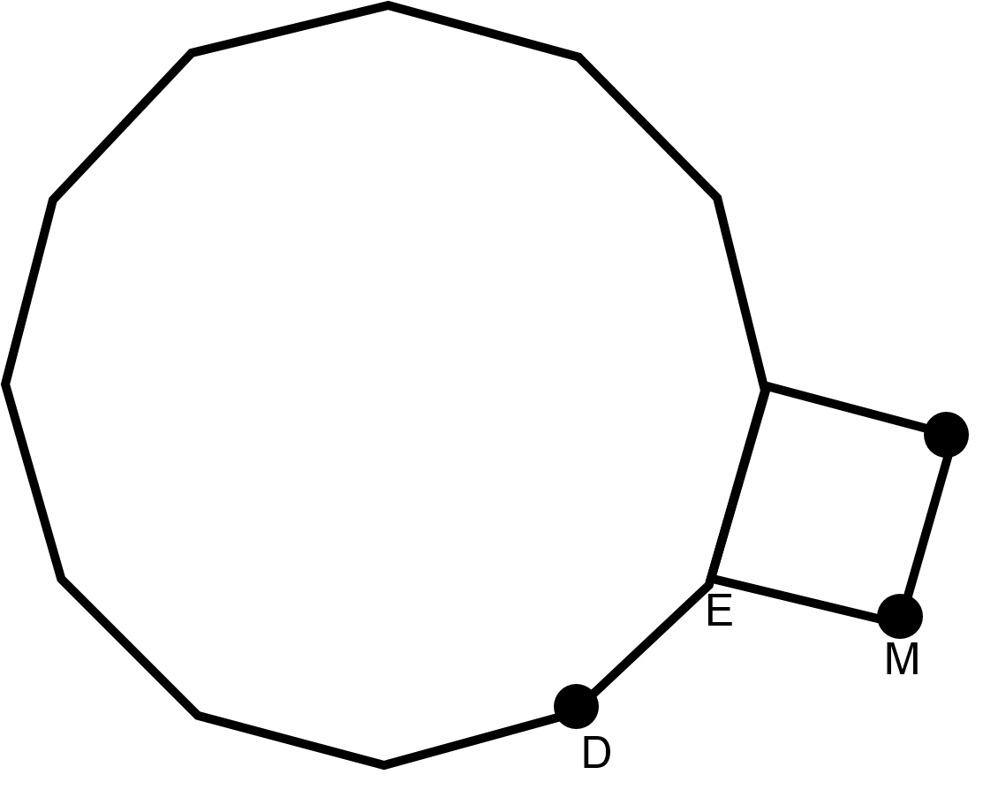

- 30°
- 60°
- 90°
- 120°

- If a polygon has an exterior angle of 72°, then I have _________ sides.

- 5
- 7
- 10
- 1

- How many sides does a regular polygon have if its interior angles is 135°?

- 6
- 8
- 9
- 12

- If part of a regular polygon is shown, how many sides does it have?
