Part I
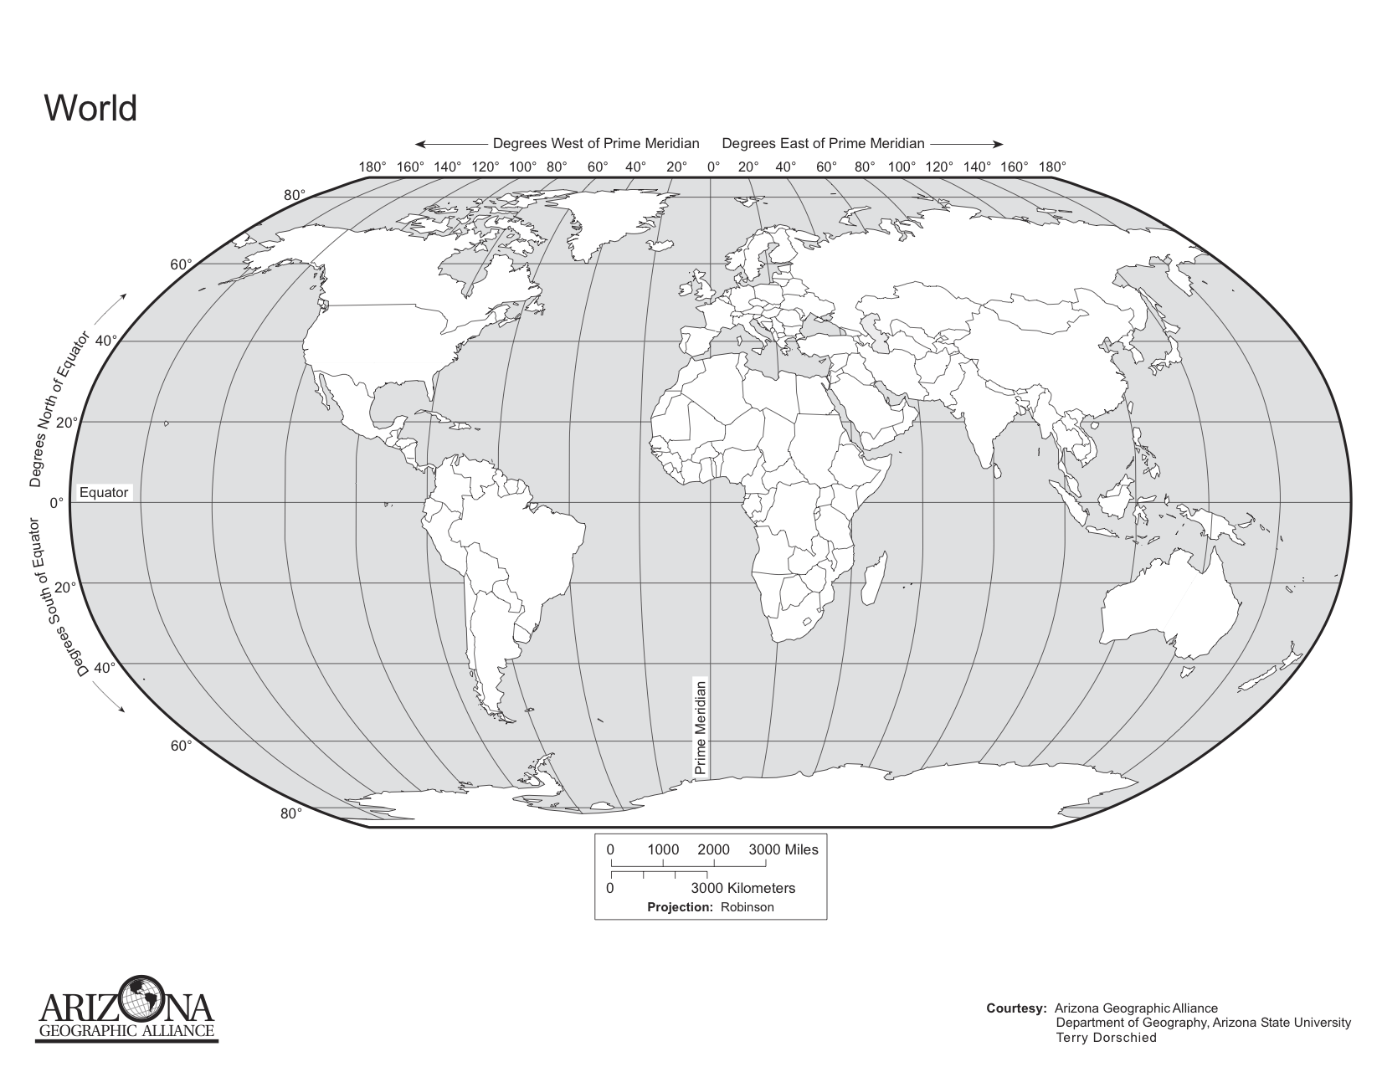
For this assignment, you will create a map of the world’s plate boundaries. On the map provided, outline and label each of the plates.

Part II
Questions
- How do oceanographers know the location of the plate boundaries?

- Are there areas with earthquakes but not on plate boundaries? If so, explain why.

Submit the completed map and your answers to the questions via the drop box.

