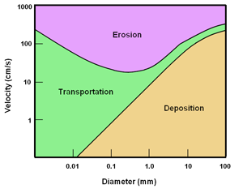
Using the Hjulstrom Diagram shown to the left and the following data table, decide whether each sample would be eroded, transported, or deposited based on its size and the velocity of the water carrying it. Then enter that information in the last column of the data table. Once you have completed the data table, please complete the questions below.

Sample Number | Velocity (cm/sec) | Size (mm) | Erosion, Transportation, OR Deposition
1 | 12 | 0.04
2 | 90 | 0.001
3 | 8 | 0.3
4 | 0.5 | 0.5
5 | 13 | 0.03
6 | 365 | 0.002
7 | 975 | 6
8 | 2 | 15
9 | 12 | 0.6
10 | 80 | 0.6
11 | 500 | 1
12 | 43 | 43
13 | 8 | 45
14 | 9 | 33
15 | 2 | 98
16 | 100 | 0.002
17 | 3 | 0.006
18 | 100 | 100
Analysis Questions
- Which of the samples from the data table will be eroded?
- Which of the samples from the data table will be deposited?
- Which sediment samples are clay?
- Which sediment samples are silt?
- Which sediment samples are sand?
- Which sediment samples are gravel?
- What is the relationship between velocity and grain size diameter?
Once you have completed your assignment, please submit your work to the dropbox.

