Answer the following questions. Once you have finished answering the questions, submit your responses to the dropbox.

Study the NOAA map Total Sediment Thickness of the World's Oceans & Marginal Seas

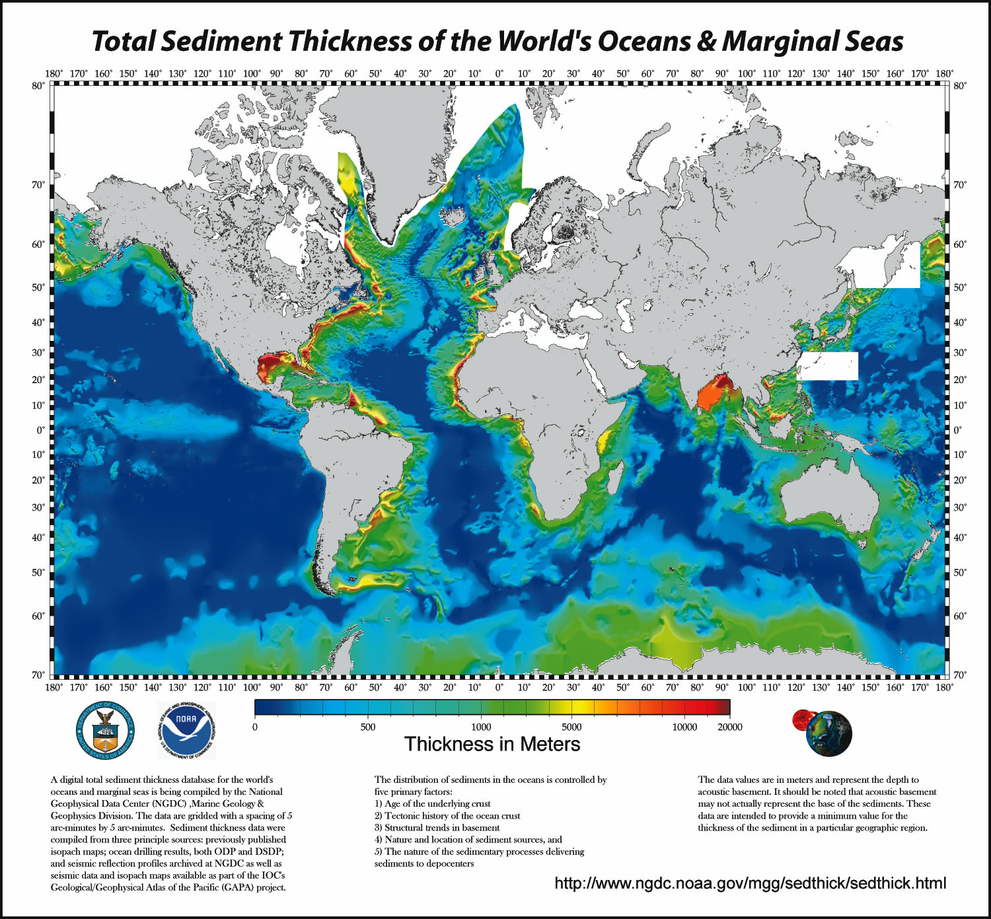

(Divins, D.L., Total Sediment Thickness of the World's Oceans & Marginal Seas, NOAA National Geophysical Data Center, Boulder, CO, 2003.)

Using the map's legend, identify the areas on the map that have the thickest sediment levels.

- Generally where do areas of thickest sediment occur?

- Based on what you have learned about sediment layers of the oceans, why do you believe that these areas have the thickest sediment?

- Based on what you have learned about sediment layers of the oceans, what type of sediment do you think is found in these areas?

- Based on the map's legend, what generalization can you make regarding variation in sediment depth? Why do you believe sediment depth varies in this way?

