Now that you have learned the basics of speed and velocity, demonstrate your understanding of velocity calculations and interpreting position-time graphs by answering the following questions. Make sure to completely answer each question and to show all of your work.

**Part I: Velocity Calculations**

1. What is the velocity of a car that traveled a total of 750 meters north in 85 seconds? (Answer in units of meters per second)
2. What is the velocity of a plane that traveled 3100 miles from New York to California in 5.0 hours? (Answer in units of miles per hour)
3. It took 3.5 hrs for a train to travel the distance between two cities at a speed of 120 miles/hr. How many miles lie between the two cities?
4. How many hours would it take a car to travel a distance of 250 km if it is traveling at a speed of 55 km/hr?
5. A plane traveled for 2.5 hours at a speed of 1200 km/hr. How many kilometers did it travel?
6. An ant carries food at a speed of 1.0 cm/s. How long (in seconds) will it take the ant to carry a cookie crumb from the kitchen table to the ant hill, a distance of 15 meters (1500 cm)?
7. The water in the James River flows at an average speed of 5.0 km/hr. If you and a friend decide to float in a canoe down the river a distance of 16 km, how long will it take?

**Part II: Position/Time Graphs**

The following graph represents the motion of an object.

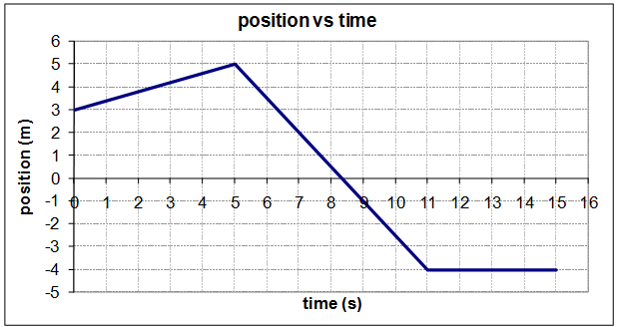

1. Examine the graph and determine:
   1. The initial position
   2. The final position
   3. The total distance travelled
   4. The average speed for the trip
   5. The average velocity for the trip
   6. The maximum speed
   7. The time at which the object was furthest from the origin
   8. The average speed for the first five seconds
   9. The average velocity for the time period of 5 to 11 seconds
2. Sketch a position-time graph that corresponds to the description below: The object starts at a position of negative four meters
   * It moves at a velocity of +0.5 m/s for six seconds
   * The object is then at rest for three seconds
   * It reverses direction and moves at a speed of 0.75 m/s for four seconds
   * It continues at a constant speed for another two seconds so that its average velocity over the entire trip is +1/3 m/s.