In this application, answer the following questions. When you have completed your assignment, submit it to the dropbox.

1. Calculate the speed of light in diamond. The index of refraction of diamond is 2.42.
2. A ray of light is traveling from air to diamond. The index of refraction of diamond is 2.42. The angle the light ray makes with the normal in the air is 30°. What angle will the light make with the normal in the diamond? Draw a ray diagram as part of your solution.
3. A ray of light is traveling from glass to air. The index of refraction of glass is 1.5. The angle the light ray makes with the normal in the glass is forty degrees. What angle will the light ray make with then normal in the air? Draw a ray diagram as part of your solution.
4. Minilab. This photograph was taken of a light ray traveling from air to a liquid in a semicircular container.

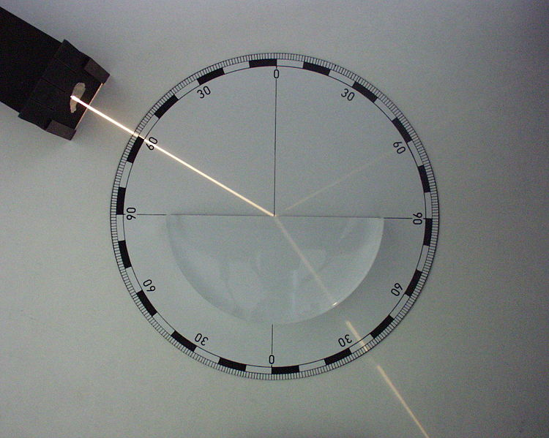

Use the protractor markings on the picture to make the measurements necessary to estimate the index of refraction of this liquid. Describe the measurements you made and show your work for your calculations.

1. High index lenses have an index of refraction of 1.72, what is the critical angle for this material?