|  |
| --- |
| Diagram 1 – Object closer than focal point |
| convex_case1.jpg |
| Diagram 2 – Object at focal point |
| convex_focalpt.jpg |
| Diagram 3 – Object between f and 2f |
| convex_betwfandc.jpg |

|  |
| --- |
| Diagram 4 – Object at 2f |
| convexlens_at2f.jpg |
| Diagram 5 – Object beyond 2f |
| convex_beyondC.jpg |

**Summary of Images formed by Convex Lenses**

|  |  |  |  |  |
| --- | --- | --- | --- | --- |
| **Object location** | **Image Type**  **(real or virtual)** | **Orientation**  **Upright or Inverted** | **Size**  **Larger or Smaller** | **Image Location** |
| **Closer than f** |  |  |  |  |
| **At f** |  |  |  |  |
| **Between f and 2f** |  |  |  |  |
| **At 2f** |  |  |  |  |
| **Beyond 2f** |  |  |  |  |

**Concave Lens**

**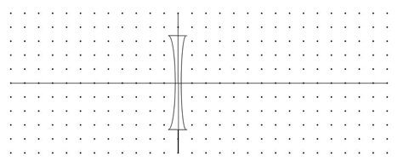**

|  |  |  |  |  |
| --- | --- | --- | --- | --- |
| **Object location** | **Image Type**  **(real or virtual)** | **Orientation**  **Upright or Inverted** | **Size**  **Larger or Smaller** | **Image Location** |
| **Any location** |  |  |  |  |