These application questions will assess your understanding of Newton's First Law and Balanced Forces. Make sure to completely answer each question and to show all of your work.

1. A 47 kg box is sitting at rest on a table.
   1. List the force(s) acting on the box and specify their magnitude in Newtons.
   2. What is the net force acting on the box?
2. A boy now pushes the box from question 1 at a constant velocity of 2.2 m/s. The boy pushes with a force of 55 N. What is the force of friction acting on the box?
3. A 1200 kg car is driving with a constant velocity of 25 m/s. What is the net force acting on the car?
4. A sign hangs unevenly from 2 vertical ropes. The tension in the first rope is 38 N. The sign has a mass of 8.0 kg. What is the tension in the second rope?
5. A 450 kg elevator is suspended by a single cable in the elevator shaft.
   1. What is the tension in the cable when the elevator is standing still?
   2. What is the tension in the cable when the elevator is moving up at a constant velocity of 3.5 m/s?
6. A 17 kg child is handed a bunch of 137 helium balloons at the county fair. She finds that if she stands on a bathroom scale while holding the balloons, it shows that she weighs only 55 N.
   1. What is the upward force due to each balloon?
   2. How many total balloons would it take to just lift her off the ground?
7. Predict the reading on each spring scale below. Assume that the spring scale is being held in place and that all objects are at rest. Explain your reasoning. The masses are each 200 g.

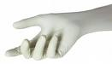

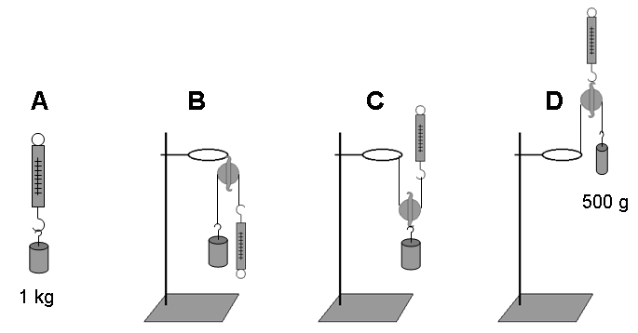

200 g

200 g

1. A force of 250 N is required to start a 40 kg box moving across a concrete floor. What is the coefficient of static friction (µs) between the box and the floor?
2. A sled on snow has a µs of 0.15 and a µk of 0.10. If the combined mass of the sled and the rider is equal to 65 kg.
   1. At what force will the rider begin to move?
   2. What applied force would be required to keep the sled moving at a constant velocity?
3. A horizontal force of 7.0 N pushes a block weighing 5.0 N against a vertical wall. The µs between the wall and the block is 0.60, and the µk was 0.40. Will the block move? (support your answer with a calculation)
4. A 2.5 kg block is initially at rest on a horizontal surface. A horizontal force, ***P***, is applied to the block as shown below. The coefficients of friction for the block and the surface are µs = 0.40 and µk = 0.25. Determine the magnitude and direction of the frictional force acting on the block if the magnitude of ***P*** is:
   1. 8.0 N

***P***

* 1. 9.5 N
  2. 12 N