These application questions will assess your understanding of forces at an angle and vectors. Make sure to completely answer each question and to show all of your work.

For each of the right triangles below, provide the magnitudes of the missing forces and the missing angles.

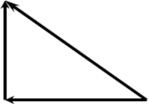1. 2.

θ = 35˚

θ = 14˚

F = _______

Fx = _____

Fy = 12 N

Fx =_______

F = 15 N

Fy _______

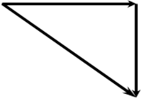3. 4.

θ = 38˚

θ = 48˚

Fx = 12 N

Fy =154 N

Fx =______

F =______

F =_____

Fy = _____

5. 6.

Fy = 27 N

θ =_______

θ = 65˚

F = 43 N

Fy = 92 N

Fx =______

F =______

Fx =______

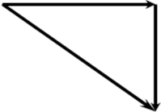7. 8.

θ =_____

θ =_____

Fy = ______

F = 63 N

Fx =41 N

Fx =19 N

Fy = 11 N

F = ______

Determine the x- and y- components of the following vectors. For these, up is positive y, right is positive x.

17 N

9.

Fx = _________

Fy = _________

47˚

10.

15 N

90˚

Fx = _________

Fy = _________

11.

Fx = _________

45˚

14 N

Fy = _________

12.

Fx = _________

22 N

18˚

Fy = _________