Part A: Launch the Pumpkin (or any of the other choices, it matters not)

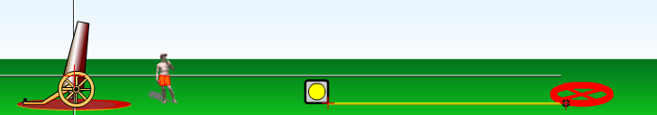

1. Launch the pumpkin for each of the following sets of conditions. For each launch, guess where the pumpkin will land. Move the target to that spot before you launch. See how well you do!
2. Record the time from the white box at the top of the screen.

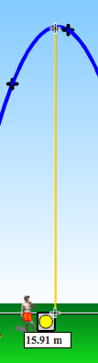 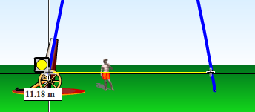

1. Use the measuring tape at the bottom of the screen to measure the **peak height** and **range.** Be sure to measure to the point where the pumpkin reaches the x-axis (grey line).

**All measurements are made using the cannon as the origin (0,0).** Complete the table below:

|  |  |  |  |  |  |
| --- | --- | --- | --- | --- | --- |
|  | 10° | 30° | 45° | 60° | 80° |
| Initial speed (m/s) | 15 | 15 | 15 | 15 | 15 |
| Range (m) |  |  |  |  |  |
| Peak Height (m) |  |  |  |  |  |
| Time (s) |  |  |  |  |  |

1. What angle of launch produced the largest range? Why do you think this occurred? (Hint: think about the components of the initial velocity)
2. What observation can you make about the ranges for complementary launch angles? (Complementary angles are angles that add to 90 degrees.)
3. For what angle of launch does the pumpkin spend the longest time in the air?
4. For what angle of launch does the pumpkin go the highest into the air? Do you think that the maximum height is related to the time in the air? Explain why or why not.
5. What happens to the path of the projectile if air resistance (drag) is turned on? Draw an example.
6. How does mass affect the range of the projectile. Try it and summarize your findings.

**Summary of Projectile Motion Facts:**

1. The angle that produces the largest range is _______________.
2. ___________________ angles have the same range.
3. ______________ is not a factor in how far a projectile will travel.
4. When comparing two projectiles, the projectile that has the largest ___________ will spend the longest time in the air, regardless of how far the projectile goes in the horizontal direction.
5. Introducing air resistance causes the range to __________________.