1. 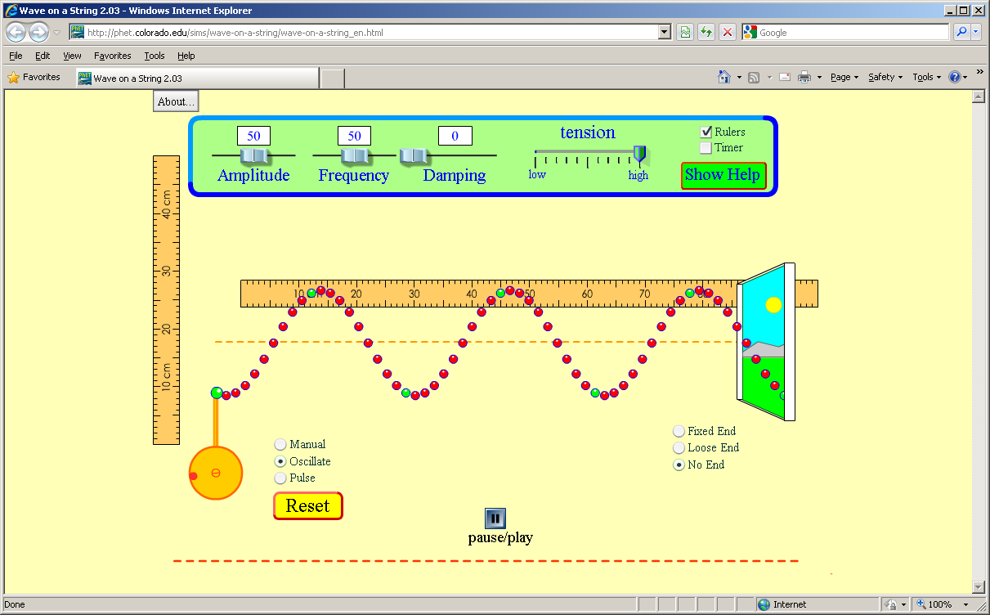Make the following adjustments:
   1. Set “Damping” to zero
   2. Check the “rulers” box
   3. Change from “Manual” to “Oscillate”
   4. Change from “Fixed End” to “No End”

**During this experiment**

1. Set the frequency at 25 Hz.

**

*This wave has a wavelength  
of 0.33 m*

* 1. Press “pause/play” to pause the animation
  2. Use the horizontal ruler to measure the wavelength of your wave (the distance from one high point, called a crest, to the next).
  3. Record the wavelength in the table below.
  4. Repeat for the five different frequencies listed, measuring the wavelength of each wave produced. ***Do not change the amplitude or tension settings****.*

|  |  |  |  |
| --- | --- | --- | --- |
| Trial | Frequency (Hz) | Wavelength (m) | Wave Speed (m/s) |
| 1 | 25 |  | *Wave speed is the product of frequency and wavelength.*  ***v = f λ***  *Calculate the wave speed for each pair of frequencies and wavelengths.* |
| 2 | 40 |  |  |
| 3 | 55 |  |  |
| 4 | 70 |  |  |
| 5 | 85 |  |  |

* 1. What happens to wave speed as the frequency increases?

*As frequency increases, wave speed ____________________*

* 1. What happens to wavelength as frequency increases?

*As frequency increases, wavelength ____________________*



*0 1 2 3 4 5 6 7 8 9 10*

1. *S*et the frequency at 30 Hz. Set the tension at “high”.
   1. Press “pause/play” to pause the animation
   2. Read the tension of the wave from the tension setting. Let “High” equal “10”, “Low” equal “0” and let each mark on the tension slider be 1 unit.
   3. Use the horizontal ruler to measure the wavelength of your wave.
   4. Record the wavelength in the table below.
   5. Repeat for the five different string tensions listed, measuring the wavelength of each wave produced.

|  |  |  |  |  |
| --- | --- | --- | --- | --- |
| Trial | Tension | Frequency  (Hz) | Wavelength (m) | Wave Speed (m/s) |
| 1 | 10 | 30 |  |  |
| 2 | 9 | 30 |  |  |
| 3 | 8 | 30 |  |  |
| 4 | 7 | 30 |  |  |
| 5 | 6 | 30 |  |  |

* 1. What happens to wave speed as the tension decreases?

*As tension decreases, wave speed ____________________*

* 1. What happens to wavelength as frequency increases?

*As tension decreases, wavelength ____________________*

1. *S*et the frequency at 40 Hz and set the tension at “high”.
   1. Press “pause/play” to pause the animation



*This wave has an amplitude of 0.09 cm*

* 1. Use the vertical ruler to measure the amplitude of your wave (the distance from the yellow dotted line to the highest point of the wave).
  2. Use the horizontal ruler to measure the wavelength of your wave.
  3. Record the amplitude and wavelength in the table below
  4. Repeat for the five different amplitudes, measuring the amplitude and wavelength of each wave produced. ***Do not change the frequency or tension settings.***

|  |  |  |  |  |
| --- | --- | --- | --- | --- |
| Trial | Amplitude | Frequency  (Hz) | Wavelength (m) | Wave Speed (m/s) |
| 1 |  | 30 |  |  |
| 2 |  | 30 |  |  |
| 3 |  | 30 |  |  |
| 4 |  | 30 |  |  |
| 5 |  | 30 |  |  |

* 1. What happens to wave speed as the amplitude increases?

*As amplitude increases, wave speed ____________________*

* 1. What happens to wavelength as amplitude increases?

*As amplitude increases, wavelength ____________________*