1. Use one battery and four identical resistors. Draw a schematic of a circuit that will have the same current in each resistor and draw the maximum possible current from the battery.

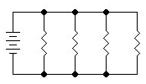

1. Use one battery and four identical resistors. Draw a schematic of a circuit that will have the same current in each resistor and draw the least possible current from the battery.

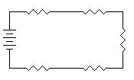

1. For the circuit below, the battery has 9 volts and the three resistors are 3 Ω, 6 Ω, and 9 Ω. Calculate the total resistance of the circuit and the total current the battery delivers. Show your work.

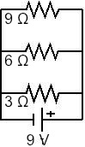

1. For the circuit below, the battery has 6 volts and the three resistors are 2 Ω, 4 Ω and 6 Ω. Find the current through the 4 Ω resistor and the voltage drop across the 6 Ω resistor.

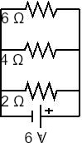

1. For the circuit below, the battery has 6 volts and the three resistors are 2 Ω, 4 Ω and 6 Ω. Find the current through the 4 Ω resistor and the voltage drop across the 6 Ω resistor.

