**I. Series Circuit**

Construct the circuit figure 1 using The Circuit Construction Kit (CCK) simulation at the PhET site. Make the resistors have different resistances and record the each value. Use the ammeter, moving it to take readings in the different places seen in figure 2. Then use the voltmeter to take voltage readings. Calculate R using Ohm’s Law (V=IR) for the total resistance in last column.

Figure 1 Figure 2

|  |  |
| --- | --- |
|  |  |

|  |  |  |  |
| --- | --- | --- | --- |
| Resistor | Voltage (V) | Current (A) | Resistance (Ω)  **(from Ohm’s Law)**  **R=V/I**  (column 2 divided by column 3) |
| 1 |  |  |  |
| 2 |  |  |  |
| 3 |  |  |  |
| Total | VT reading  (Battery Voltage) | IT reading  (Battery Current) | RT=VT/IT |

a. How is the total resistance related to the individual resistances? Total current to the individual currents? Total voltage to the individual voltages?

b. Write a paragraph explaining what you think is happening in series circuits to cause the above relationships to occur. (*You made a similar circuit with light bulbs using CCK.* *You may want to experiment with the simulation again, keeping in mind that light bulbs are just resistors that glow.*).

**II. Parallel Circuits**

Wire the circuit in figure 3 with the same value resistors that you used in Part 1. Take readings in different places shown in figure 4 by moving the meters. Make a table like the one below, calculating resistances using Ohm’s Law in the last column. For each entry in column four you will divide the entry in column two by the entry in column three.

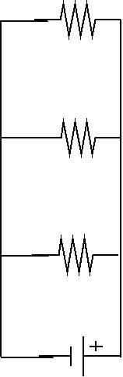 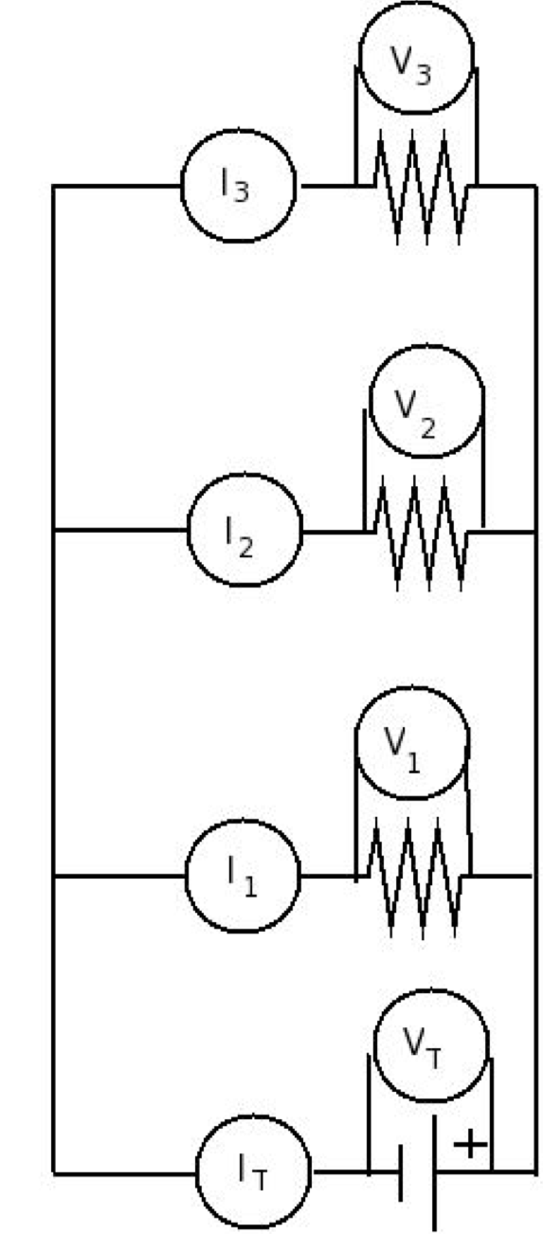

Figure 3 Figure 4

|  |  |  |  |
| --- | --- | --- | --- |
| **Resistor** | **Voltage (V)** | **Current(A)** | **Resistance(Ω)**  **(from Ohm’s Law)**  **R=V/I**  **(column 2 divided by column 3)** |
| **1** |  |  |  |
| **2** |  |  |  |
| **3** |  |  |  |
| Total | VT reading  (Battery Voltage) | IT reading  (Battery Current) | RT=VT/IT |

a. How is the total resistance related to the individual resistances? Explain what you think is happening.

b. The mathematical relationship for finding total resistance in a parallel circuit is given by:  Show that your data fits the equation.

c. Imagine you and your friends are running in the neighborhood like electrons flowing through a circuit. Make up stories that would serve as analogies for a parallel versus series circuits. Share your stories on the discussion board to see if they make sense.

d. Summarize the similarities and differences between the series and parallel circuits. Include your reasoning about what you think is happening. Post your response on the discussion board, then read and reply to at least three of your classmates posts.