The circuit below has five identical resistors, each resistor is a 1 Ω resistor. The battery has 6 V.

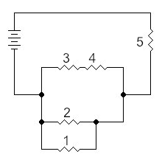

For this circuit, answer the following questions:

1. Which two resistors have the same current?
2. Which resistor has the most current?
3. Which resistor has the least current?
4. Which resistor, if removed, would stop the current flow in the circuit?