Introduction - Mr. Baker
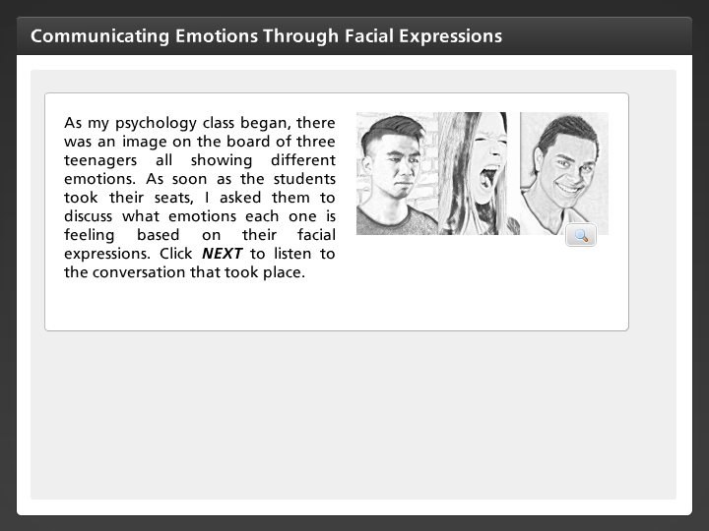
As my psychology class began, there was an image on the board of three teenagers all showing different emotions. As soon as the students took their seats, I asked them to discuss what emotions each one is feeling based on their facial expressions. Click NEXT to listen to the conversation that took place.

Cindy
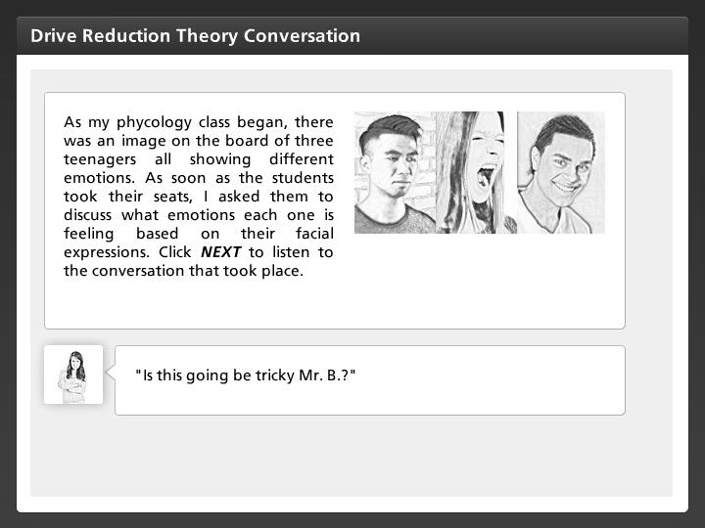
"Is this going be tricky Mr. B.?"

Mr. Baker
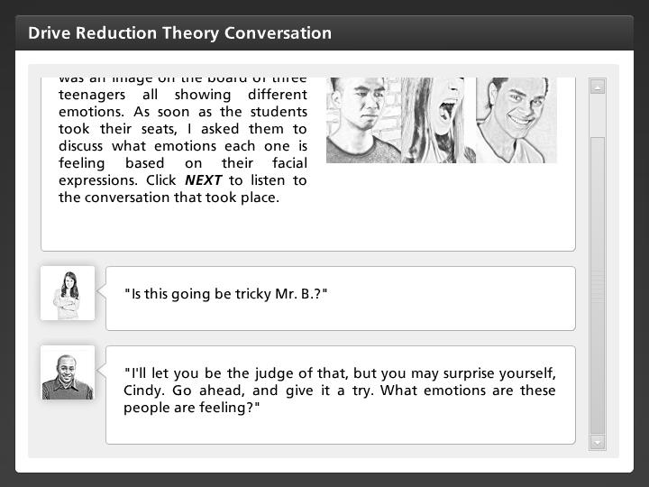
"I'll let you be the judge of that, but you may surprise yourself, Cindy. Go ahead, and give it a try. What emotions are these people are feeling?"

Cindy
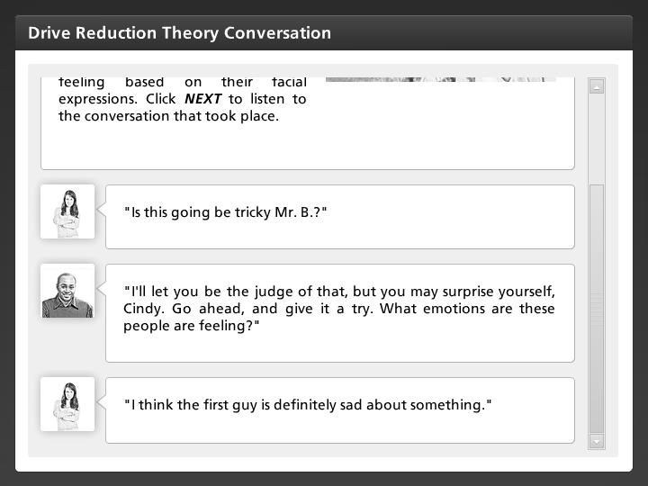
"I think the first guy is definitely sad about something."

Janelle
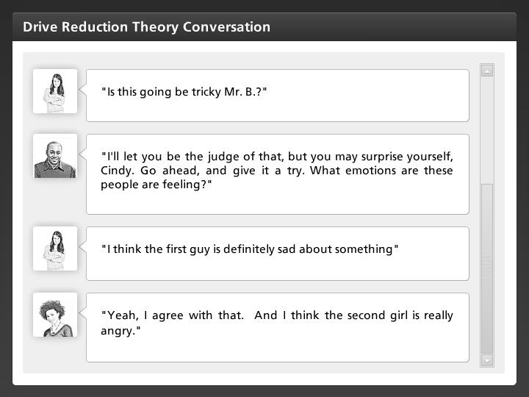
"Yeah, I agree with that. And I think the second girl is really angry."

Marcos
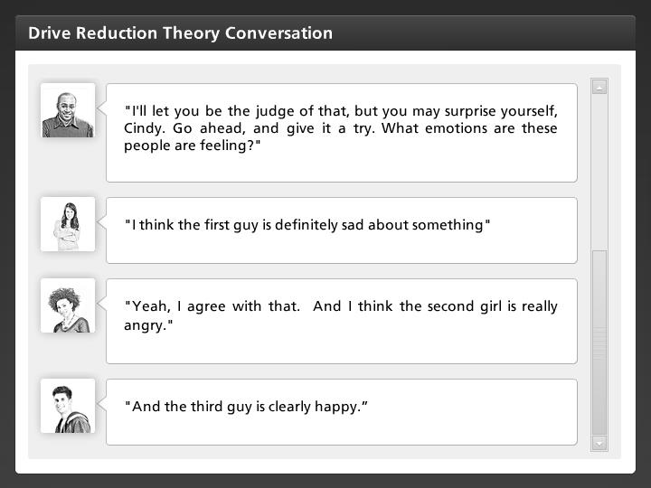
"And the third guy is clearly happy.”

Mr. Baker
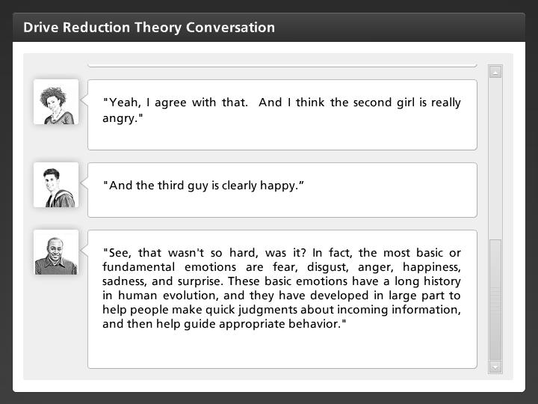
"See, that wasn't so hard, was it? In fact, the most basic or fundamental emotions are fear, disgust, anger, happiness, sadness, and surprise. These basic emotions have a long history in human evolution, and they have developed in large part to help people make quick judgments about incoming information, and then help guide appropriate behavior."

Hannah
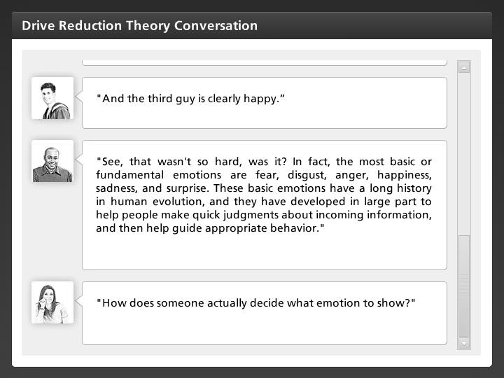
"How does someone actually decide what emotion to show?"

Mr. Baker
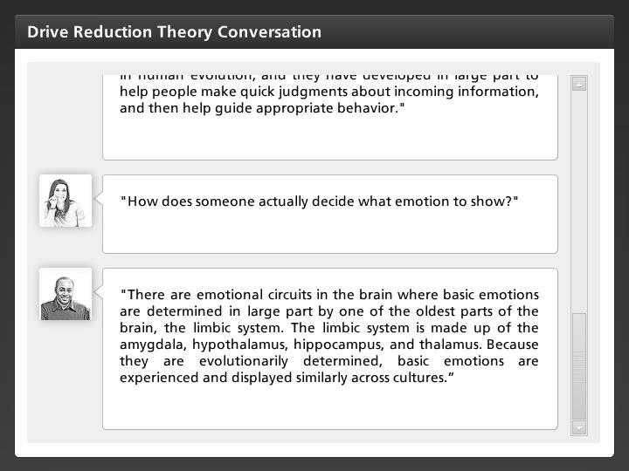
"There are emotional circuits in the brain where basic emotions are determined in large part by one of the oldest parts of the brain, the limbic system. The limbic system is made up of the amygdala, hypothalamus, hippocampus, and thalamus. Because they are evolutionarily determined, basic emotions are experienced and displayed similarly across cultures.”

Donnie
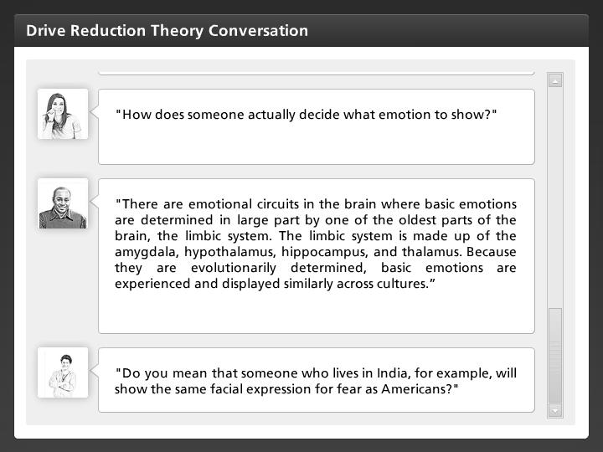
"Do you mean that someone who lives in India, for example, will show the same facial expression for fear as Americans?"

Mr. Baker
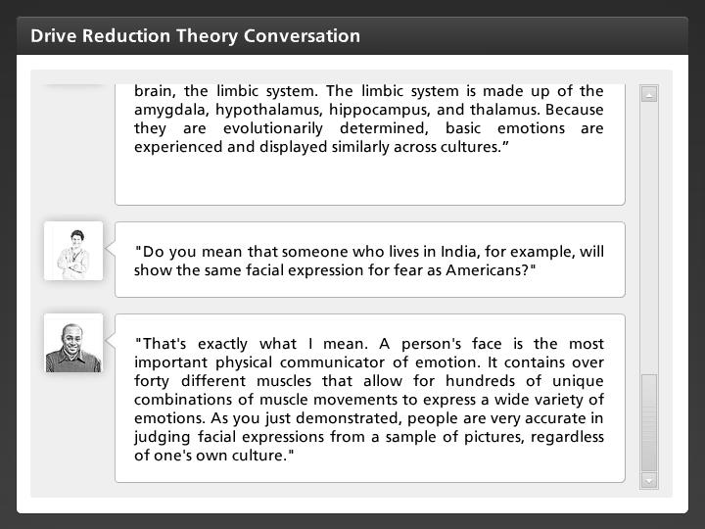
"That's exactly what I mean. A person's face is the most important physical communicator of emotion. It contains over forty different muscles that allow for hundreds of unique combinations of muscle movements to express a wide variety of emotions. As you just demonstrated, people are very accurate in judging facial expressions from a sample of pictures, regardless of one's own culture."

Marcos
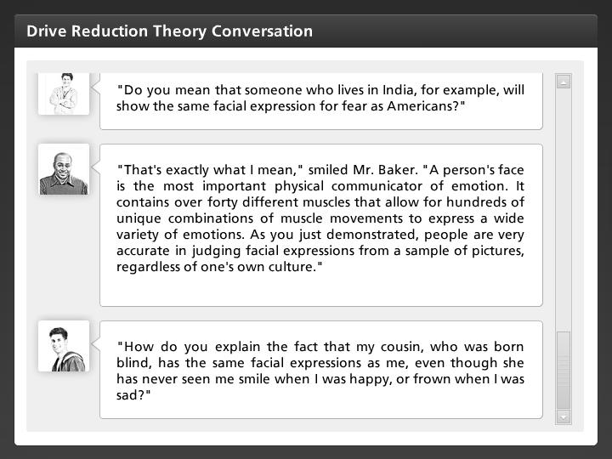
"How do you explain the fact that my cousin, who was born blind, has the same facial expressions as me, even though she has never seen me smile when I was happy, or frown when I was sad?"

Mr. Baker
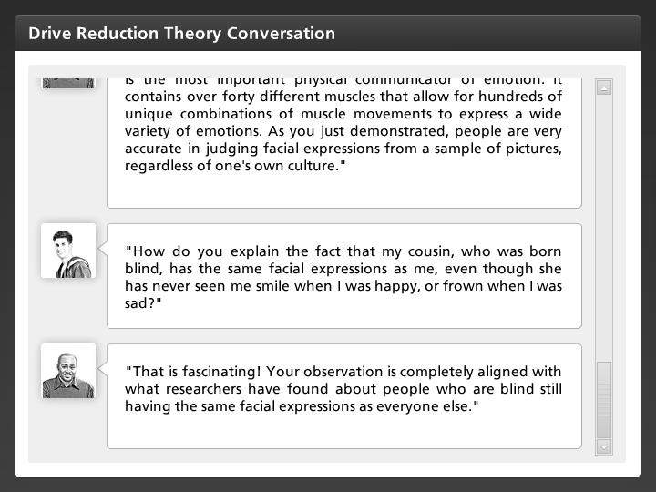
"That is fascinating! Your observation is completely aligned with what researchers have found about people who are blind still having the same facial expressions as everyone else."

Hannah
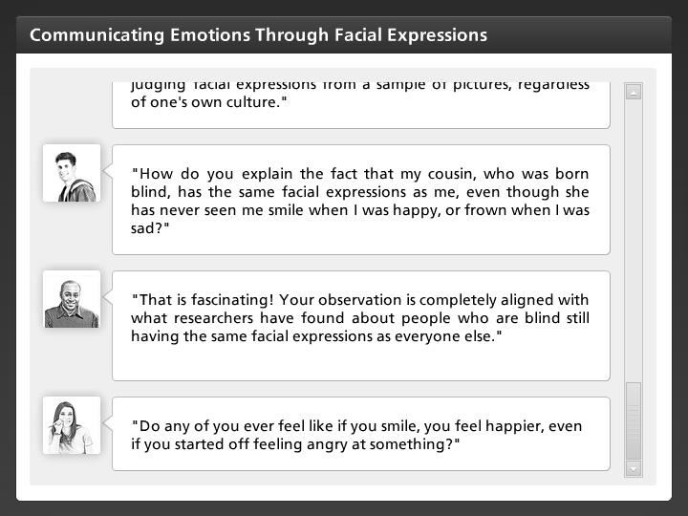
"Do any of you ever feel like if you smile, you feel happier, even if you started off feeling angry at something?"

Janelle
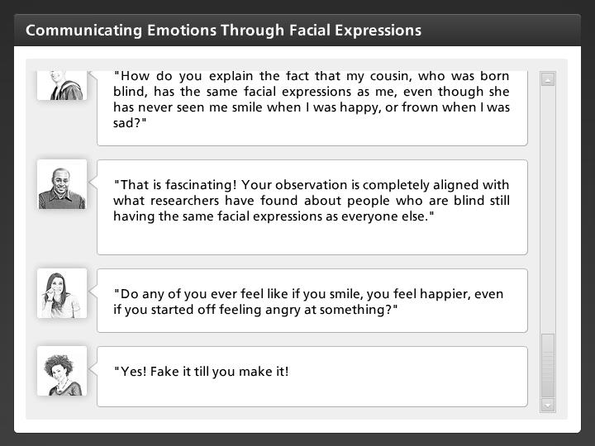
"Yes! Fake it till you make it!"

Mr. Baker
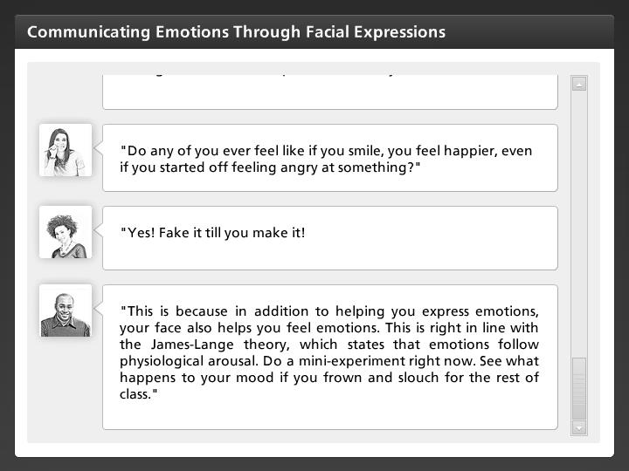
"This is because in addition to helping you express emotions, your face also helps you feel emotions. This is right in line with the James-Lange theory, which states that emotions follow physiological arousal. Do a mini-experiment right now. See what happens to your mood if you frown and slouch for the rest of class."

