Use this template to help analyze the political cartoon and prepare and audio script prior to recording your audio message.
Political Cartoon:
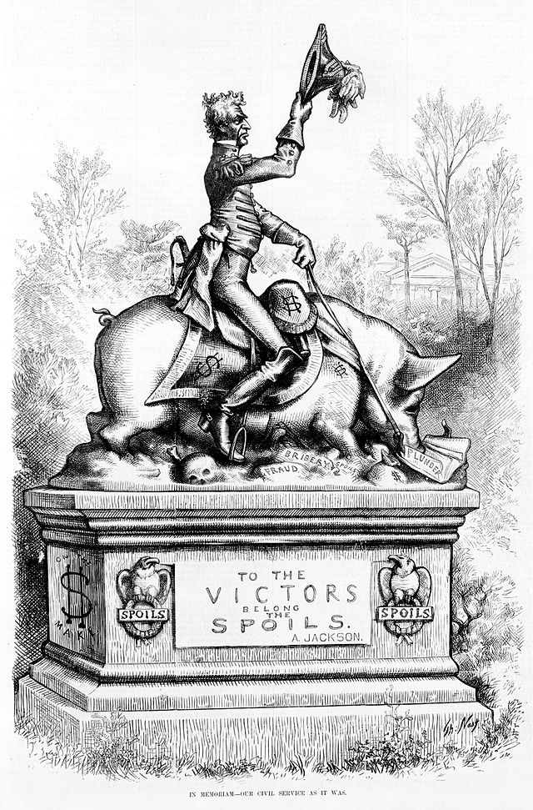
Title: In memoriam-our civil service as it was
Author: Thomas Nast
Published: Harper’s Weekly, April 28th, 1877 pg. 325

Part 1: Analysis
Analyze the cartoon to determine the message of each by looking at the words, symbols, and actions conveyed in the cartoon. Try to determine the cartoon’s intended audience. While analyzing the political cartoon it will help to answer the following questions. Write all responses in the blank spaces provided.

- What people or objects to do you see in the cartoon?

- Does the cartoon have a caption or title? What is the main message of this cartoon?

- Does the cartoon use any descriptive words or phrases to identity people or objects within the cartoon? Explain the use of the words or phrases used by the cartoonist.

- Does the cartoon contain any dates or numbers?

- Which words or phrases are the most significant? Explain the meaning of these words or phrases.

- What action is taking place in the cartoon? Explain the action.

- What groups would agree and disagree with the cartoon? Explain your reasoning.

Part II: Audio Script

Write a script in which you describe the political cartoon, making sure to answer the questions that apply to the cartoon. Be sure to include explanations and reference items found in the cartoon.

