# Module: Sub-Saharan Africa, Topic Application: Sub-Saharan Africa Map Analysis

## Map Analysis Activity

As you traveled through Eastern and Southern Africa, you saw the diverse physical and cultural geography of this region. You also examined the various political systems and economic activities of Sub-Saharan Africa.

For this assignment, you will study the following maps:

* Sub-Saharan Africa’s population density
* Sub-Saharan Africa’s language families
* Sub-Saharan Africa’s religions

After interpreting each map, provide answers to each of the questions.

### Part I: Population Density

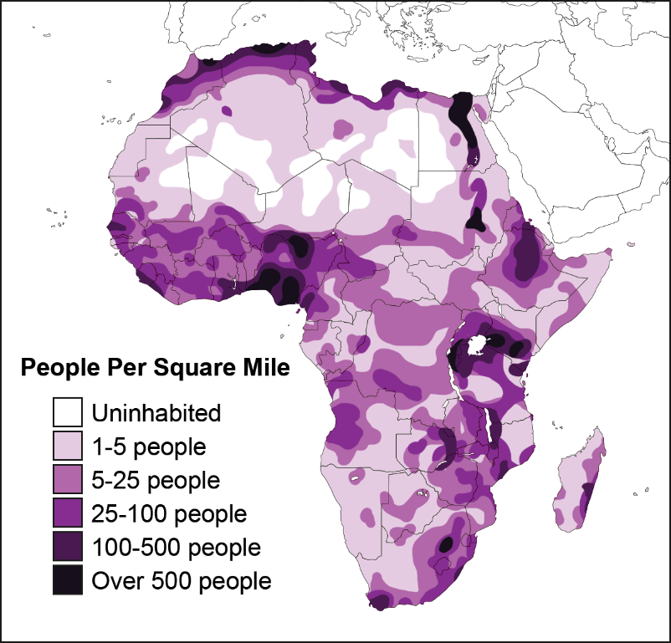

Africa Population Density Map: Detailed Description

1. How does the population density vary throughout Sub-Saharan Africa?
2. Which countries have areas with more than 500 people per square mile (identify at least three)?
3. Which areas of Sub-Saharan Africa have the lowest population density?
4. Why do some areas of Sub-Saharan Africa have a high population density while another areas have a low population density? Describe each area and explain why the area has a high or low population density.

### Part II: Language Families

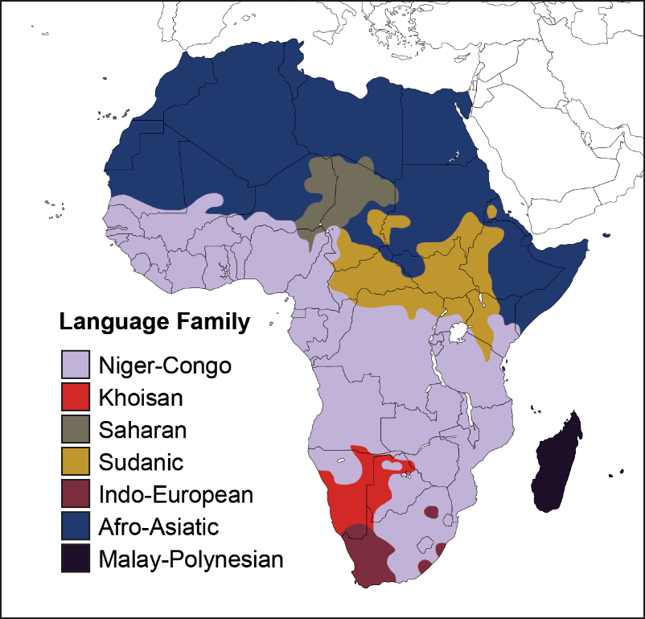

African Language Families Map: Detailed Description

1. How do the language families vary throughout Sub-Saharan Africa?
2. List the language families found in each of the listed locations.
   1. Somalia
   2. Madagascar
   3. Rainforest
   4. Great Rift Valley
   5. Serengeti
3. Which countries have the greatest number of language families present? What benefits would having a variety of languages in one country pose? What challenges might these countries face because of this?

### Part III: Religions

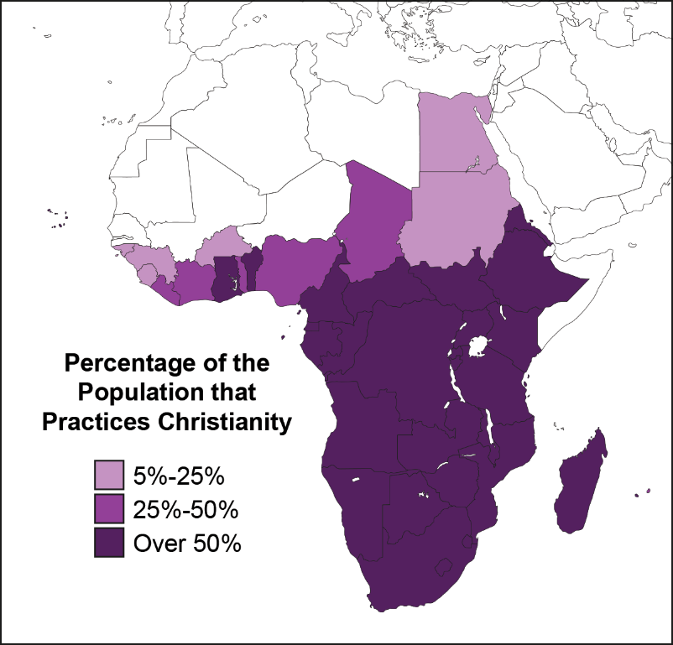

Percentage of African Population that Practices Christianity Map: Detailed Description

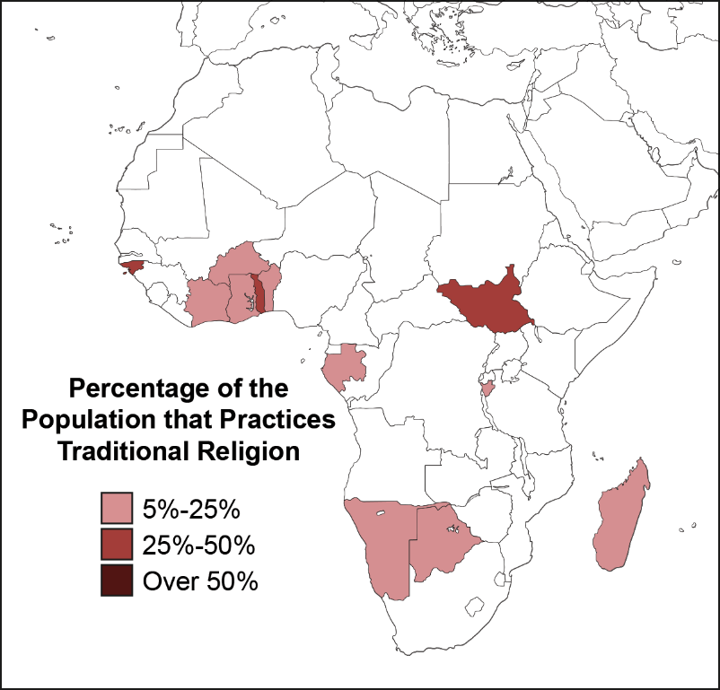

Percentage of African Population that Practices Traditional Religion Map: Detailed Description

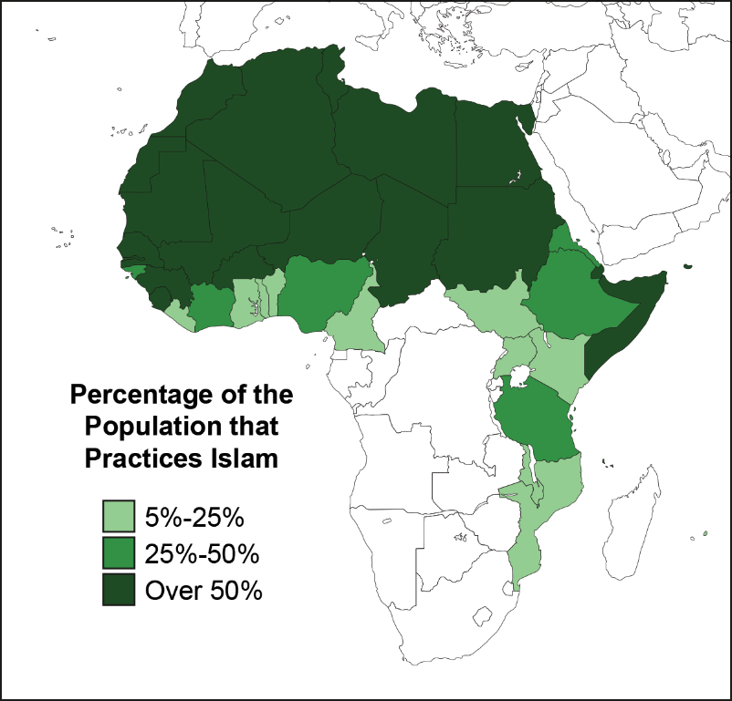

Percentage of African Population that Practices Islam Map: Detailed Description

1. How do religions vary throughout Sub-Saharan Africa?
2. List the primary religion found in each of the listed locations.
   1. South Africa
   2. Botswana
   3. Somalia
3. Where in Sub-Saharan Africa are the greatest number of traditional religious practitioners?
4. Where in Sub-Saharan Africa is Islam practiced?
5. Which part of Sub-Saharan Africa practices Christianity?
6. How might these countries benefit from having this diversity of religions? How might religious diversity become a challenge for these countries?

## Detailed Descriptions of Maps

### Population Density Map

The map has no title. This map displays the population density of Sub-Saharan Africa, using color. The map shows the landmasses of Southern Europe, Africa, the Middle East, the Anatolian Peninsula, and a portion of southwest Asia. A compass rose does not exist on this map. It is assumed that the cardinal direction of north is toward the top of the map, west is to the left of the map, east is to the right of the map, and south is toward the bottom of the map. A map key exists on the left side of the map, which explains the colors used for the different population densities. This key is labeled People Per Square Mile.

On this map,

* Areas shaded white are uninhabited
* Areas shaded light pink contain 1-to-5 people per square mile
* Areas shaded pink contain 5-to-25 people per square mile
* Areas shaded magenta contain 25-to-100 people per square mile
* Areas shaded purple contain 100-to-500 people per square mile
* Areas shaded dark purple contain more than 500 people

### Africa Language Families Map

The map has no title. This map displays the language families of Sub-Saharan Africa, using color. The map shows the landmasses of Southern Europe, Africa, the Middle East, the Anatolian Peninsula, and a portion of southwest Asia. A compass rose does not exist on this map. It is assumed that the cardinal direction of north is toward the top of the map, west is to the left of the map, east is to the right of the map, and south is toward the bottom of the map. A map key exists on the left side of the map, which explains the colors used for the different language families. This key is labeled Language Family.

On this map,

* Areas shaded grey represent the Niger-Congo language family
* Areas shaded red represent the Khoisan language family
* Areas shaded green represent the Saharan language family
* Areas shaded yellow represent the Sudanic language family
* Areas shaded purple represent the Indo-European language family
* Areas shaded blue represent the Afro-Asiatic language family
* Areas shaded dark purple represent the Malay-Polynesian language family

### Percentage of African Population that Practices Christianity Map

The map has no title. This map displays the percentage of the population that practices Christianity in Sub-Saharan Africa, using color. The map shows the landmasses of Southern Europe, Africa, the Middle East, the Anatolian Peninsula, and a portion of southwest Asia. A compass rose does not exist on this map. It is assumed that the cardinal direction of north is toward the top of the map, west is to the left of the map, east is to the right of the map, and south is toward the bottom of the map. A map key exists on the left side of the map, which explains the colors used for the different percentages of the population that practice Christianity. This key is labeled Percentage of the Population that Practices Christianity.

On this map,

* Areas shaded pink represent 5-to-25 percent
* Areas shaded magenta represent 25-100 percent
* Areas shaded purple represent more than 50 percent

### Percentage of African Population that Practices Traditional Religion Map

The map has no title. This map displays the percentage of the population that practices Traditional Religion in Sub-Saharan Africa, using color. The map shows the landmasses of Southern Europe, Africa, the Middle East, the Anatolian Peninsula, and a portion of southwest Asia. A compass rose does not exist on this map. It is assumed that the cardinal direction of north is toward the top of the map, west is to the left of the map, east is to the right of the map, and south is toward the bottom of the map. A map key exists on the left side of the map, which explains the colors used for the different percentages of the population that practice Traditional Religion. This key is labeled Percentage of the Population that Practices Traditional Religion.

On this map,

* Areas shaded light red represent 5-to-25 percent
* Areas shaded red represent 25-100 percent
* Areas shaded dark red represent over 50 percent

### Percentage of African Population that Practices Islam Map

The map has no title. This map displays the percentage of the population that practices Islam in Sub-Saharan Africa, using color. The map shows the landmasses of Southern Europe, Africa, the Middle East, the Anatolian Peninsula, and a portion of southwest Asia. A compass rose does not exist on this map. It is assumed that the cardinal direction of north is toward the top of the map, west is to the left of the map, east is to the right of the map, and south is toward the bottom of the map. A map key exists on the left side of the map, which explains the colors used for the different percentages of the population that practice Islam. This key is labeled Percentage of the Population that Practices Islam.

On this map,

* Areas shaded light green represent 5-to-25 percent
* Areas shaded green represent 25-100 percent
* Areas shaded dark green represent more than 50 percent