# Tips for Viewing and Navigating Content Interactivities

Throughout the course, you will find interactivities used to deliver content. The layout of interactivities will vary depending on the content. In most instances, audio will be included in the interactivity. This document provides tips for viewing and navigating course interactivities.

## Player Buttons

Some interactivities use **player buttons** to control navigation. Instructions on how to navigate these learning objects are included in the interactivity.

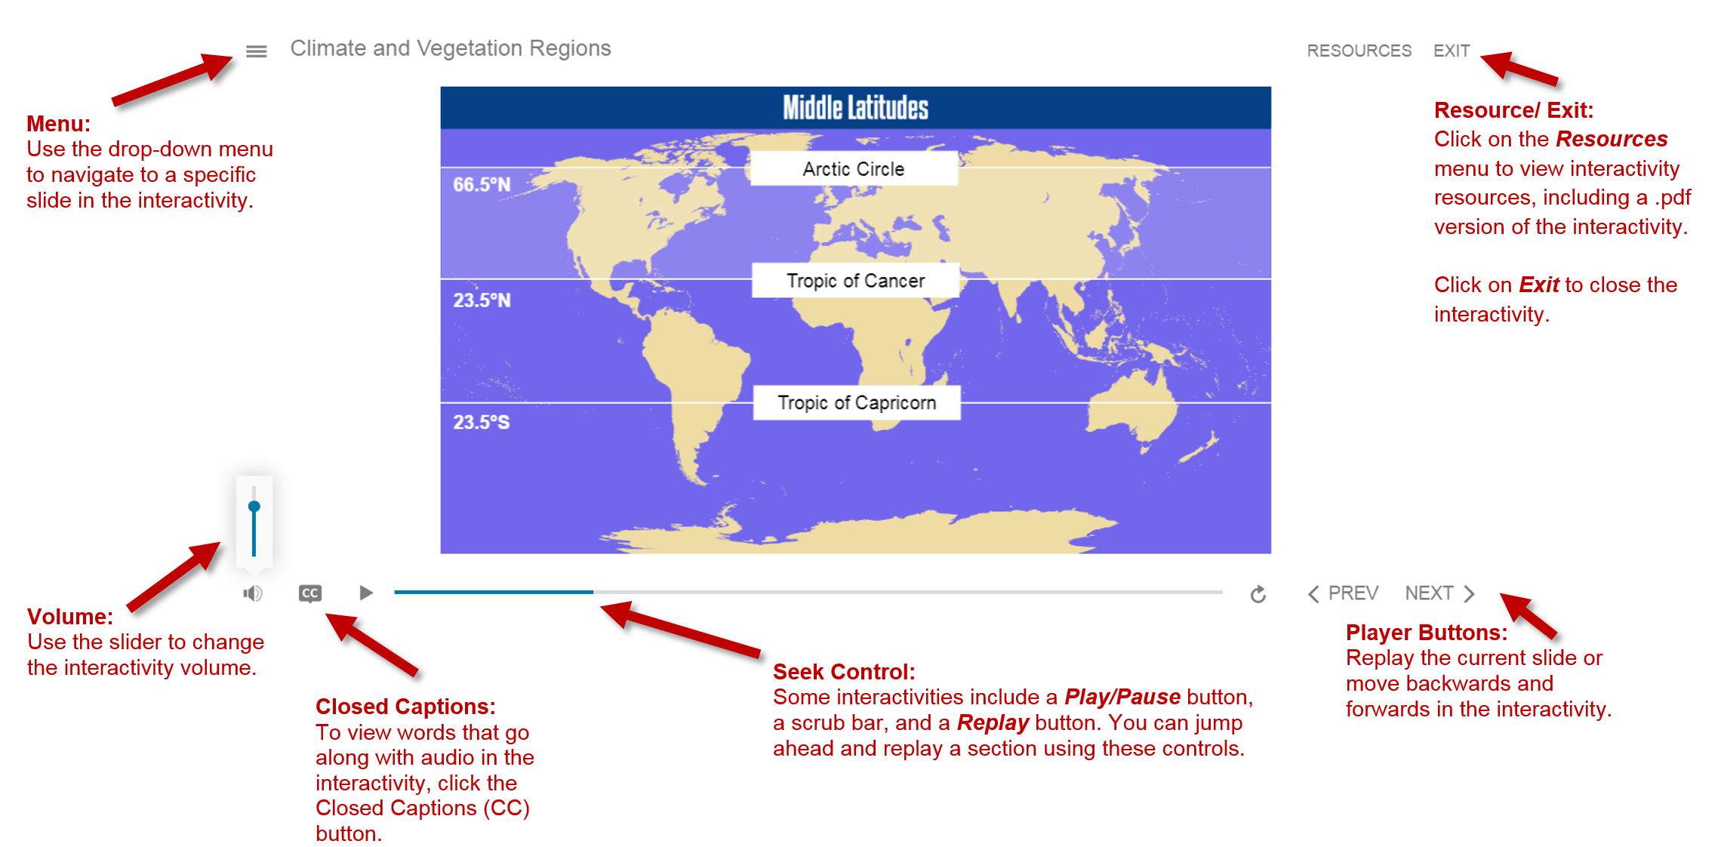Detailed Description of Image

## Exiting an Interactivity

All interactivities are set to open in a new browser tab. To exit an interactivity, simply close the browser tab by clicking the “**x**” located in the corresponding tab. The final slide of interactivities include on-screen instructions and buttons used to **restart** or **exit** the interactivity.

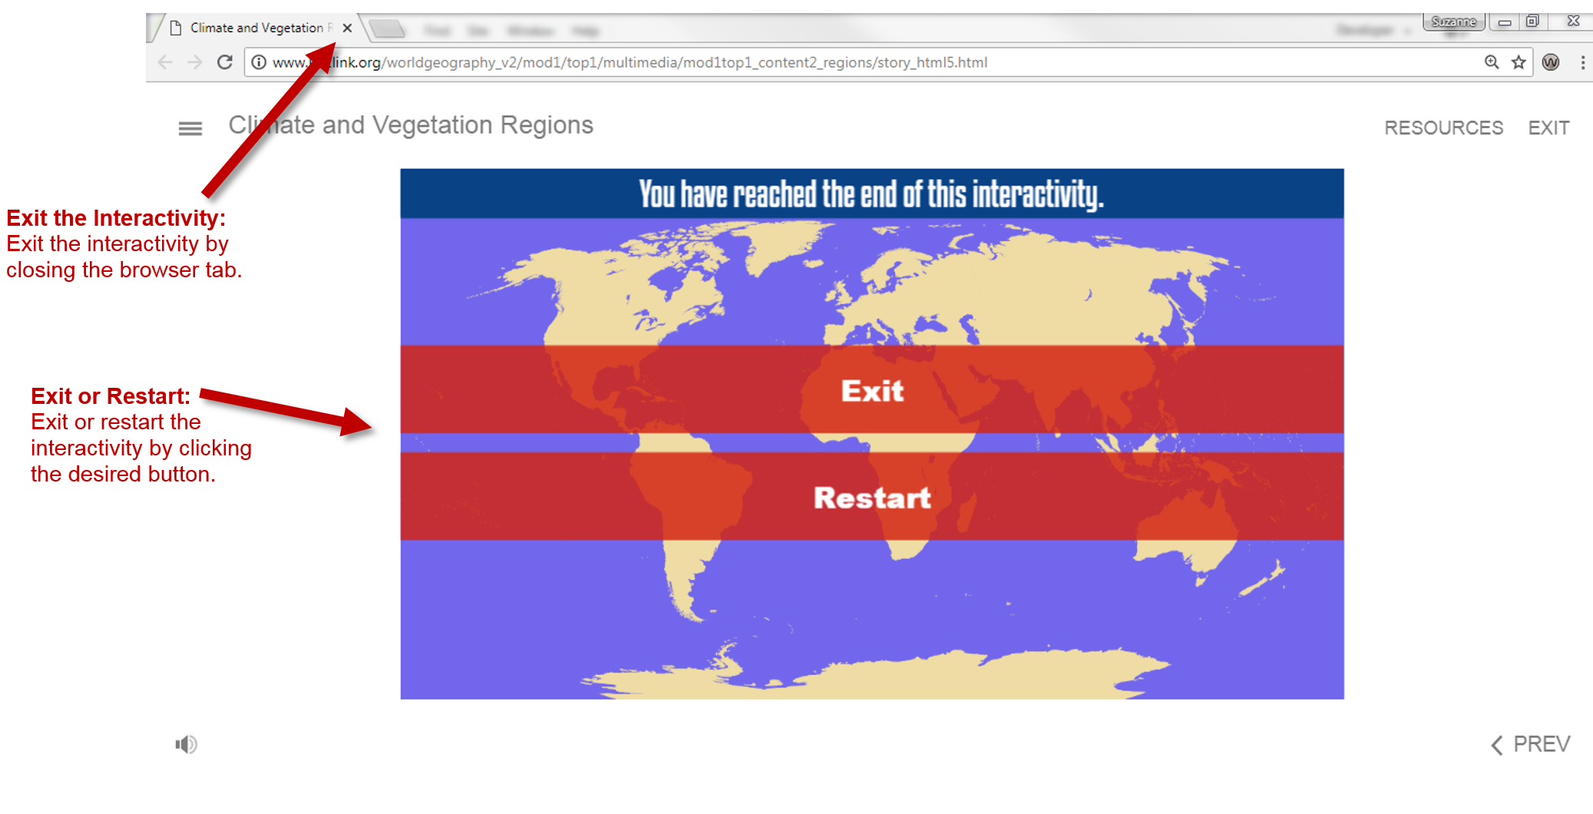Detailed Description of Image

## Player Buttons Image

* **Menu:** Use the drop-down menu to navigate to a specific slide in the interactivity.
* **Volume:** Use the slider to change the interactivity volume.
* **Closed Captioning:** Use the button to turn closed captioning on or off.
* **Seek Control:** Some interactivities include a Play/Pause button, a scrub bar, and a Replay button. You can jump ahead and replay a section using this control.
* **Next and Previous Buttons:** Replay the current slide or move backwards and forwards in the interactivity.
* **Resources/Restart/Exit:** Click on the Resources menu to view interactivity resources, including a .pdf version of the interactivity. Click on Restart to replay the interactivity from the beginning. Click on Exit to close the interactivity.

## Exiting an Interactivity

* Exit the interactivity by closing the browser tab and/or window.
* Exit or restart the interactivity by clicking the desired button on the final interactivity screen.