# Tips for Viewing and Navigating Review Interactivities

Throughout the course, you will find interactivities used to review content. Most review interactivities follow a similar layout. In most instances, audio will not be included in the interactivity. This document provides tips for viewing and navigating review interactivities.

## Title Slide

All review interactivities include a title slide, and an on-screen button to start the review. It can be accessed by using a mouse to click on the button or tabbing to the button and selecting Enter.

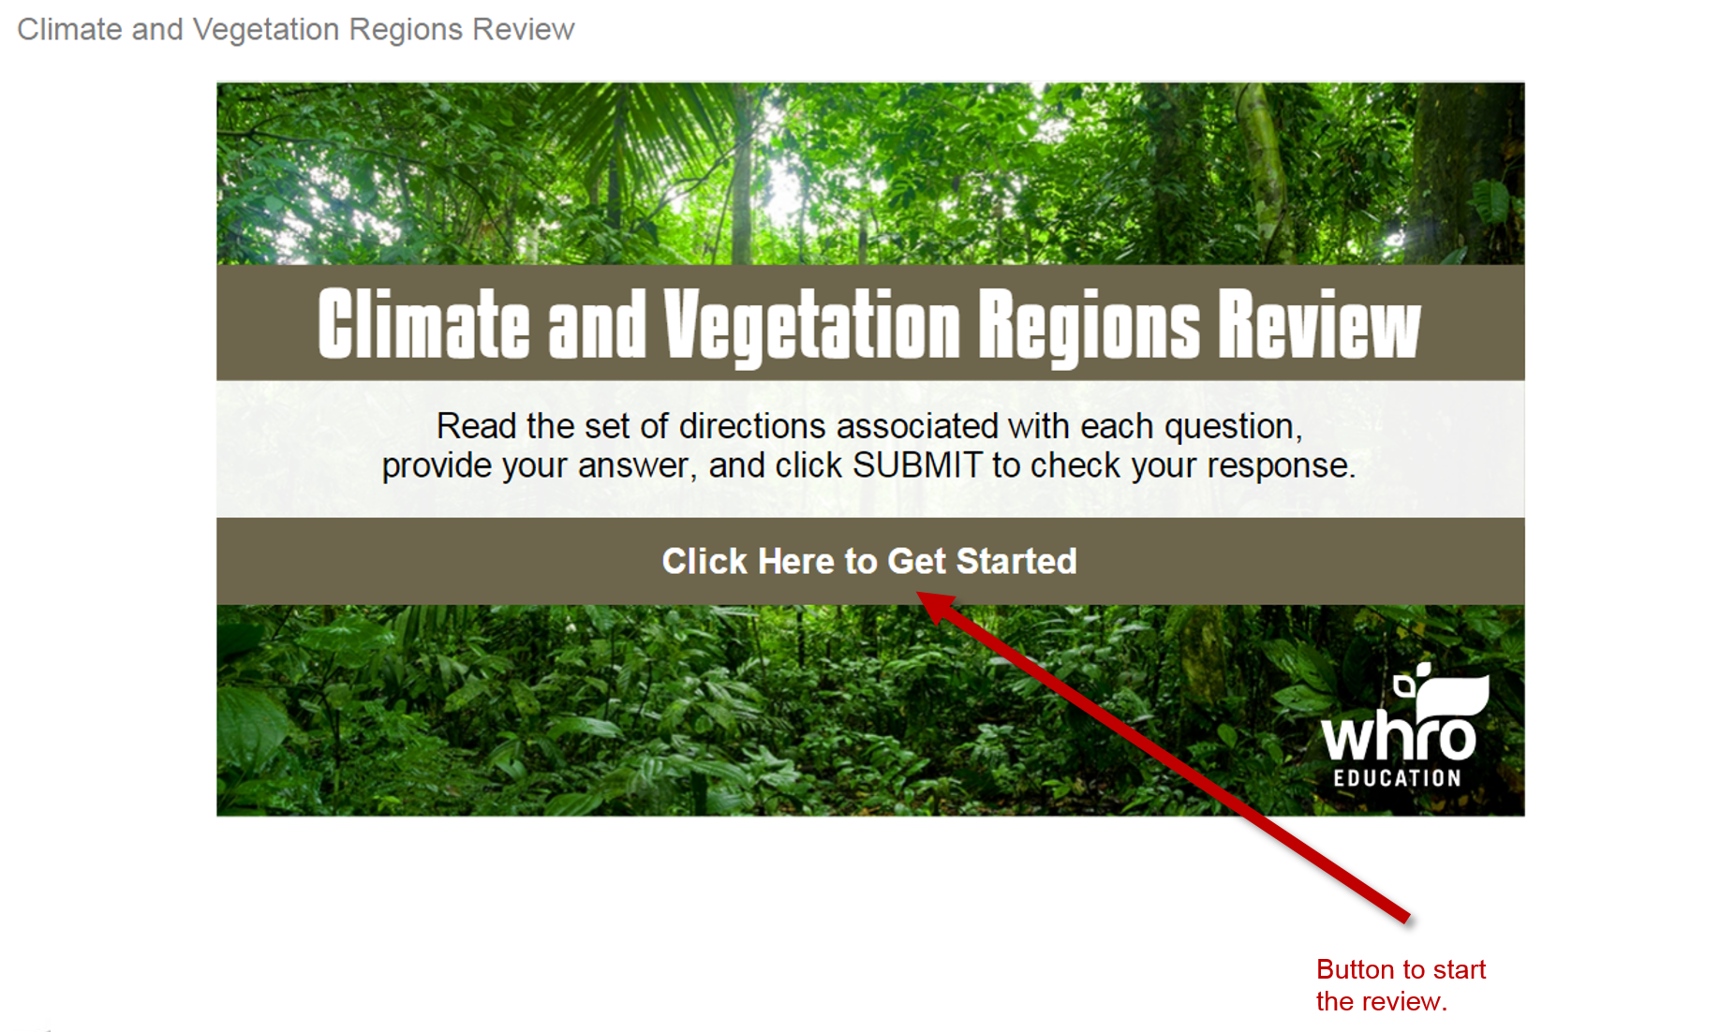

## Submitting a Question

A variety of question types are used in review interactivities. Each question includes the question text, and answer field, and a ***Submit*** button. Once you have answered a question, click the ***Submit*** button to check your answer.

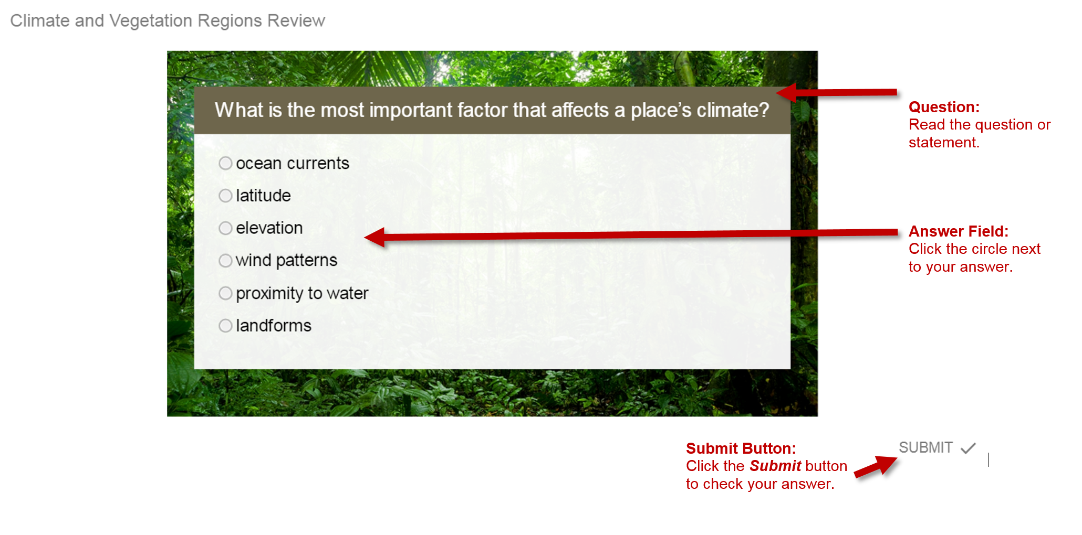

## The Feedback Slide

In most review interactivities, you will have one chance to answer each question. After clicking the ***Submit*** button, you will receive corrective feedback. Click the ***Continue*** button to view the next question.

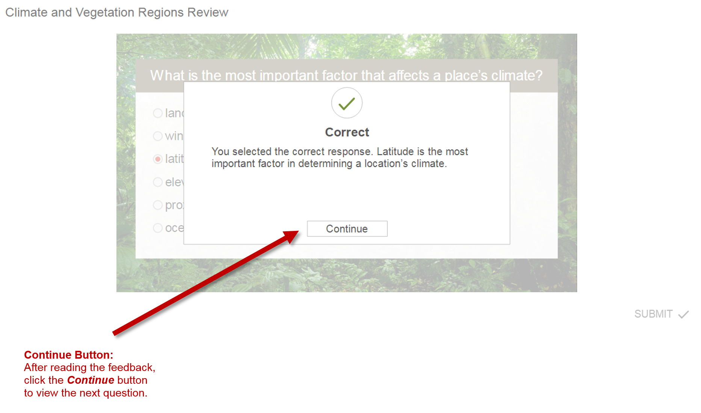

## The Results Slide

All review interactivities include a **results slide,** which appears when all of the questions have been answered. The results slide contains your score and options to retry the quiz, review the quiz, print the results, or exit the quiz.

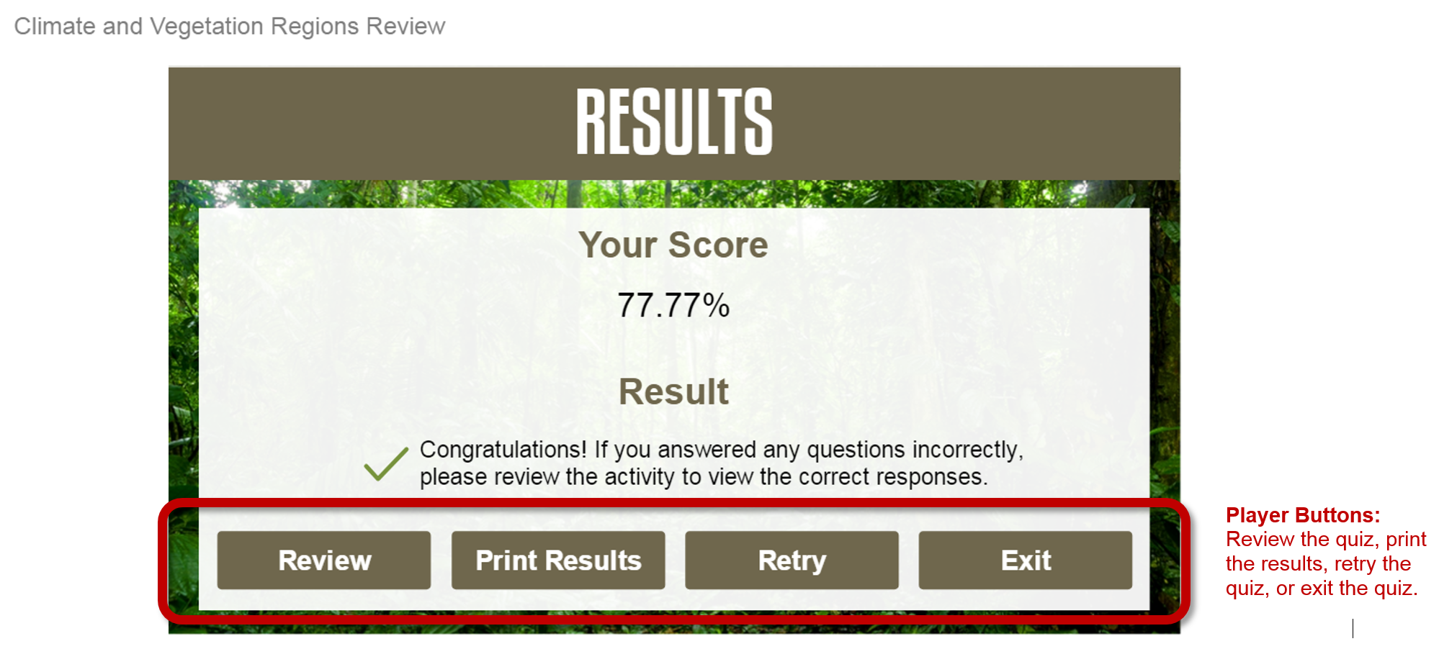

## How to View and Print the Review Interactivity Results

Upon clicking the ***Print Results*** button, you will be prompted to enter your name in the blank field. Click the ***OK*** button to view the results page.

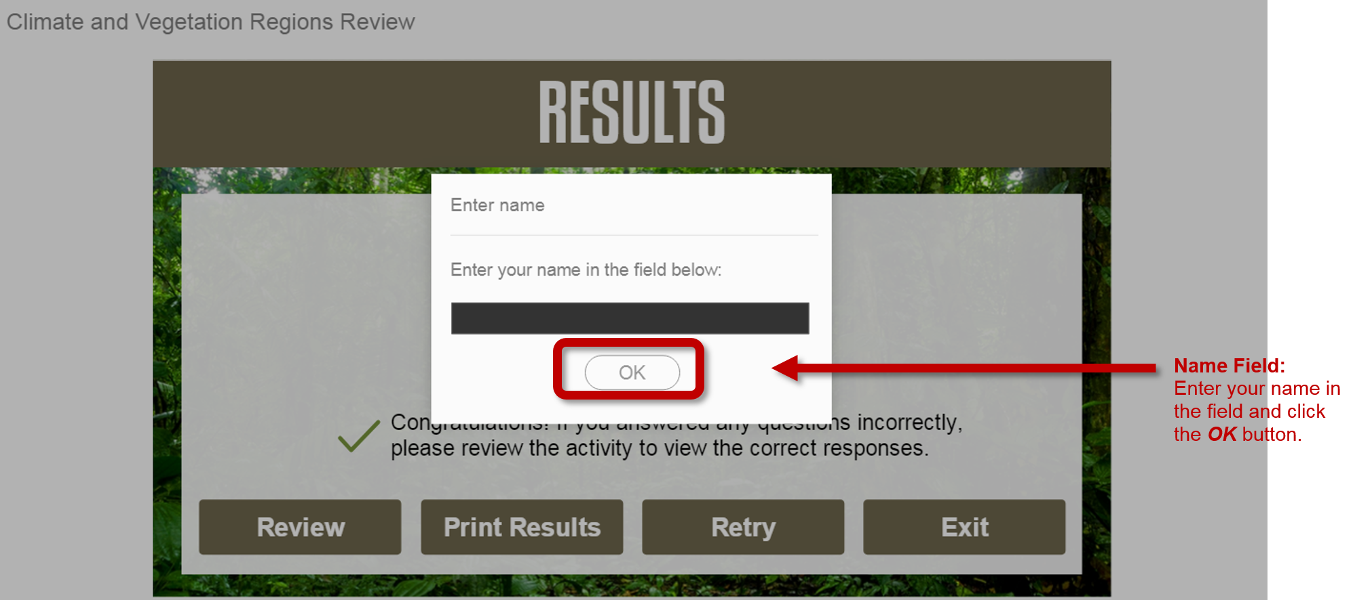

How to View and Print the Review Interactivity Results (continued)

The results page will be displayed in a new browser window. Your instructor may ask you to submit this page. Three options for saving and/or printing this page include the following:

1. Print the results page to submit it in-person or scan the printed page to create a digital copy.
2. Print or save the results page as an **Adobe® PDF** file.
3. Take a screen shot of the results page to save it as an image file.

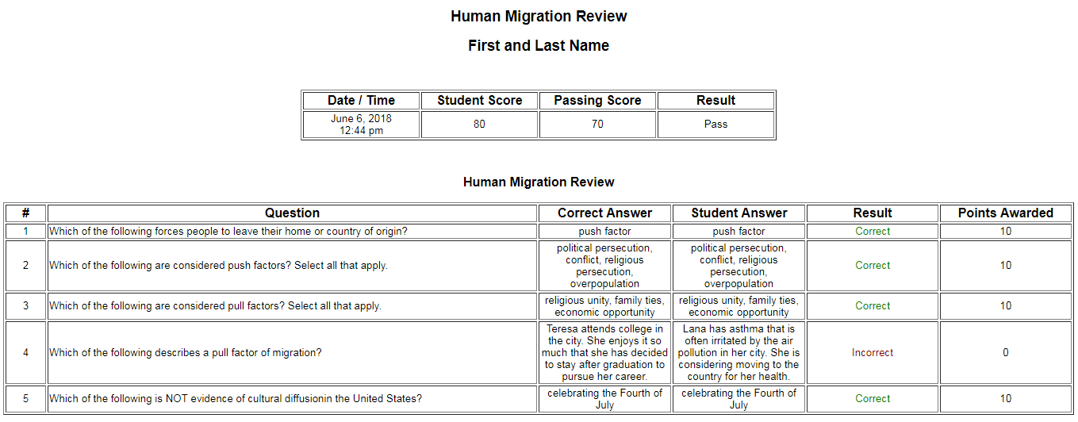

## How to Exit a Review Interactivity

All review interactivities are set to open in a new browser tab. To exit a review interactivity, simply close the browser tab by click the “**x**” located in the corresponding tab. Additionally, all interactivities have an ***Exit*** button that can be used to exit the review interactivity.

