Illustrate the shape below so that it reflects the appropriate apparel for the character profile you are completing for this assignment. To illustrate the image, you may draw and color over the shape. If you would like to create your own character image with another piece of software, you may do so.
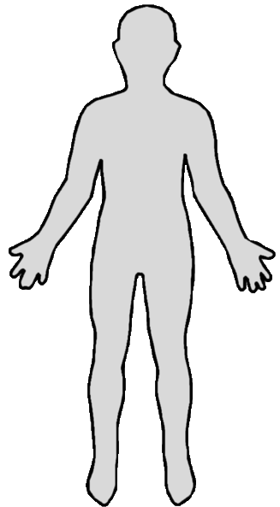

Questions

Which character did you select?

What is your character’s name? Why did you select that name?

When and where was your character born?

How would you describe your character’s personality?

What is your character’s education?

What are your characters strengths and weaknesses?

What are your characters likes and dislikes?

What is the most important event in your character’s life?

What are some of your character’s greatest accomplishments?

