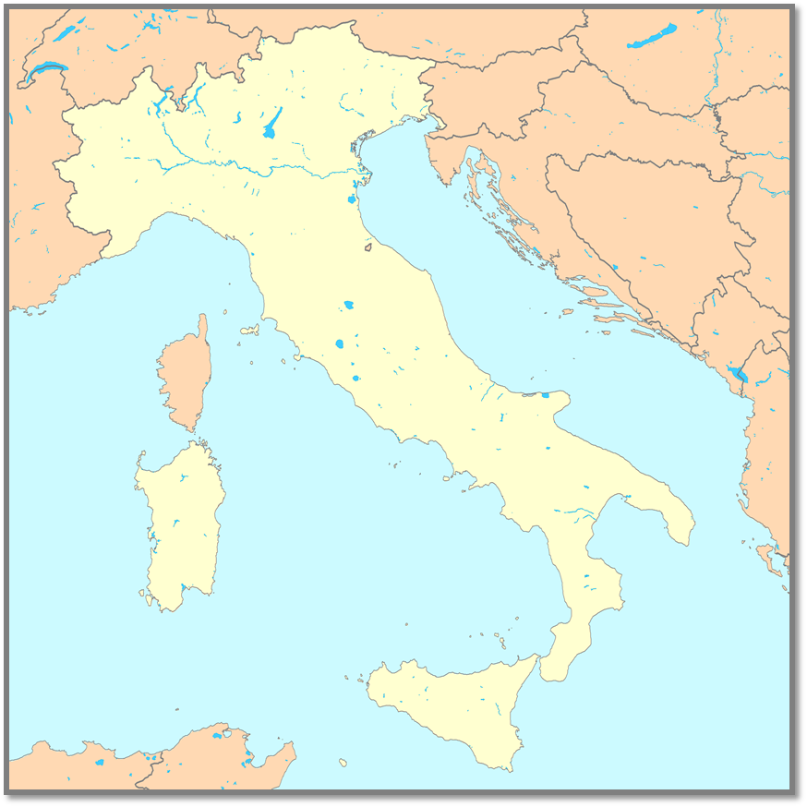
Using this map, label the following locations:
- Alps Mountains
- Carthage
- Italian Peninsula
- Rome
- Mediterranean Sea

